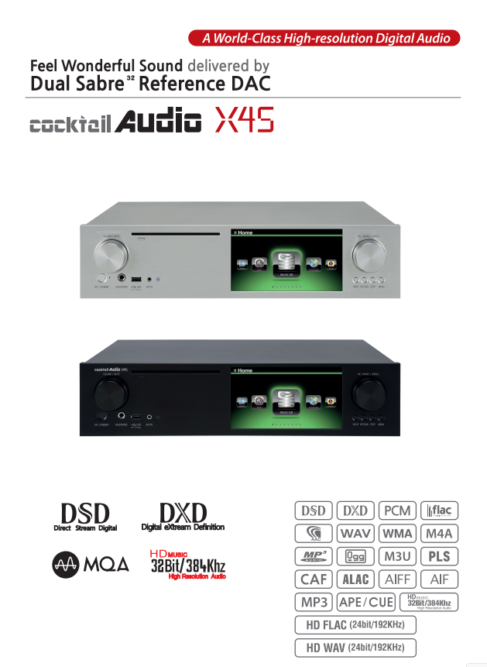

Rev2.0 English

Gracenote® End User License Agreement
This application or device contains software from Gracenote, Inc. of Emeryville, California (“Gracenote”). The software from Gracenote (the “Gracenote Software”) enables this application to perform disc and/or file identification and obtain music-related information, including name, artist, track, and title information (“Gracenote Data”) from online servers or embedded databases (collectively, “Gracenote Servers”) and to perform other functions. You may use Gracenote Data only by means of the intended End-User functions of this application or device.
You agree that you will use Gracenote Data, the Gracenote Software, and Gracenote Servers for your own personal non-commercial use only. You agree not to assign, copy, transfer or transmit the Gracenote Software or any Gracenote Data to any third party. YOU AGREE NOT TO USE OR EXPLOIT GRACENOTE DATA, THE GRACENOTE SOFTWARE, OR GRACENOTE SERVERS, EXCEPT AS EXPRESSLY PERMITTED HEREIN.
You agree that your non-exclusive license to use the Gracenote Data, the Gracenote Software, and Gracenote Servers will terminate if you violate these restrictions. If your license terminates, you agree to cease any and all use of the Gracenote Data, the Gracenote Software, and Gracenote Servers. Gracenote reserves all rights in Gracenote Data, the Gracenote Software, and the Gracenote Servers, including all ownership rights. Under no circumstances will Gracenote become liable for any payment to you for any information that you provide. You agree that Gracenote, Inc. may enforce its rights under this Agreement against you directly in its own name.
The Gracenote service uses a unique identifier to track queries for statistical purposes. The purpose of a randomly assigned numeric identifier is to allow the Gracenote service to count queries without knowing anything about who you are. For more information, see the web page for the Gracenote Privacy Policy for the Gracenote service.
The Gracenote Software and each item of Gracenote Data are licensed to you “AS IS.” Gracenote makes no representations or warranties, express or implied, regarding the accuracy of any Gracenote Data from in the Gracenote Servers. Gracenote reserves the right to delete data from the Gracenote Servers or to change data categories for any cause that Gracenote deems sufficient. No warranty is made that the Gracenote Software or Gracenote Servers are error-free or that functioning of Gracenote Software or Gracenote Servers will be uninterrupted. Gracenote is not obligated to provide you with new enhanced or additional data types or categories that Gracenote may provide in the future and is free to discontinue its services at any time.
GRACENOTE DISCLAIMS ALL WARRANTIES EXPRESS OR IMPLIED, INCLUDING, BUT NOT LIMITED TO, IMPLIED WARRANTIES OF MERCHANTABILITY, FITNESS FOR A PARTICULAR PURPOSE, TITLE, AND NON-INFRINGEMENT. GRACENOTE DOES NOT WARRANT THE RESULTS THAT WILL BE OBTAINED BY YOUR USE OF THE GRACENOTE SOFTWARE OR ANY GRACENOTE SERVER. IN NO CASE WILL GRACENOTE BE LIABLE FOR ANY CONSEQUENTIAL OR INCIDENTAL DAMAGES OR FOR ANY LOST PROFITS OR LOST REVENUES.

© Gracenote, Inc. 2009


※ NOTICE
Gracenote service is only licensed for 2 years.
Can be extended for 1 year for 5EURO

NOTIFICATION of GNU General Public License

This product contains a software which, as a free software, is fully or partly subject to the terms of a license of the GNU General Public License Version 2/Version 3 or GNU Lesser General Public License ("LGPL"). Upon request (nwkoh@novatron.co.kr), you will also receive the software's source code on a customary data storage device. In return, we will claim the production costs of this storage device. You can find the complete license text subsequently.

You can learn more on http://www.gnu.org/licenses/gpl-2.0.html. Since this is a free software, the software developers exclude the liability to the extent permitted by law. Please note that, naturally, the warranty for the hardware is not affected by this and is fully in place. We gladly answer any of your questions at nwkoh@novatron.co.kr.

GNU GENERAL PUBLIC LICENSE
Version 2, June 1991
Copyright (C) 1989, 1991 Free Software Foundation, Inc., 51 Franklin Street, Fifth Floor, Boston, MA 02110-1301 USA
Everyone is permitted to copy and distribute verbatim copies of this license document, but changing it is not allowed.

Preamble
The licenses for most software are designed to take away your freedom to share and change it. By contrast, the GNU General Public
License is intended to guarantee your freedom to share and change free software--to make sure the software is free for all its users. This
General Public License applies to most of the Free Software Foundation's software and to any other program whose authors commit to
using it. (Some other Free Software Foundation software is covered by the GNU Lesser General Public License instead.) You can apply it to
your programs, too. When we speak of free software, we are referring to freedom, not price. Our General Public Licenses are designed to make sure that you have the freedom to distribute copies of free software (and charge for this service if you wish), that you receive source code or can get it if you want it, that you can change the software or use pieces of it in new free programs; and that you know you can do these things. To protect your rights, we need to make restrictions that forbid anyone to deny you these rights or to ask you to surrender the rights. These restrictions translate to certain responsibilities for you if you distribute copies of the software, or if you modify it. For example, if you distribute copies of such a program, whether gratis or for a fee, you must give the recipients all the rights that you have. You must make sure that they, too, receive or can get the source code. And you must show them these terms so they know their rights.
We protect your rights with two steps: (1) copyright the software, and (2) offer you this license which gives you legal permission to copy,
distribute and/or modify the software. Also, for each author's protection and ours, we want to make certain that everyone understands that there is no warranty for this free software. If the software is modified by someone else and passed on, we want its recipients to know that what they have is not the original, so that any problems introduced by others will not reflect on the original
authors' reputations. Finally, any free program is threatened constantly by software patents. We wish to avoid the danger that redistributors of a free program will individually obtain patent licenses, in effect making the program proprietary. To prevent this, we have made it clear that any patent must be licensed for everyone's free use or not licensed at all. The precise terms and conditions for copying, distribution and modification follow.

GNU GENERAL PUBLIC LICENSE
TERMS AND CONDITIONS FOR COPYING, DISTRIBUTION AND MODIFICATION 0. This License applies to any program or other work which contains a notice placed by the copyright holder saying it may be distributed under the terms of this General Public License. The "Program", below, refers to any such program or work, and a "work based on the Program" means either the Program or any derivative work under copyright law: that is to say, a work containing the Program or a portion of it, either verbatim or with modifications and/or translated into another language. (Hereinafter, translation is included without limitation in the term "modification".) Each licensee is addressed as "you".
Activities other than copying, distribution and modification are not covered by this License; they are outside its scope. The act of
running the Program is not restricted, and the output from the Program is covered only if its contents constitute a work based on the
Program (independent of having been made by running the Program). Whether that is true depends on what the Program does.
1. You may copy and distribute verbatim copies of the Program's source code as you receive it, in any medium, provided that you
conspicuously and appropriately publish on each copy an appropriate copyright notice and disclaimer of warranty; keep intact all the
notices that refer to this License and to the absence of any warranty; and give any other recipients of the Program a copy of this License
along with the Program. You may charge a fee for the physical act of transferring a copy, and
you may at your option offer warranty protection in exchange for a fee.
2. You may modify your copy or copies of the Program or any portion of it, thus forming a work based on the Program, and copy and distribute such modifications or work under the terms of Section 1 above, provided that you also meet all of these conditions: a) You must cause the modified files to carry prominent notices stating that you changed the files and the date of any change.
b) You must cause any work that you distribute or publish, that in whole or in part contains or is derived from the Program or any
part thereof, to be licensed as a whole at no charge to all third parties under the terms of this License.
c) If the modified program normally reads commands interactively when run, you must cause it, when started running for such
interactive use in the most ordinary way, to print or display an announcement including an appropriate copyright notice and a
notice that there is no warranty (or else, saying that you provide a warranty) and that users may redistribute the program under
these conditions, and telling the user how to view a copy of this License. (Exception: if the Program itself is interactive but does not normally print such an announcement, your work based on the Program is not required to print an announcement.)
These requirements apply to the modified work as a whole. If identifiable sections of that work are not derived from the Program,
and can be reasonably considered independent and separate works in themselves, then this License, and its terms, do not apply to those
sections when you distribute them as separate works. But when you distribute the same sections as part of a whole which is a work based
on the Program, the distribution of the whole must be on the terms of this License, whose permissions for other licensees extend to the
entire whole, and thus to each and every part regardless of who wrote it. Thus, it is not the intent of this section to claim rights or contest
your rights to work written entirely by you; rather, the intent is to exercise the right to control the distribution of derivative or
collective works based on the Program. In addition, mere aggregation of another work not based on the Program with the Program (or with a work based on the Program) on a volume of a storage or distribution medium does not bring the other work under the scope of this License.
3. You may copy and distribute the Program (or a work based on it, under Section 2) in object code or executable form under the terms of
Sections 1 and 2 above provided that you also do one of the following:
a) Accompany it with the complete corresponding machine-readable source code, which must be distributed under the terms of Sections
1 and 2 above on a medium customarily used for software interchange; or,
b) Accompany it with a written offer, valid for at least three years, to give any third party, for a charge no more than your
cost of physically performing source distribution, a complete machine-readable copy of the corresponding source code, to be
distributed under the terms of Sections 1 and 2 above on a medium customarily used for software interchange; or,
c) Accompany it with the information you received as to the offer to distribute corresponding source code. (This alternative is
allowed only for noncommercial distribution and only if you received the program in object code or executable form with such
an offer, in accord with Subsection b above.) The source code for a work means the preferred form of the work for making modifications to it. For an executable work, complete source code means all the source code for all modules it contains, plus any associated interface definition files, plus the scripts used to control compilation and installation of the executable. However, as a special exception, the source code distributed need not include anything that is normally distributed (in either source or binary
form) with the major components (compiler, kernel, and so on) of the operating system on which the executable runs, unless that component itself accompanies the executable. If distribution of executable or object code is made by offering access to copy from a designated place, then offering equivalent access to copy the source code from the same place counts as distribution of the source code, even though third parties are not compelled to copy the source along with the object code.
4. You may not copy, modify, sublicense, or distribute the Program except as expressly provided under this License. Any attempt
otherwise to copy, modify, sublicense or distribute the Program is void, and will automatically terminate your rights under this License.
However, parties who have received copies, or rights, from you under this License will not have their licenses terminated so long as such
parties remain in full compliance.
5. You are not required to accept this License, since you have not signed it. However, nothing else grants you permission to modify or
distribute the Program or its derivative works. These actions are prohibited by law if you do not accept this License. Therefore, by
modifying or distributing the Program (or any work based on the Program), you indicate your acceptance of this License to do so, and
all its terms and conditions for copying, distributing or modifying the Program or works based on it.
6. Each time you redistribute the Program (or any work based on the Program), the recipient automatically receives a license from the
original licensor to copy, distribute or modify the Program subject to these terms and conditions. You may not impose any further
restrictions on the recipients' exercise of the rights granted herein. You are not responsible for enforcing compliance by third parties to
this License.
7. If, as a consequence of a court judgment or allegation of patent infringement or for any other reason (not limited to patent issues),
conditions are imposed on you (whether by court order, agreement or otherwise) that contradict the conditions of this License, they do not
excuse you from the conditions of this License. If you cannot distribute so as to satisfy simultaneously your obligations under this
License and any other pertinent obligations, then as a consequence you may not distribute the Program at all. For example, if a patent
license would not permit royalty-free redistribution of the Program byall those who receive copies directly or indirectly through you, then
the only way you could satisfy both it and this License would be to refrain entirely from distribution of the Program.
If any portion of this section is held invalid or unenforceable under any particular circumstance, the balance of the section is intended to
apply and the section as a whole is intended to apply in other circumstances.
It is not the purpose of this section to induce you to infringe any patents or other property right claims or to contest validity of any
such claims; this section has the sole purpose of protecting the integrity of the free software distribution system, which is
implemented by public license practices. Many people have made generous contributions to the wide range of software distributed
through that system in reliance on consistent application of that system; it is up to the author/donor to decide if he or she is willing
to distribute software through any other system and a licensee cannot impose that choice.
This section is intended to make thoroughly clear what is believed to be a consequence of the rest of this License.
8. If the distribution and/or use of the Program is restricted in certain countries either by patents or by copyrighted interfaces, the
original copyright holder who places the Program under this License may add an explicit geographical distribution limitation excluding
those countries, so that distribution is permitted only in or among countries not thus excluded. In such case, this License incorporates
the limitation as if written in the body of this License.
9. The Free Software Foundation may publish revised and/or new versions of the General Public License from time to time. Such new versions will be similar in spirit to the present version, but may differ in detail to address new problems or concerns.
Each version is given a distinguishing version number. If the Program specifies a version number of this License which applies to it and "any
later version", you have the option of following the terms and conditions either of that version or of any later version published by the Free
Software Foundation. If the Program does not specify a version number of this License, you may choose any version ever published by the Free Software Foundation.
10. If you wish to incorporate parts of the Program into other free programs whose distribution conditions are different, write to the author to ask for permission. For software, which is copyrighted by the Free Software Foundation, write to the Free Software Foundation; we sometimes make exceptions for this. Our decision will be guided by the two goals of preserving the free status of all derivatives of our free software and of promoting the sharing and reuse of software generally. NO WARRANTY
11. BECAUSE THE PROGRAM IS LICENSED FREE OF CHARGE, THERE IS NO WARRANTY FOR THE PROGRAM, TO THE EXTENT PERMITTED BY APPLICABLE LAW. EXCEPT WHEN OTHERWISE STATED IN WRITING THE COPYRIGHT HOLDERS AND/OR OTHER PARTIES
PROVIDE THE PROGRAM "AS IS" WITHOUT WARRANTY OF ANY KIND, EITHER EXPRESSED OR IMPLIED, INCLUDING, BUT NOT LIMITED TO, THE IMPLIED WARRANTIES OF MERCHANTABILITY AND FITNESS FOR A PARTICULAR PURPOSE. THE ENTIRE RISK AS
TO THE QUALITY AND PERFORMANCE OF THE PROGRAM IS WITH YOU. SHOULD THE PROGRAM PROVE DEFECTIVE, YOU ASSUME THE COST OF ALL NECESSARY SERVICING, REPAIR OR CORRECTION.
12. IN NO EVENT UNLESS REQUIRED BY APPLICABLE LAW OR AGREED TO IN WRITING WILL ANY COPYRIGHT HOLDER, OR ANY OTHER PARTY WHO MAY MODIFY AND/OR REDISTRIBUTE THE PROGRAM AS PERMITTED ABOVE, BE LIABLE TO YOU FOR DAMAGES,
INCLUDING ANY GENERAL, SPECIAL, INCIDENTAL OR CONSEQUENTIAL DAMAGES ARISING OUT OF THE USE OR INABILITY TO USE THE PROGRAM (INCLUDING BUT NOT LIMITED TO LOSS OF DATA OR DATA BEING RENDERED INACCURATE OR LOSSES SUSTAINED BY
YOU OR THIRD PARTIES OR A FAILURE OF THE PROGRAM TO OPERATE WITH ANY OTHER PROGRAMS), EVEN IF SUCH HOLDER OR OTHER PARTY HAS BEEN ADVISED OF THE POSSIBILITY OF SUCH DAMAGES. END OF TERMS AND CONDITIONS
How to Apply These Terms to Your New Programs If you develop a new program, and you want it to be of the greatest
possible use to the public, the best way to achieve this is to make it free software which everyone can redistribute and change under these terms. To do so, attach the following notices to the program. It is safest to attach them to the start of each source file to most effectively
convey the exclusion of warranty; and each file should have at least the "copyright" line and a pointer to where the full notice is found.
<one line to give the program's name and a brief idea of what it does.>Copyright (C) <year><name of author>
This program is free software; you can redistribute it and/or modify it under the terms of the GNU General Public License as published by
the Free Software Foundation; either version 2 of the License, or (at your option) any later version.
This program is distributed in the hope that it will be useful, but WITHOUT ANY WARRANTY; without even the implied warranty of
MERCHANTABILITY or FITNESS FOR A PARTICULAR PURPOSE. See the GNU General Public License for more details.
You should have received a copy of the GNU General Public License along with this program; if not, write to the Free Software Foundation, Inc., 51 Franklin Street, Fifth Floor, Boston, MA 02110-1301 USA. Also, add information on how to contact you by electronic and paper mail.
If the program is interactive, make it output a short notice like this when it starts in an interactive mode: Gnomovision version 69, Copyright (C) year name of author Gnomovision comes with ABSOLUTELY NO WARRANTY; for details type `show w'.
This is free software, and you are welcome to redistribute it under certain conditions; type `show c' for details. The hypothetical commands `show w' and `show c' should show the appropriate parts of the General Public License. Of course, the commands you use may be called something other than `show w' and `show c'; they could even be mouse-clicks or menu items--whatever suits your program. You should also get your employer (if you work as a programmer) or your school, if any, to sign a "copyright disclaimer" for the program, if necessary. Here is a sample; alter the names: Yoyodyne, Inc., hereby disclaims all copyright interest in the program `Gnomovision' (which makes passes at compilers) written by James Hacker. <signature of Ty Coon>, 1 April 1989 Ty Coon, President of Vice
This General Public License does not permit incorporating your program into proprietary programs. If your program is a subroutine library, you may consider it more useful to permit linking proprietary applications with the library. If this is what you want to do, use the GNU Lesser General Public License instead of this License.

GNU GENERAL PUBLIC LICENSE
Version 3, 29 June 2007
Copyright © 2007 Free Software Foundation, Inc. <http://fsf.org/>
Everyone is permitted to copy and distribute verbatim copies of this license document, but changing it is not allowed.

Preamble
The GNU General Public License is a free, copyleft license for software and other kinds of works. The licenses for most software and other practical works are designed to take away your freedom to share and change the works. By contrast, the GNU General Public License is
intended to guarantee your freedom to share and change all versions of a program--to make sure it remains free software for all its users. We, the Free Software Foundation, use the GNUGeneral Public License for most of our software; it applies also to any other work released
this way by its authors. You can apply it to your programs, too.When we speak of free software, we are referring to freedom, not price. Our General PublicLicenses are designed to make sure that you have the freedom to distribute copies of freesoftware (and charge for them if you wish), that you receive source code or can get it if youwant it, that you can change the software or use pieces of it in new free programs, and thatyou know you can do these things.To protect your rights, we need to prevent others from denying you these rights or asking youto surrender the rights. Therefore, you have certain responsibilities if you distribute copies ofthe software, or if you modify it: responsibilities to respect the freedom of others.For example, if you distribute copies of such a program, whether gratis or for a fee, you must pass on to the recipients the same freedoms that you received. You must make sure that they, too, receive or can get the source code. And you must show them these terms so they know their rights. Developers that use the GNU GPL protect your rights with two steps: (1) assert copyright on the software, and (2) offer you this License giving you legal permission to copy, distribute and/or modify it.
For the developers' and authors' protection, the GPL clearly explains that there is no warranty for this free software. For both users' and authors' sake, the GPL requires that modified versions be marked as changed, so that their problems will not be attributed erroneously to
authors of previous versions. Some devices are designed to deny users access to install or run modified versions of the software inside them, although the manufacturer can do so. This is fundamentally incompatible with the aim of protecting users' freedom to change the software. The systematic pattern of such abuse occurs in the area of products for individuals to use, which is precisely where it is most unacceptable. Therefore, we have designed this version of the GPL to prohibit the practice for those products. If such problems arise substantially in other domains, we stand ready to extend this provision to those domains in future versions of the GPL, as
needed to protect the freedom of users. Finally, every program is threatened constantly by software patents. States should not allow
patents to restrict development and use of software on general-purpose computers, but in those that do, we wish to avoid the special danger that patents applied to a free program could make it effectively proprietary. To prevent this, the GPL assures that patents cannot be used to render the program non-free. The precise terms and conditions for copying, distribution and modification follow.

TERMS AND CONDITIONS
0. Definitions.
“This License” refers to version 3 of the GNU General Public License. “Copyright” also means copyright-like laws that apply to other kinds of works, such as semiconductor masks. “The Program” refers to any copyrightable work licensed under this License. Each licensee is
addressed as “you”. “Licensees” and “recipients” may be individuals or organizations. To “modify” a work means to copy from or adapt all or part of the work in a fashion requiring copyright permission, other than the making of an exact copy. The resulting work is called a
“modified version” of the earlier work or a work “based on” the earlier work. A “covered work” means either the unmodified Program or a work based on the Program. To “propagate” a work means to do anything with it that, without permission, would make you directly or secondarily liable for infringement under applicable copyright law, except executing it on a computer or modifying a private copy. Propagation includes copying, distribution (with or without modification), making available to the public, and in some
countries other activities as well. To “convey” a work means any kind of propagation that enables other parties to make or
receive copies. Mere interaction with a user through a computer network, with no transfer of a copy, is not conveying.
An interactive user interface displays “Appropriate Legal Notices” to the extent that it includes a convenient and prominently visible feature that (1) displays an appropriate copyright notice, and (2) tells the user that there is no warranty for the work (except to the
extent that warranties are provided), that licensees may convey the work under this License, and how to view a copy of this License. If the interface presents a list of user commands or options, such as a menu, a prominent item in the list meets this criterion.

1. Source Code.
The “source code” for a work means the preferred form of the work for making modifications to it. “Object code” means any non-source form of a work. A “Standard Interface” means an interface that either is an official standard defined by a recognized standards body, or, in the case of interfaces specified for a particular programming language, one that is widely used among developers working in that language.
The “System Libraries” of an executable work include anything, other than the work as awhole, that (a) is included in the normal form of packaging a Major Component, but which is not part of that Major Component, and (b) serves only to enable use of the work with that
Major Component, or to implement a Standard Interface for which an implementation is available to the public in source code form. A “Major Component”, in this context, means a major essential component (kernel, window system, and so on) of the specific operating
system (if any) on which the executable work runs, or a compiler used to produce the work, or an object code interpreter used to run it.
The “Corresponding Source” for a work in object code form means all the source code needed to generate, install, and (for an executable work) run the object code and to modify the work, including scripts to control those activities. However, it does not include the work's System Libraries, or general-purpose tools or generally available free programs which are used unmodified in performing those activities but which are not part of the work. For example, Corresponding Source includes interface definition files associated with source files for the work, and the source code for shared libraries and dynamically linked subprograms that the work is specifically designed to require, such as by intimate data communication or control nflow between those subprograms and other parts of the work. The Corresponding Source need not include anything that users can regenerate automatically from other parts of the Corresponding Source.The Corresponding Source for a work in source code form is that same work.
2. Basic Permissions.
All rights granted under this License are granted for the term of copyright on the Program, and are irrevocable provided the stated conditions are met. This License explicitly affirms your unlimited permission to run the unmodified Program. The output from running a covered work is covered by this License only if the output, given its content, constitutes a covered work. This License acknowledges your rights of fair use or other equivalent, as provided by copyright law. You may make, run and propagate covered works that you do not convey, without conditions so long as your license otherwise remains in force. You may convey covered works to others
for the sole purpose of having them make modifications exclusively for you, or provide you with facilities for running those works, provided that you comply with the terms of this License in conveying all material for which you do not control copyright. Those thus making or running the covered works for you must do so exclusively on your behalf, under your direction and control, on terms that prohibit them from making any copies of your copyrighted material outside their relationship with you. Conveying under any other circumstances is permitted solely under the conditions stated below. Sublicensing is not allowed; section 10 makes it unnecessary.
3. Protecting Users' Legal Rights From Anti-Circumvention Law.
No covered work shall be deemed part of an effective technological measure under any applicable law fulfilling obligations under article 11 of the WIPO copyright treaty adopted on 20 December 1996, or similar laws prohibiting or restricting circumvention of such measures.
When you convey a covered work, you waive any legal power to forbid circumvention of technological measures to the extent such circumvention is effected by exercising rights under this License with respect to the covered work, and you disclaim any intention to limit operation or modification of the work as a means of enforcing, against the work's users, your or third parties' legal rights to forbid circumvention of technological measures.
4. Conveying Verbatim Copies.
You may convey verbatim copies of the Program's source code as you receive it, in any medium, provided that you conspicuously and appropriately publish on each copy an appropriate copyright notice; keep intact all notices stating that this License and any nonpermissive
terms added in accord with section 7 apply to the code; keep intact all notices of the absence of any warranty; and give all recipients a copy of this License along with the Program. You may charge any price or no price for each copy that you convey, and you may offer
support or warranty protection for a fee.
5. Conveying Modified Source Versions.
You may convey a work based on the Program, or the modifications to produce it from the Program, in the form of source code under the terms of section 4, provided that you also meet all of these conditions:
• a) The work must carry prominent notices stating that you modified it, and giving a relevant date.
• b) The work must carry prominent notices stating that it is released under this License and any conditions added under section 7. This requirement modifies the requirement in section 4 to “keep intact all notices”.
• c) You must license the entire work, as a whole, under this License to anyone who comes into possession of a copy. This License will therefore apply, along with any applicable section 7 additional terms, to the whole of the work, and all its parts, regardless of how they are
packaged. This License gives no permission to license the work in any other way, but it does not invalidate such permission if you have separately received it.
• d) If the work has interactive user interfaces, each must display Appropriate Legal Notices; however, if the Program has interactive interfaces that do not display Appropriate Legal Notices, your work need not make them do so. A compilation of a covered work with other separate and independent works, which are notby their nature extensions of the covered work, and which are not combined with it such as toform a larger program, in or on a volume of a storage or distribution medium, is called an“aggregate” if the compilation and its resulting copyright are not used to limit the access orlegal rights of the compilation's users beyond what the individual works permit. Inclusion of acovered work in an aggregate does not cause this License to apply to the other parts of theaggregate.
6. Conveying Non-Source Forms.
You may convey a covered work in object code form under the terms of sections 4 and 5, provided that you also convey the machine-readable Corresponding Source under the terms of this License, in one of these ways:
• a) Convey the object code in, or embodied in, a physical product (including a physical distribution medium), accompanied by the Corresponding Source fixed on a durable physical medium customarily used for software interchange.
• b) Convey the object code in, or embodied in, a physical product (including a physical distribution medium), accompanied by a written offer, valid for at least three years and valid for as long as you offer spare parts or customer support for that product model, to give
anyone who possesses the object code either (1) a copy of the Corresponding Source for all the software in the product that is covered by this License, on a durable physical medium customarily used for software interchange, for a price no more than your reasonable cost of
physically performing this conveying of source, or (2) access to copy the Corresponding Source from a network server at no charge.
• c) Convey individual copies of the object code with a copy of the written offer to provide the Corresponding Source. This alternative is allowed only occasionally and noncommercially, and only if you received the object code with such an offer, in accord with subsection 6b.
• d) Convey the object code by offering access from a designated place (gratis or for a charge), and offer equivalent access to the Corresponding Source in the same way through the same place at no further charge. You need not require recipients to copy the Corresponding Source along with the object code. If the place to copy the object code is a network server, the
Corresponding Source may be on a different server (operated by you or a third party) that supports equivalent copying facilities, provided you maintain clear directions next to the object code saying where to find the Corresponding Source. Regardless of what server hosts
the Corresponding Source, you remain obligated to ensure that it is available for as long as needed to satisfy these requirements.
• e) Convey the object code using peer-to-peer transmission, provided you inform other peers where the object code and Corresponding Source of the work are being offered to thegeneral public at no charge under subsection 6d.
A separable portion of the object code, whose source code is excluded from the Corresponding Source as a System Library, need not be included in conveying the object code work.
A “User Product” is either (1) a “consumer product”, which means any tangible personal property which is normally used for personal, family, or household purposes, or (2) anything designed or sold for incorporation into a dwelling. In determining whether a product is a
consumer product, doubtful cases shall be resolved in favour of coverage. For a particular product received by a particular user, “normally used” refers to a typical or common use of that class of product, regardless of the status of the particular user or of the way in which the
particular user actually uses, or expects or is expected to use, the product. A product is a consumer product regardless of whether the product has substantial commercial, industrial or non-consumer uses, unless such uses represent the only significant mode of use of the
product.
“Installation Information” for a User Product means any methods, procedures, authorization keys, or other information required to install and execute modified versions of a covered work in that User Product from a modified version of its Corresponding Source. The information must suffice to ensure that the continued functioning of the modified object code is in no case prevented or interfered with solely because modification has been made. If you convey an object code work under this section in, or with, or specifically for use in, a
User Product, and the conveying occurs as part of a transaction in which the right of possession and use of the User Product is transferred to the recipient in perpetuity or for a fixed term (regardless of how the transaction is characterized), the Corresponding Source conveyed under this section must be accompanied by the Installation Information. But this requirement does not apply if neither you nor any third party retains the ability to install modified object code on the User Product (for example, the work has been installed in ROM). The requirement to provide Installation Information does not include a requirement to continue to provide support service, warranty, or updates for a work that has been modified or installed by the recipient, or for the User Product in which it has been modified or installed.
Access to a network may be denied when the modification itself materially and adversely affects the operation of the network or violates the rules and protocols for communication across the network. Corresponding Source conveyed, and Installation Information provided, in accord with this section must be in a format that is publicly documented (and with an implementation available to the public in source code form), and must require no special password or key for unpacking, reading or copying.
7. Additional Terms.
“Additional permissions” are terms that supplement the terms of this License by making exceptions from one or more of its conditions. Additional permissions that are applicable to the entire Program shall be treated as though they were included in this License, to the extent
that they are valid under applicable law. If additional permissions apply only to part of the Program, that part may be used separately under those permissions, but the entire Program remains governed by this License without regard to the additional permissions.
When you convey a copy of a covered work, you may at your option remove any additional permissions from that copy, or from any part of it. (Additional permissions may be written to require their own removal in certain cases when you modify the work.) You may place
additional permissions on material, added by you to a covered work, for which you have or can give appropriate copyright permission.
Notwithstanding any other provision of this License, for material you add to a covered work, you may (if authorized by the copyright holders of that material) supplement the terms of this License with terms:
• a) Disclaiming warranty or limiting liability differently from the terms of sections 15 and 16 of this License; or
• b) Requiring preservation of specified reasonable legal notices or author attributions in that material or in the Appropriate Legal Notices displayed by works containing it; or
• c) Prohibiting misrepresentation of the origin of that material, or requiring that modified versions of such material be marked in reasonable ways as different from the original version; or
• d) Limiting the use for publicity purposes of names of licensors or authors of the material; or
• e) Declining to grant rights under trademark law for use of some trade names, trademarks, or service marks; or
• f) Requiring indemnification of licensors and authors of that material by anyone who conveys the material (or modified versions of it) with contractual assumptions of liability to the recipient, for any liability that these contractual assumptions directly impose on those
licensors and authors. All other non-permissive additional terms are considered “further restrictions” within themeaning of section 10. If the Program as you received it, or any part of it, contains a noticestating that it is governed by this License along with a term that is a further restriction, you may remove that term. If a license document contains a further restriction but permits
relicensing or conveying under this License, you may add to a covered work material governed by the terms of that license document, provided that the further restriction does not survive such relicensing or conveying. If you add terms to a covered work in accord with this section, you must place, in the relevant source files, a statement of the additional terms that apply to those files, or a notice indicating
where to find the applicable terms. Additional terms, permissive or non-permissive, may be stated in the form of a separately
written license, or stated as exceptions; the above requirements apply either way.
8. Termination.
You may not propagate or modify a covered work except as expressly provided under this License. Any attempt otherwise to propagate or modify it is void, and will automatically terminate your rights under this License (including any patent licenses granted under the third
paragraph of section 11). However, if you cease all violation of this License, then your license from a particular copyright holder is reinstated (a) provisionally, unless and until the copyright holder explicitly and finally terminates your license, and (b) permanently, if the copyright holder fails to notify you of the violation by some reasonable means prior to 60 days after the cessation. Moreover, your license from a particular copyright holder is reinstated permanently if the copyright holder notifies you of the violation by some reasonable means, this is the first time you have received notice of violation of this License (for any work) from that copyright
holder, and you cure the violation prior to 30 days after your receipt of the notice. Termination of your rights under this section does not terminate the licenses of parties who have received copies or rights from you under this License. If your rights have been terminated and not permanently reinstated, you do not qualify to receive new licenses for the same material under section 10.
9. Acceptance Not Required for Having Copies.
You are not required to accept this License in order to receive or run a copy of the Program. Ancillary propagation of a covered work occurring solely as a consequence of using peer-topeer transmission to receive a copy likewise does not require acceptance. However, nothing other than this License grants you permission to propagate or modify any covered work. These actions infringe copyright if you do not accept this License. Therefore, by modifying or propagating a covered work, you indicate your acceptance of this License to do so.

10. Automatic Licensing of Downstream Recipients.
Each time you convey a covered work, the recipient automatically receives a license from the original licensors, to run, modify and propagate that work, subject to this License. You are not responsible for enforcing compliance by third parties with this License.
An “entity transaction” is a transaction transferring control of an organization, or substantially all assets of one, or subdividing an organization, or merging organizations. If propagation of a covered work results from an entity transaction, each party to that transaction who receives a copy of the work also receives whatever licenses to the work the party's predecessor in interest had or could give under the previous paragraph, plus a right to possession of the Corresponding Source of the work from the predecessor in interest, if the predecessor has it or can get it with reasonable efforts. You may not impose any further restrictions on the exercise of the rights granted or affirmed
under this License. For example, you may not impose a license fee, royalty, or other charge for exercise of rights granted under this License, and you may not initiate litigation (including a cross-claim or counterclaim in a lawsuit) alleging that any patent claim is infringed by
making, using, selling, offering for sale, or importing the Program or any portion of it.
11. Patents.
A “contributor” is a copyright holder who authorizes use under this License of the Program or a work on which the Program is based. The work thus licensed is called the contributor's “contributor version”. A contributor's “essential patent claims” are all patent claims owned or controlled by the contributor, whether already acquired or hereafter acquired, that would be infringed by some
manner, permitted by this License, of making, using, or selling its contributor version, but do not include claims that would be infringed only as a consequence of further modification of the contributor version. For purposes of this definition, “control” includes the right to grant patent sublicenses in a manner consistent with the requirements of this License. Each contributor grants you a non-exclusive, worldwide, royalty-free patent license under the contributor's essential patent claims, to make, use, sell, offer for sale, import and otherwise run, modify and propagate the contents of its contributor version. In the following three paragraphs, a “patent license” is any express agreement or commitment, however denominated, not to enforce a patent (such as an express permission to practice a
patent or covenant not to sue for patent infringement). To “grant” such a patent license to a party means to make such an agreement or commitment not to enforce a patent against the party. If you convey a covered work, knowingly relying on a patent license, and the Corresponding Source of the work is not available for anyone to copy, free of charge and under the terms of this License, through a publicly available network server or other readily accessible means, then you must either (1) cause the Corresponding Source to be so available, or (2) arrange to deprive yourself of the benefit of the patent license for this particular work, or (3) arrange, in a manner consistent with the requirements of this License, to extend the patent license to downstream recipients. “Knowingly relying” means you have actual knowledge that, but for the patent license, your conveying the covered work in a country, or your recipient's use of the
covered work in a country, would infringe one or more identifiable patents in that country that you have reason to believe are valid.
If, pursuant to or in connection with a single transaction or arrangement, you convey, or propagate by procuring conveyance of, a covered work, and grant a patent license to some of the parties receiving the covered work authorizing them to use, propagate, modify or convey a
specific copy of the covered work, then the patent license you grant is automatically extended to all recipients of the covered work and works based on it. A patent license is “discriminatory” if it does not include within the scope of its coverage, prohibits the exercise of, or is conditioned on the non-exercise of one or more of the rights that are specifically granted under this License. You may not convey a covered work if you are a party to an arrangement with a third party that is in the business of distributing software, under which you make payment to the third party based on the extent of your activity of conveying the work, and under which the third party grants, to any of the parties who would receive the covered work from you, a discriminatory patent license (a) in connection with copies of the covered work conveyed by you (or copies made from those copies), or (b) primarily for and in connection with specific products or compilations that contain the
covered work, unless you entered into that arrangement, or that patent license was granted, prior to 28 March 2007.
Nothing in this License shall be construed as excluding or limiting any implied license or other defences to infringement that may otherwise be available to you under applicable patent law.
12. No Surrender of Others' Freedom.
If conditions are imposed on you (whether by court order, agreement or otherwise) that contradict the conditions of this License, they do not excuse you from the conditions of this License. If you cannot convey a covered work so as to satisfy simultaneously your obligations
under this License and any other pertinent obligations, then as a consequence you may not convey it at all. For example, if you agree to terms that obligate you to collect a royalty for further conveying from those to whom you convey the Program, the only way you could
satisfy both those terms and this License would be to refrain entirely from conveying the Program.
13. Use with the GNU Affero General Public License.
Notwithstanding any other provision of this License, you have permission to link or combine any covered work with a work licensed under version 3 of the GNU Affero General Public License into a single combined work, and to convey the resulting work. The terms of this
License will continue to apply to the part which is the covered work, but the special requirements of the GNU Affero General Public License, section 13, concerning interaction through a network will apply to the combination as such.
14. Revised Versions of this License.
The Free Software Foundation may publish revised and/or new versions of the GNU General Public License from time to time. Such new versions will be similar in spirit to the present version, but may differ in detail to address new problems or concerns.
Each version is given a distinguishing version number. If the Program specifies that a certain numbered version of the GNU General Public License “or any later version” applies to it, you have the option of following the terms and conditions either of that numbered version or of
any later version published by the Free Software Foundation. If the Program does not specify a version number of the GNU General Public License, you may choose any version ever published by the Free Software Foundation. If the Program specifies that a proxy can decide which future versions of the GNU General Public License can be used, that proxy's public statement of acceptance of a version
permanently authorizes you to choose that version for the Program. Later license versions may give you additional or different permissions. However, no additional obligations are imposed on any author or copyright holder as a result of your choosing to follow a later version.
15. Disclaimer of Warranty.
THERE IS NO WARRANTY FOR THE PROGRAM, TO THE EXTENT PERMITTED BY´APPLICABLE LAW. EXCEPT WHEN OTHERWISE STATED IN WRITING THE COPYRIGHT HOLDERS AND/OR OTHER PARTIES PROVIDE THE PROGRAM “AS IS” WITHOUT WARRANTY OF ANY KIND, EITHER EXPRESSED OR IMPLIED, INCLUDING, BUT NOT LIMITED TO, THE IMPLIED WARRANTIES OF MERCHANTABILITY AND FITNESS FOR A PARTICULAR PURPOSE. THE ENTIRE RISK AS TO THE QUALITY AND PERFORMANCE OF THE PROGRAM IS WITH
YOU. SHOULD THE PROGRAM PROVE DEFECTIVE, YOU ASSUME THE COST OF ALL NECESSARY SERVICING, REPAIR OR CORRECTION.
16. Limitation of Liability.
IN NO EVENT UNLESS REQUIRED BY APPLICABLE LAW OR AGREED TO IN WRITING WILL ANY COPYRIGHT HOLDER, OR ANY OTHER PARTY WHO MODIFIES AND/OR CONVEYS THE PROGRAM AS PERMITTED ABOVE, BE LIABLE TO YOU FOR DAMAGES, INCLUDING ANY GENERAL, SPECIAL, INCIDENTAL OR CONSEQUENTIAL DAMAGES ARISING OUT OF THE USE OR INABILITY TO USE THE PROGRAM (INCLUDING BUT NOT LIMITED TO LOSS OF DATA OR DATA BEING RENDERED INACCURATE OR LOSSES SUSTAINED BY YOU OR THIRD PARTIES OR A FAILURE OF THE PROGRAM TO OPERATE WITH ANY OTHER PROGRAMS), EVEN IF SUCH HOLDER OR OTHER PARTY HAS BEEN ADVISED OF THE POSSIBILITY OF SUCH DAMAGES.
17. Interpretation of Sections 15 and 16.
If the disclaimer of warranty and limitation of liability provided above cannot be given local legal effect according to their terms, reviewing courts shall apply local law that most closely approximates an absolute waiver of all civil liability in connection with the Program, unless warranty or assumption of liability accompanies a copy of the Program in return for a fee.
END OF TERMS AND CONDITIONS

GNU LESSER GENERAL PUBLIC LICENSE
Version 3, 29 June 2007
Copyright © 2007 Free Software Foundation, Inc. <http://fsf.org/>
Everyone is permitted to copy and distribute verbatim copies of this license document, but changing it is not allowed.
This version of the GNU Lesser General Public License incorporates the terms and conditions of version 3 of the GNU General Public License, supplemented by the additional permissions listed below.

0. Additional Definitions.
As used herein, “this License” refers to version 3 of the GNU Lesser General Public License, and the “GNU GPL” refers to version 3 of the GNU General Public License. “The Library” refers to a covered work governed by this License, other than an Application or
a Combined Work as defined below. An “Application” is any work that makes use of an interface provided by the Library, but
which is not otherwise based on the Library. Defining a subclass of a class defined by the Library is deemed a mode of using an interface provided by the Library. A “Combined Work” is a work produced by combining or linking an Application with the Library. The particular version of the Library with which the Combined Work was made is also called the “Linked Version”. The “Minimal Corresponding Source” for a Combined Work means the Corresponding Source for the Combined Work, excluding any source code for portions of the Combined
Work that, considered in isolation, are based on the Application, and not on the Linked Version. The “Corresponding Application Code” for a Combined Work means the object code and/or source code for the Application, including any data and utility programs needed for
reproducing the Combined Work from the Application, but excluding the System Libraries of the Combined Work.
1. Exception to Section 3 of the GNU GPL.
You may convey a covered work under sections 3 and 4 of this License without being bound by section 3 of the GNU GPL.
2. Conveying Modified Versions.
If you modify a copy of the Library, and, in your modifications, a facility refers to a function or data to be supplied by an Application that uses the facility (other than as an argument passed when the facility is invoked), then you may convey a copy of the modified version:
• a) under this License, provided that you make a good faith effort to ensure that, in the event an Application does not supply the function or data, the facility still operates, and performs whatever part of its purpose remains meaningful, or
• b) under the GNU GPL, with none of the additional permissions of this License applicable to that copy.
3. Object Code Incorporating Material from Library Header Files.
The object code form of an Application may incorporate material from a header file that is part of the Library. You may convey such object code under terms of your choice, provided that, if the incorporated material is not limited to numerical parameters, data structure layouts
and accessors, or small macros, inline functions and templates (ten or fewer lines in length), you do both of the following:
• a) Give prominent notice with each copy of the object code that the Library is used in it and that the Library and its use are covered by this License.
• b) Accompany the object code with a copy of the GNU GPL and this license document.
4. Combined Works.
You may convey a Combined Work under terms of your choice that, taken together, effectively do not restrict modification of the portions of the Library contained in the Combined Work and reverse engineering for debugging such modifications, if you also do each of the following:
• a) Give prominent notice with each copy of the Combined Work that the Library is used in it and that the Library and its use are covered by this License.
• b) Accompany the Combined Work with a copy of the GNU GPL and this license document.
• c) For a Combined Work that displays copyright notices during execution, include the copyright notice for the Library among these notices, as well as a reference directing the user to the copies of the GNU GPL and this license document.
• d) Do one of the following:
o 0) Convey the Minimal Corresponding Source under the terms of this License, and the Corresponding Application Code in a form suitable for, and under terms that permit, the user to recombine or relink the Application with a modified version of the Linked Version to produce a modified Combined Work, in the manner specified by section 6 of the GNU GPL for conveying Corresponding Source.
o 1) Use a suitable shared library mechanism for linking with the Library. A suitable mechanism is one that (a) uses at run time a copy of the Library already present on the user's computer system, and (b) will operate properly with a modified version of the Library that is interface-compatible with the Linked Version.
• e) Provide Installation Information, but only if you would otherwise be required to provide such information under section 6 of the GNU GPL, and only to the extent that such information is necessary to install and execute a modified version of the Combined Work produced by recombining or relinking the Application with a modified version of the Linked Version. (If you use option 4d0, the Installation Information must accompany the Minimal Corresponding Source and Corresponding Application Code. If you use option 4d1, you must
provide the Installation Information in the manner specified by section 6 of the GNU GPL for conveying Corresponding Source.)
5. Combined Libraries.
You may place library facilities that are a work based on the Library side by side in a single library together with other library facilities that are not Applications and are not covered by this License, and convey such a combined library under terms of your choice, if you do both
of the following:
• a) Accompany the combined library with a copy of the same work based on the Library, uncombined with any other library facilities, conveyed under the terms of this License.
• b) Give prominent notice with the combined library that part of it is a work based on the Library, and explaining where to find the accompanying uncombined form of the same work.
6. Revised Versions of the GNU Lesser General Public License.
The Free Software Foundation may publish revised and/or new versions of the GNU Lesser General Public License from time to time. Such new versions will be similar in spirit to the present version, but may differ in detail to address new problems or concerns.
Each version is given a distinguishing version number. If the Library as you received it
specifies that a certain numbered version of the GNU Lesser General Public License “or any later version” applies to it, you have the option of following the terms and conditions either of that published version or of any later version published by the Free Software Foundation. If
the Library as you received it does not specify a version number of the GNU Lesser General Public License, you may choose any version of the GNU Lesser General Public License ever published by the Free Software Foundation. If the Library as you received it specifies that a proxy can decide whether future versions of the GNU Lesser General Public License shall apply, that proxy's public statement of
acceptance of any version is permanent authorization for you to choose that version for the Library.

Contents

Gracenote End User License Agreement ...................................................................................................................... 2
Notification of GNU General Public License ................................................................................................................3
Important safety instructions ……………………………………………………………..……………………………..……………… 23

- Product overview ………………………………………………..………………………………………………….…………. 27
1-1. Front view …………………………………………….…………………………………….………………………………. 27
  - Rear view ………………………………………………………….……………………….………………….…….………. 27
  - View of remote control and key function ………………………………….…………………….……….. 28
- Prepare …………………………………………………………………………………….………………..…………….…….…… 29
2-1. Check the contents of X45 package ………………………………………….………….….……….……….. 29
2-2. Install AAA batteries into the remote controller …………………….………..………..……….………. 29
2-3. Optional items, WiFi USB dongle …………………............................................................................... 29
2-4. To use X45 as USB DAC via its USB Audio Input …………………………..…….……………….…… 30
2-4-1. USB Audio Class 2.0 Driver Software for Windows OS …………..…….………….…….. 30
2-4-2. How to install USB Audio Driver Software to Windows PC ………….……….…………. 30
2-4-3. Special software (Player) for DSD file on your Windows PC …………….…..…………. 32
2-5. X45 purchased without storage …….…………………………………………….…….….……………………. 33
2-5-1. HDD installation …………………………………………………………………….…………….…………… 33
2-5-2. HDD Format …………………………………………………………….……………….…………....…………. 33
2-6. X45 purchased with an internal storage installed …………….…..…….……..…..……………..……. 33
- Turn ON and Start ……………………………………………………………………..……….…………..…………….……. 34
3-1. Wizard Setup (Setup Assistant) …………………………………………….………...……..…...………………..34
3-2. Turn ON for normal use ……………………………………………………….….…………..….…..……………….34
3-3. When using X45 as an USB Digital to Analog Converter (DAC) ………………………………. 35
- SETUP …………………………………………………………………………………………….…………….…………………….. 35
4-1. Music DB ……………………………………………………………………….…….……………………..…...……………35
4-1-1. Display Mode …………………………………………………….………..…………………..……....……….….35
4-1-2. Album View ……………………………………………………………….….…………..…..…….…....…….…..36
4-1-3. Track Numbering ……………………………………………………………………….………………………. 36
4-1-4. Append Artist in Album name ……………………………………………….….……….................... 36
4-1-5. Append Artist in Album Track View ………………………………......……….……………………. 36
4-1-6. Thumbnails in Text List ………………………………………………………................…………………. 37
4-1-7. Storage for Music DB ………………………………………………..……..……..…….……..……….…….37
4-1-8. Music DB Scan Status ………………………………………..…………………………………………………37
4-1-9. Rescan Resources …………………………………………………….……………..…………………………. 37
4-1-10. Music DB Initialization ………………………………………………..…………..……………………….. 38
4-1-11. Backup Music DB …………………………………………………………..…….…….…....……….........… 38
4-1-12. Restore Music DB …………………………………………………………….….……………………………. 40
4-1-13. Converting old Music DB to new Music DB ……….…………….……………………………. 41
4-2. CD Ripping …………………………………………………………………….….……………………………….………. 42
4-2-1. Bit Rate and Quality ……………………………………………….…………………………………..…….. 42
4-2-2. Audio Format (Audio Rip Format) ……………………..……….…………………….………..…….. 43
4-2-3. FreeDB TextCode ……………………………………………………….………………………………..…….. 43
4-2-4. FreeDB Install ……………………………………………….……………….…………………………….…….. 44
4-2-5. FreeDB Update ………………………………………………………………….……………………….……... 44
4-2-6. FreeDB Delete ................................................................................................................................. 44
4-2-7. Auto Rip ……………………………………………………………….…………….……………………….………45
4-3. Audio ……………………………………………………………………………………….……………………………………45
4-3-1. Player View………………………………………………………………….………………..……………….……..45
4-3-2. USB/HDMI Audio Out.......................................... ………………….………….…….…………....……..45
4-3-3. DSD Signal Type ......................................................…………….......…………………..…….…….……46
4-3-4. Analog In Volume ...........................................................................................................................46
4-3-5. Analog Out Volume .......................................................................................................................46
4-3-6. Analog Line Out ..............................................................................................................................46
4-3-7. Analog XLR Out ............................................................................................................................. 47
4-3-8. Recording Sample Rate ................................................................................................................47
4-3-9. Digital Out Volume …………..………………………………………..…….………..….……….…….……..47
4-3-10. Digital Out ………………….……………………………………………….…..………..……………….……. 47
4-3-11. AES/EBU ……………………………………………………………………………….........……..……….……. 48
4-3-12. SPDIF …………………......…………………………………………………….…………..…..……........……… 48
4-3-13. Gapless Play ………………………………………………………………….……………….….………...……48
4-3-14. Slide Show Effect ……………………………………………………….………………………………..….. 49
4-3-15. Slide Show Time ……………………………………………………….……………….……………………. 49
4-3-16. Replaygain …………………………………………………………………….…….……….…….…..………….49
4-3-16-1. What’s the Replaygain function ……………………………………..……....………….49
4-3-16-2. Premise for the Replaygain function …………………………….…..…….….……..49
4-3-16-3. How to write(add) ‘Replaygain Info’ into metadata of each music
file(track) ……………………………………………………………………….…...….…..….………50
4-3-16-4. How to clear ‘Replaygain Info’ from metadata of each music
file(track) …………………………………………………………………..….…….….…….…..……50
4-3-17. Limit Sample Rate in Audio Convert ……………………………………..……………..….……….51
4-3-18. Power On Volume ……………………………….……………………………………………………………. 51
4-4. Network ………………………………………………………………………….………..………….…...….……………... 52
4-4-1. Wired Setup …………………………………………………….….…………….…………..…...………..…….. 52
4-4-1-1. DHCP (Auto IP) ……………………………………….………………………..…..……………….. 52
4-4-1-2. Static IP ………………………………………………….………………………….…….………..…… 52
4-4-2. Wireless Setup ………………………………………………….…….…………….…….….……………………53
4-4-2-1. Open SSID …………………………………………………………….…………….…………………. 53
4-4-2-2. Hidden SSID …………………………………………………………...………….……….…………. 53
4-4-2-3. WiFi Repeater Roaming function ............................................................................. 54
4-4-3. Network Info …………………………………………………….…………….….………………..……………….54
4-4-4. Wireless Info …………………………………………………….…………………..……………….……………..54
4-4-5. Wake ON LAN ...................................................................................................................................54
4-5. Network Service …………………………………………………….…..………………….….……………………….…54
4-5-1. Samba Server …………………………………………….……………………………..…………….……….…..55
4-5-2. Network Sharing (Samba Client) ……………….…………………………..….…………………….….55
4-5-3. UPnP Server ……………………………………………………..……………..….……….………………..…..….57
4-5-4. FTP Server …………………………………………………………………….….…..…….……………….….……57
4-5-5. Shareplay(Airplay) .......................................................................................................................... 58
4-6. Internet Service ……………………………………………………….………….….……….…….………..……...…….58
4-6-1. List View …………………………………………………………………………….….……….…………….………58
4-6-2. Thumbnails in Text List ………………………………………………………….……….….……….……….59
4-6-3. Qobuz, TIDAL, Deezer, Napster, HighresAudio are available ……….………….……….. 59
4-7. System ……………………………………………………………………………….…….……….…………...….………… 59
4-7-1. OSD Language ………………………………………….………………..….………….…….….…...………… 59
4-7-2. FM Radio/DAB+ Selection ......................................................................................................... 60
4-7-3. FM Broadcast Band ……………………………………………………………………………….…………... 60
4-7-4. Use RDS When seek All …………………………………………………..…………………….……………. 60
4-7-5. Auto Play …………………………………………………………….…….……………….……….……..……..... 60
4-7-6. Resume Play ……………………………………………………………..…..………….......…..………..……... 60
4-7-7. Play in Browser ................................................................................................................................ 61
4-7-8. Factory Reset ……………………………..……………………………………...……..…..………………...….. 61
4-7-9. HDD Sleep ……………………………………………………………………………..……..………….…………. 61
4-7-10. Format Storage ……………………………………………………..…….……..……….….………..………..62
4-7-11. File System Fix ……………………………………………………………….………...………….…..….…62
4-7-12. Brightness ……..……………………………………………………………….….….....….…………..….……. 63
4-7-13. Alarm …………………………………………………………………………….…….….….………………………63
4-7-14. Auto Shutdown ………………………………………………………..……..………………………………...64
4-7-15. Scroll Speed …………………………………………………………….…..……..………..………………….. 64
4-7-16. List Line Count …………………………………………………..……….…….…..…………………………. 65
4-7-17. User Front .........................................................................................................................................65
4-7-18. Browser View …………………………………………………………….………………….……………………65
4-7-19. Thumbnails in Text List ………………………………………………….………………….……………….65
4-7-20. ErP Regulation ................................................................................................................................66
4-7-21. R1 and R2 Keys of 2nd Remote Control …………..……………………………………………… 66
4-8. Time …………………………………………………………….………………………..…..…….…..……..………………. 66
4-8-1. Time Format ……………….………………………………………….…………….……..…….....……………. 66
4-8-2. Time Set (Internet) …………………………………………………………….…...……..…….….………….. 67
4-8-3. Time Set (Manually) ….…………………………………………….…..….…..…..………….....………….. 67
4-9. Firmware ……………………………………………………………………………..……….....……….……..…………….67
4-9-1. Current Firmware ………………………………………………………….……....….……….………………...67
4-9-2. Update manually (Firmware update manually) …………..………..………...….…..…...……..68
4-9-3. Update automatically (Automatic Firmware Update by network) …….….….………..68
4-9-4. What is Automatic Firmware Update by network ? …………………..….…………..….…….68
4-9-5. Check now for new firmware ………………………………………………..…….…….………..……. 69
4-10. License for Gracenote ………………………………….……………………………….….……………….………..69
4-10-1. Limited Gracenote Service ……………………..………………………………….….……….………….69
4-10-2. How to activate license for Gracenote Service …………………………………….…………..69
- What is the CD Database(MusicDB) of X45 ………......……..………….…………….…..……………….… 70
5-1. Making the most use of Music DB …….………..………………………………….….………………………..70
5-2. Music DB storage (Main storage) Selection and ‘My Music’ folder ………..….……………….70
5-3. How to add music to the Music DB ………………..………….………………………………………………..71
5-4. How to remove from the Music DB ……………………………………………………………………………. 71
5-5. How to initialize the Music DB ……………………………………………………………………………………. 72
5-6. Automatic Indexing (Registration to Music DB) …………………………………………………………. 72
5-7. Music DB Scan Path overview ……………………………………………………………………………………….72
5-8. Rescan Resources(folders) function ……………………..……………………………………………………… 73
5-9. How to delete Album/songs and others in the Music DB ………..………………………………. 74
- CD Loading (Ripping) ……………………………………………………………………………………..…….………….. 75
6-1. Ripping format and converting ………………….…………………………………………………………………75
6-2. Where ripped files are stored …………………..…………………………………………………………………. 75
6-3. How to register (scan) ripped files into the Music DB ………..…………………………………….. 75
6-4. When the X45 is connected to network (Internet)…………….………….….……….….……………. 75
6-4-1. Ripping All ……………………………………………………………………………….………….……………… 76
6-4-2. Ripping Track ………………………………………………………………………….…….……..………………. 76
6-4-3. Structure of ID3 Tag Edit Dialog Screen in CD Ripping ...................................................77
6-4-4. How to merge all tracks of Multi-Album into one folder(one album) when
ripping multi-album CDs .............................................................................................................78
6-4-5. How to merge all tracks of Multi-Album into one folder(one album) after
already ripped multi-album CDs to separate folders(albums) ....................................79
6-4-6. Automatic Ripping (Auto Rip) function ...................................................................................80
6-5. In the case that X45 is NOT connected to network (Internet) ……..…..….…….…..…....…… 81
6-5-1. Ripping All ……………………………………………………………………………………..….….….…..…….. 81
6-5-2. Ripping Track …………………………………………………………………………….….………..….…..…… 82
6-6. If the FreeDB is installed onto the hard disk of the X45……………..……………...…..……..….. 82
6-7. To check the status of CD ripping and converting………………….……..….…..…………...…..….. 82
- How to use the Music DB(database)…………………………………………………….……..…….……..…….… 83
7-1. Play music loaded (ripped) onto the X45.…………………………..………..……..…..……….….…….. 83
7-2. SEARCH function ………………………………………………………………………..………….…...…..………….. 85
7-3. How to manage Music DB ……………………………………………………..………………..….…..…..…..… 85
7-3-1. Deleting or renaming music in the Music DB…………………..…..…..……….……..………. 85
7-3-2. Cover Art ........................................................................................................................................... 86
7-3-3. Album Edit for Multi-Album ..................................................................................................... 86
7-3-4. How to export music from the Music DB to other storage devices………........……87
7-3-5. Creating .M3U and .PLS files when exporting .................................................................. 88
7-3-6. History function ………………………………….…………………………………………….....………………88
7-3-7. Set ‘Playing Section’ to play it repeatedly ……………………………………….….……………. 89
- Editing the TAG information of the music in the Music DB…………..…....….....…….…...…….. 89
- Audio CD direct play ………………………………………….……………….……………..……….....….…...….…….. 90
9-1. If the X45 is connected to a network (Internet)………………….…………….....……..…...….….…. 90
9-2. If the X45 is NOT connected to network (Internet) ……………………....….………….......……..…90
9-3. In case that you have installed the FreeDB data onto the
hard disk of the X45 ……………………………………………………………………………….….…......…...…....……. 91
- Data CD direct play ………………………………………………………………….…………….….……………..…...…. 91
- Playlist ………………………………………………………….…………………….………………......…….......…..…….….. 91
11-1. Playlist …………………………………………………………….……………………………..………….…….…….….…92
11-1-1. How to make a Playlist ………………………………………………………..………..….……….………92
11-1-2. How to make a Playlist with whole tracks in Album, Genre, or Artist ..................93
11-1-3. How to add songs to a Playlist whilst playing music …………….….……..……….….….93
11-1-4. Shortcut to add song(s) in MusicDB to existing playlist .............................................94
11-1-5. How to play a Playlist ……………………………………………………….……………...……………….94
11-1-6. How to change song position in a Playlist ………………………….…...…..….………..….….94
11-1-7. How to edit a Playlist ………………………………………………………………….…..……...….….….94
11-1-8. How to export Playlist ……………………..………………………………………………………………. 95
11-2. My Playlist (Virtual Playlist)…………………………………………………………..…….……...…..……..…… 95
11-3. Advanced My Playlist (Virtual Playlist) ………………….….…………....….….…….…….....………..…. 96
- The Music Streaming function ………….………………………….……………...…..…………...……....………... 96
12-1. UPnP Server/Client and Samba Server/Client function …………..……….........................…… 97
12-2. Multiple X45’s on the same network ……………………………………....….……..........……...….……97
12-3. The X45 works as a Music Server with Sonos……………… …………..……...........…….……..… 97
12-4. Shareplay function …………………………………………………………………………..….…..……………….. 98
- I – Service …………………………..…………………………………………..………………………….......…..…......……... 98
13-1. Internet Radio …………………………….………………………………………..……….…..….….…………….… 98
13-1-1. How to play the Internet radio………………………………………..…….….…………………… 98
13-1-2. How to add your favorite stations into My Favorites …….….....……….....…………. 99
13-1-3. How to run a search function on the Internet Radio …….………..…..…...…….…... 99
13-1-4. Recording from the Internet Radio ……………………………….….……......……...………… 99
13-1-4-1. How to record ………………………………………………………..……..…….….………… 100
13-1-4-2. Where is the recorded file stored?..................................................................... 100
13-1-4-3. The recorded file name structure…………………………...…..….………….….….. 100
13-1-4-4. How to edit the recorded file …………………………….……...……......……..……. 101
13-1-5. Reservation Recording …………………………………………………..……..……….….………… 101 13-1-5-1. How to set reservation recording …………………………….….…..……….……… 101
13-1-5-2. How does the reservation recording start …………….……….……..…………. 102
- FM Radio ………………………..…………………………………………..………………………………....….....…….…... 103 14-1. How to play FM Radio ………….………………………………………..…….….……….……..…….....………103
14-2. How to record FM Radio …………………………………………………….………………..…………...…… 104
- DAB+ …………........………………..…………………………………………..……………………………...…....……….…... 104
15-1. How to play DAB+ ................................................................................................................................104
15-2. How to record DAB+ .......................................................................................................................... 105
15-3. To display more information on DAB+ station ........................................................................105
- USB host port for USB devices …………………………………………...…………………..….….……............. 105
- Browser …………………………………………………………………………………………..……………..…….……….……105
17-1. Play audio file data CDs..………………………………………………..…………..………...………..……......105
17-2. File Management ……………………………………………………………………………..…..………………... 106
17-2-1. Accessing information on the HDD, USB, folder or file ……………….……………. 106
17-2-2. TAG Edit ……………………………………………………………………………………….….…………… 107
17-2-3. Copy Files ………………………………………………….………………………….…....……..………… 107
17-2-4. Move Files …………………………………………………………………………………….…….……….. 108
17-2-5. Delete Files ………………………………………………………………………….….......……….……… 108
17-2-6. PLS or M3U files with Internet Radio stations …………….………...….…...…….……. 108
17-2-7. Convert Audio Format ….............…………………………………………....….………..………… 109
17-2-8. Cut the recorded file (Cut ‘Playing Section’) ……………………...………………………. 109
17-2-9. Create Folder ............................................................................................................................ 110
- Input ……………………………………………………………………………………………………….………………..………. 110
18-1. How to play an external device via Input …………………………………….………..………………. 110
18-2. How to record……………………………………………………………………………….………………………….. 111
18-3. Where is the recorded file stored? …………………………………………….…………………..………. 111
18-4. How to edit the recorded file ……………………………………………………….………………………… 112
18-5. How to use X45 as USB Digital – to – Analogue Converter (DAC) ……….……..………. 113
- Extra function …………………………………………………………………………….....……….…..……..…..………… 114
19-1. Volume Balancing …………………………………………………………………..………….……........…….….. 114
19-2. External Screen ………………………………………………………………………..………..….…….....….……. 114
19-3. Photo Slide Show ……………………………………………………………………..……….…...…….….……... 114
19-4. Listing by Text or Album cover art ……………………………………………..……........…………..…...115
19-5. LYRICS …………………………………………………………………………………………..…….……..……...………115
19-6. Bookmark ………………………………………………………………………………………..………..……....……. 115
19-7. Resume Play …………………………………………….………………………………………..….….….…..…..…. 116
19-8. CLOCK and Display (LCD) OFF ….……….………………………………...……………….……......……… 116
19-9. Changing the play mode .……………………………………………….....……..…………..…...….....….... 117
19-10. Alarm set ……………………………..……………………………………………………….….……....….…...…... 117
19-11. Auto Shutdown ………………..……………………………………………………………..….….…....….....…. 118
19-12. Sleep mode ..……………………………………………………………………………..…..…….……..….….….. 118
19-13. Auto Play ………..…………………………………………………………………………….………..……..….....… 119
19-14. Shortcut to find file in all list modes …………….…………………..…………....……..…..….....….. 119
19-15. Seek function on the Playing Screen ……………..…………………..……..….…..…..……........….. 119
19-16. Function of Multi-Cutting(Auto-Cutting) for recorded file ..............................................120
19-16-1. How to set ‘cutting point’ by auto ……….……………………….....……..……………… 120
19-16-2. How to set ‘cutting point’ by manual …….………………………....….…...……………… 121
19-16-3. How to start cutting ……………………………….……………………….....…..…….…………… 121
19-16-4. Role of each key on ‘Multi-Cut Screen’ ….………………………....….……..…………… 122
19-17. Audio CD Burning function ...........................................................................................................123
19-18. Function of Jump to a song on Playing Screen ...................................................................124
19-19. Multi-room (Group Play) ………………………………………….……………………………………………124
19-19-1. File formats and sample rate with which Multi-room (Group Play)
function work …………………………………………………..………………………………………. 125
19-19-2. Group Play main menu ………………………………………..……………………………………125
19-19-3. Device name and Host name ………………………………..………………………………….125
19-19-4. Basic Setup by device ……………………………………………….………………………………126
19-19-4-1. How to set a device as server device ………………………………………. 126
19-19-4-2. Auto Join …………………………………………………………..….……………………. 126
19-19-4-3. Manual Join ……………………………………………………………………………….. 126
19-19-4-4. Playing screen ………..……………………………………………….…………………. 127
19-19-5. Advanced setup by MusicX NEO app ………….…………………….…………………… 127
19-19-5-1. Look for devices available over a Group Play …….……………………. 127
19-19-5-2. Start playing songs to set as server device …………….……………….. 128
19-19-5-3. How to add client devices to Group Play by manual ………….….. 129
19-19-5-4. Control devices ………………………………………………………………………..… 129
- Specification ……………………………………………………………………….………..…….…...…………....….…....... 131
- MQA(Master Quality Authenticated) …………………………………………………………….……………… 133
- Troubleshooting …………………………………………………………….……………………….…………........…..….. 133

Important safety instructions

For your own safety, please read the following important safety instructions carefully before attempting to connect this unit to the main power supply. They will enable you to get the best performance from the unit.
- Read the instructions.
- Keep the instructions.
- Heed all warnings.
- Follow all instructions.
- Do not use this product near water.
- Clean only with dry cloth.
- Do not block any ventilation openings. Install in accordance with the manufacturer’s instructions.
- Do not remove the casing of this product.
- Only use this product indoors. Do not expose the product to water, rain or high humidity.
- Keep this product away from direct sunlight, naked flames or heat.
- Do not install near any heat sources such as radiators, heat registers, stoves, or other electrical equipment(including amplifiers) that produce much heat.
- Do not place any other electrical equipment on the product.
- Do not place any sources of danger on the product(e.g. objects containing liquid, burning candles)
- This product includes batteries. Please refer to safety and disposal instructions for batteries in this user manual.
- Unplug this product during lightning storms or when unused for long time.
- Refer all servicing to qualified service personnel. Servicing is required when the product has been damaged, such as the power supply cord, damaged plug, liquid spillage, objects dropped on the unit, exposure to rain or moisture, does not operate properly, or has been dropped.
- The apparatus shall be connected to a MAINS socket outlet with a protective earthing connection
- The an all-pole MAINS SWITCH is used as the disconnect device, the location on the apparatus and the function of the switch shall be described, and the switch shall remain readily operable

WARNING
- Using headphones at a high volume can impair your hearing. This product can produce sounds in decibel ranges that may cause hearing loss for a normal person, even for exposure less than a minute. The higher decibel ranges are offered for those that may be experiencing some hearing loss. Over time your hearing ‘comfort level’ adapts to higher volumes of sound, so after prolonged listening, what sounds ‘normal’ can actually be loud and harmful to your hearing. To guard against this, set your volume to a safe level.
- Loudspeakers : Before making any connections to loudspeakers, make sure all power is turned off and only use suitable interconnects.
- Only use attachments/accessories specified and supplied by the manufacturer.
This symbol is intended to alert the user to the presence of uninsulated "dangerous voltage" within the product's enclosure that may be of sufficient magnitude to constitute a risk of electric shock to persons.



This symbol is intended to alert the user to the presence of important operating and maintenance(servicing) instructions in the literature accompanying the appliance

FCC regulations

NOTE: THE MANUFACTURER IS NOT RESPONSIBLE FOR ANY RADIO OR TV INTERFERENCE CAUSED BY UNAUTHORIZED MODIFICATIONS TO THIS EQUIPMENT. SUCH MODIFICATIONS COULD VOID THE USER AUTHORITY TO OPERATE THE EQUIPMENT.

 This equipment has been tested and found to comply with the limits for a Class B digital device, pursuant to Part 15 of the FCC Rules. These limits are designed to provide reasonable protection against harmful interference in a residential installation. This equipment generates, uses and can radiate radio frequency energy. If not installed and used in accordance with the instructions, may cause harmful interference to radio communications. However, there is no guarantee that interference will not occur in a particular installation. If this equipment does cause harmful interference to radio or television reception, which can be determined by turning the equipment off and on, the user is encouraged to try to correct the interference by one or more of the following measures.
- Re-orient or relocate the receiving antenna.
- Increase the separation between the equipment and receiver.
- Connect the equipment into an outlet on a circuit different from that to which the receiver is connected.
- Consult the dealer or an experienced radio/TV technician for help.

- Product overview

1-1. Front View
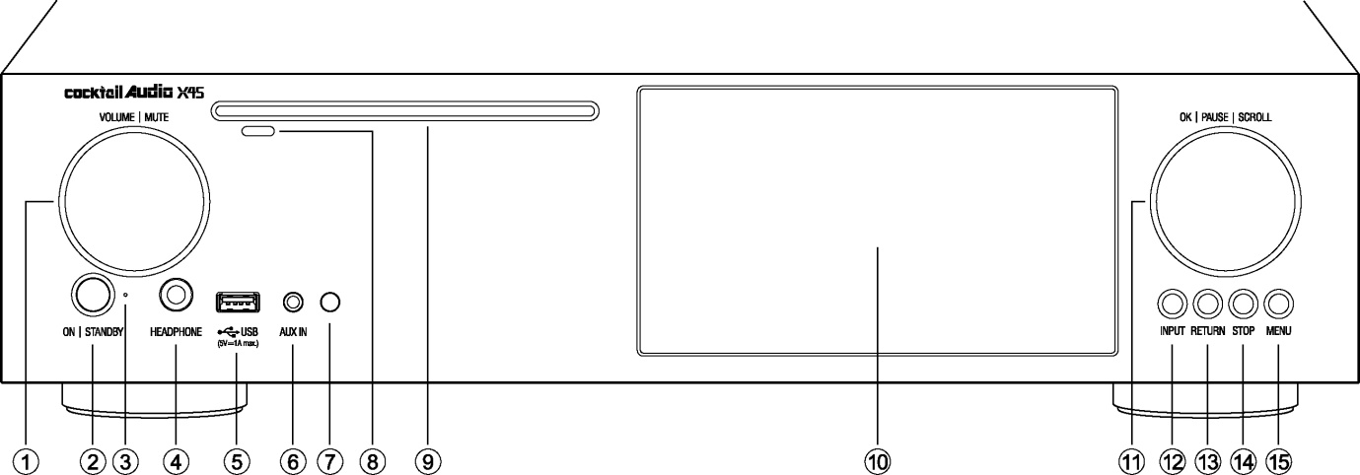
- CD-DRIVE
- LCD SCREEN
- OK/PAUSE/SCROLL Knob
- INPUT button
- RETURN button
- STOP button
- MENU button
- Volume/Mute Knob
- Power/Standby button
- Power/Standby Indicator
- HEADPHONE
- USB Host port
- AUX IN
- Remote control receiver
- CD Eject button

1-2. Rear View
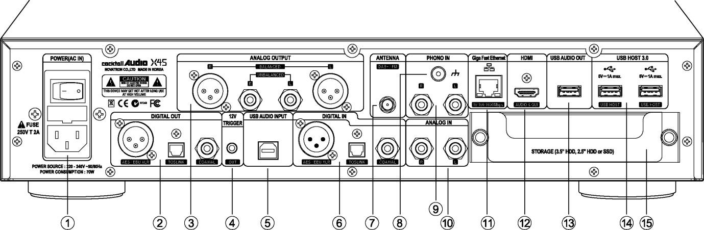
- SIGNAL GROUND
- PHONO IN
- ANALOG IN
- Giga Fast Ethernet LAN
- HDMI Out for ext screen/Audio Signal Out
- USB Class2.0 Audio Out
- USB 3.0 Host port
- Storage Deck(Drawer)
- AC Power Inlet (with fuse)
- DIGITAL OUT
- ANALOG OUT
- 12V Trigger Out
- USB Audio IN(USB DAC)
- DIGITAL IN
- DAB+/FM TUNER
- DIGITAL IN
- ANTENNA for DAB+/FM Radio

1-3. View of Remote Controller and each key’s function
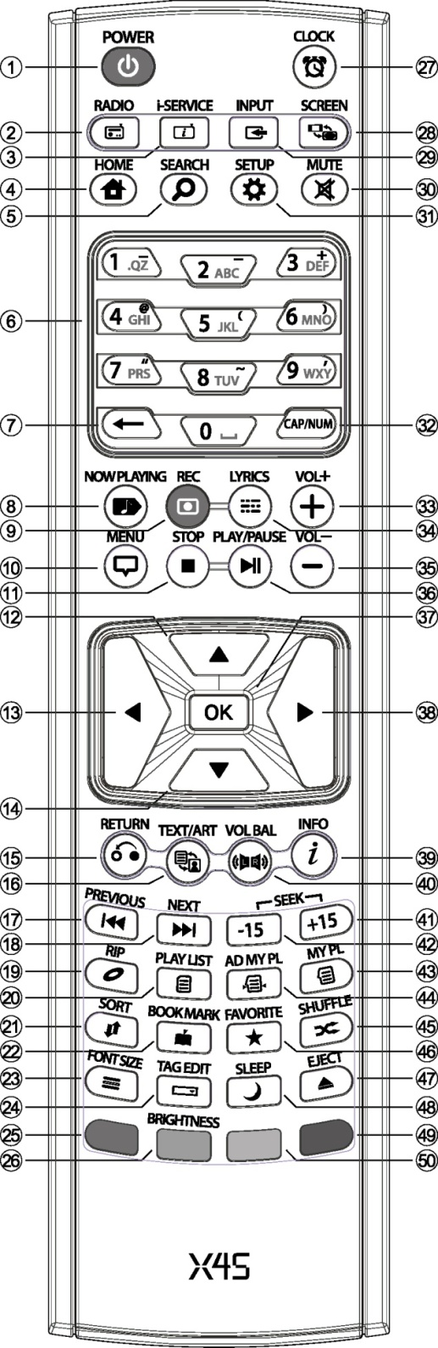
- POWER: Power ON/OFF
- RADIO: Go to DAB+ /FM Radio screen
- i-SERVICE: Go to i-Service screen
- HOME: Go to home screen
- SEARCH: To pop up search menu
- Alphanumeric: Enter number & alphabet/
Seek at Playing Screen mode
- : To delete typed alphabet
- NOW PLAYING: Go to Playing Screen
- REC: To record
- MENU: Popup menu screen
- STOP: Stop playing
- ARROW: Move cursor to upper side
- ARROW: Move cursor to left side
- ARROW: Move cursor to down side
- RETURN: Go back to upper level
- TEXT/ART: To switch text or art mode
- PREVIOUS: Play previous music
- NEXT: Play next music
- RIP: Pop up ripping menu
- PLAYLIST: Go to playlist screen
- SORT: Sort file list
- BOOK MARK: Make bookmark
- FONT SIZE: To change text line number(size)
- TAG EDIT: To popup tag edit screen
- Reserved
- BRIGHTNESS: To control screen brightness
- CLOCK: Digital clock display/OFF screen
- SCREEN: To switch LCD or HDMI screen
- INPUT: Go to Input screen
- MUTE: Mute/unmute sound
- SETUP: Go to setup
- CAP/NUM: Toggle numeric key, alphabet key and special characters
- VOL+ : Volume up
- LYRICS: To show up lyrics on the screen
- VOL- : Volume down
- PLAY/PAUSE: Toggle Play and Pause
- OK: Confirmation
- ARROW: Move cursor to right side
- INFO: Get more detailed info
- VOL BAL: Control volume balance
- SEEK/+15: Seek forward by 15 seconds.
42. SEEK/-15: Seek backward by 15 sec
43. MY PL: To make My Playlist
44. AD MY PL: To make advanced
My Playlist
45. SHUFFLE: To change play mode
46. FAVORITE: To add iRadio station or song to Favorites folder
47. EJECT: Eject CD
48. SLEEP: Go to sleep mode
49. Reserved
50. Reserved

- Prepare

2-1. Check the contents of X45 package

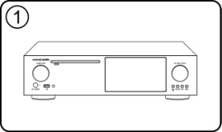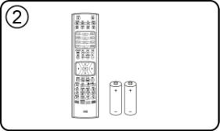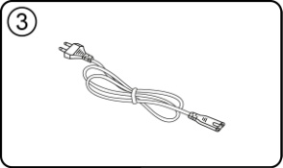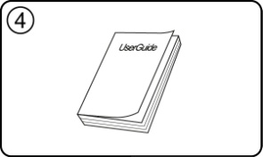

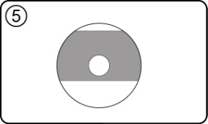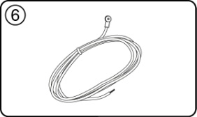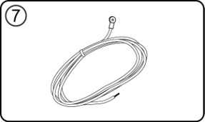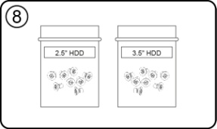
- X45 unit
- Remote controller + AAA batteries x 2EA
- Power cord
- Manual
- FreeDB Data CD
- FM Radio Antenna
- DAB Antenna
- Screw to install storage

<NOTICE> DAB Antenna is NOT provided to the countries where DAB is not available

2-2. Install AAA batteries into the remote control.
Open the battery door and insert the batteries.
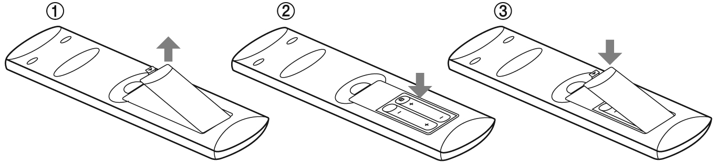

2-3. Optional items, WiFi USB dongle

If you purchased optional items, the WiFi USB dongle, it looks like below.
[NOTICE] The wifi dongle not approved by X45 manufacturer will not work properly
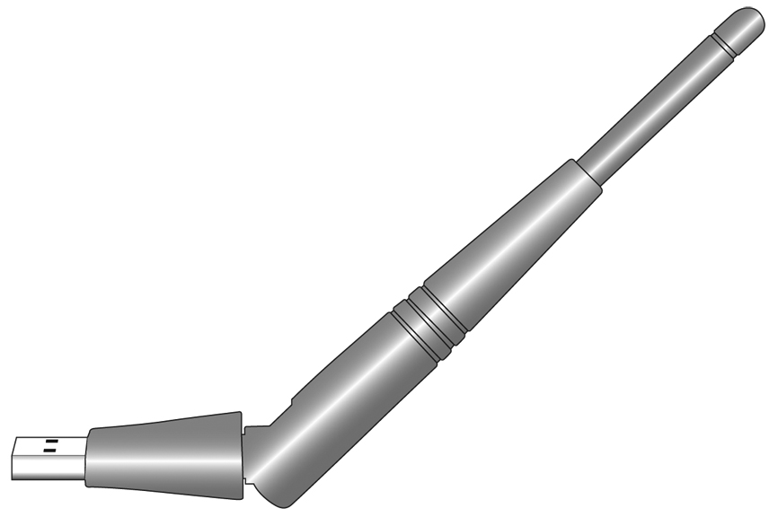
801.11b/g/n WiFi USB dongle

2-4. To use X45 as USB DAC via its USB Audio Input

※ NOTICE
(In case that 352.8Khz and 384Khz files goes into X45 via its USB Audio Input and goes out via its Digital Outputs, there may be some noises. So, we recommend that you should not use X45 digital outputs when using X45 as USB DAC

2-4-1. USB Audio Class 2.0 Driver Software for Windows OS
You should install USB Audio Class 2.0 driver software for Windows OS so that you could use X45 as an USB DAC with Windows PC properly.

You can download USB Audio Class 2.0 driver software from our website, www.cocktailaudio.com or from our local distributor website.

2-4-2. How to install USB Audio Driver Software to Windows PC
Unzip the downloaded Driver Software. Two folder will show up like below.

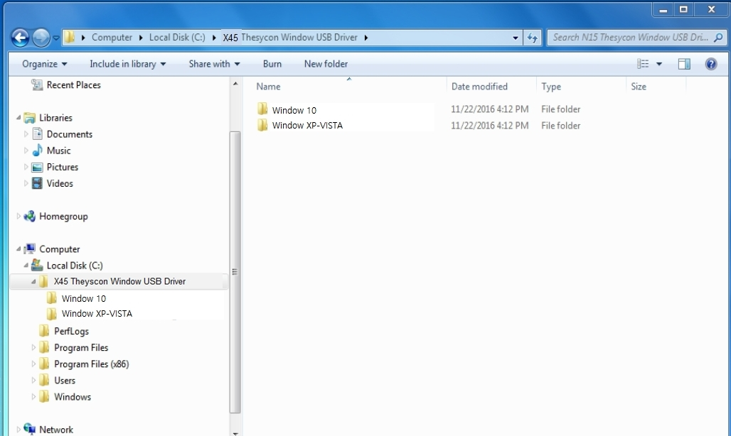
Select one suitable for your PC OS and run its EXE file with double click to install.

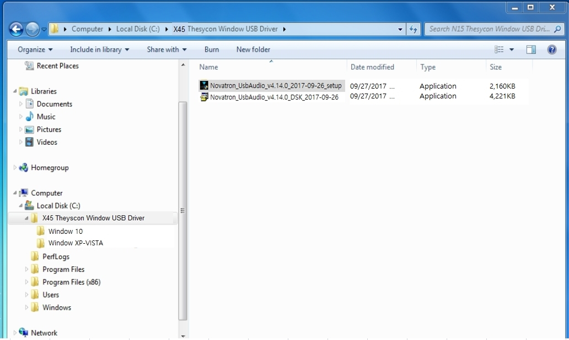

According to Setup Wizard, you can finish installation like below

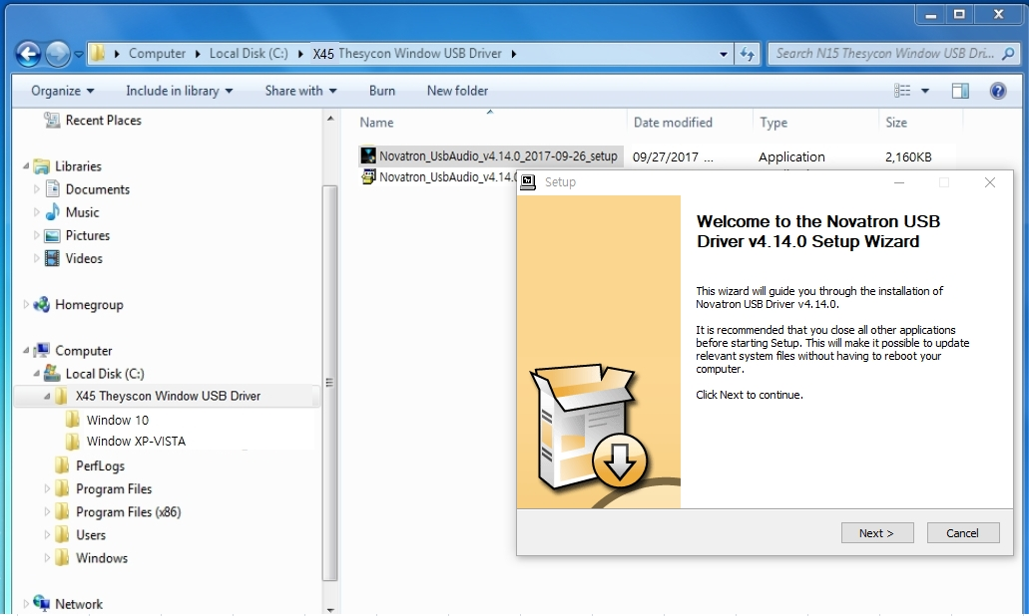

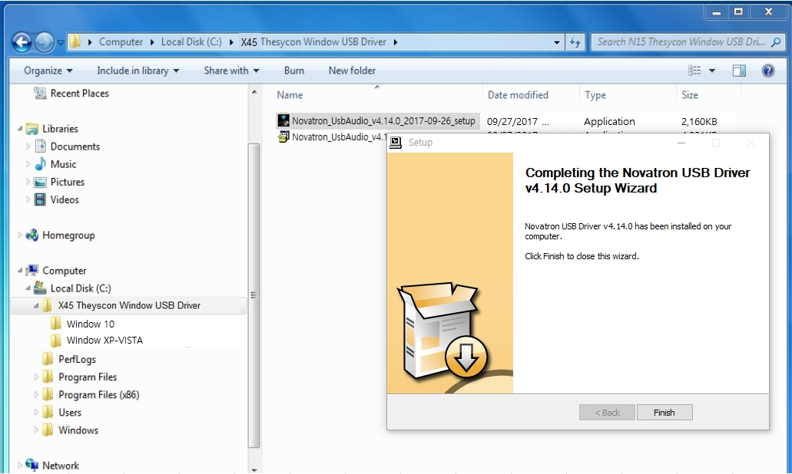

2-4-3. Special software (Player) for DSD file on your Windows PC
To play DSD file on your PC, you need to install a special software (player) like Foobar2000 or JRiver Media Center. You can download foobar2000 from www.foobar2000.org, and install it into your PC. You can download JRiver Media Center from www.jriver.com

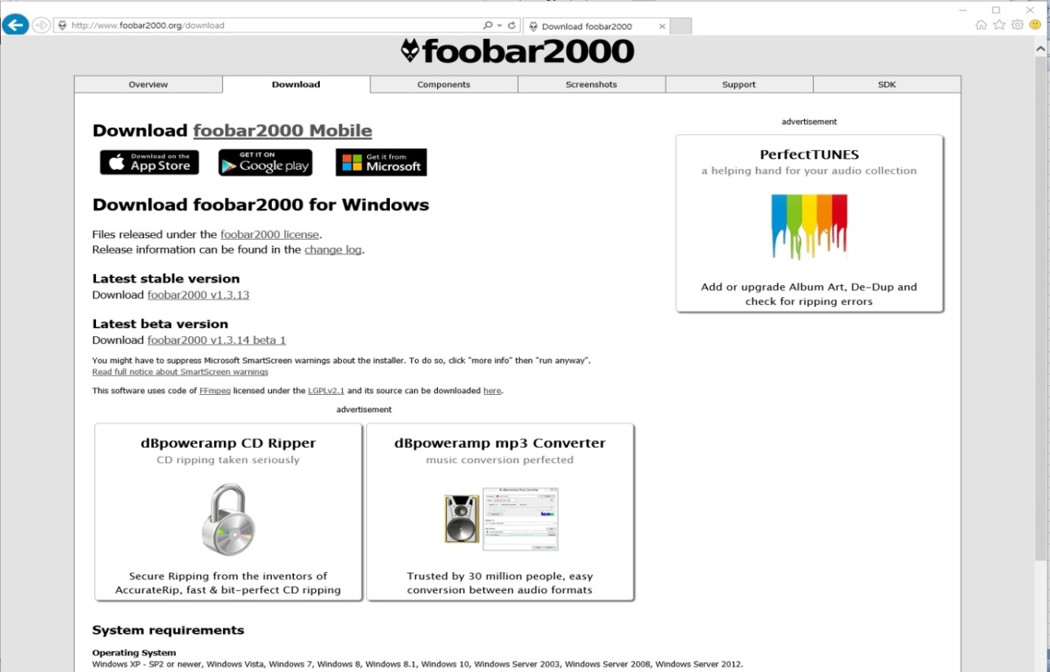

2-5. X45 purchased without storage.

You need a 3.5” or 2.5” SATA hard disk or SSD, and install it into the X45 like below picture and format it. For formatting of the installed storage into X45, please refer to the 4-7-10. Format Storage (Page 62)

2-5-1. HDD installation

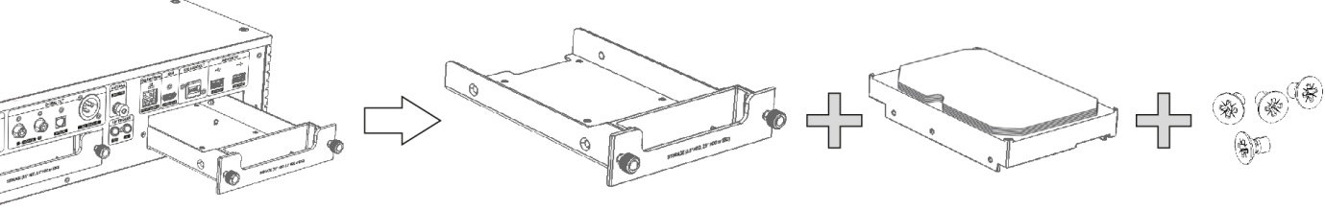

【 TIP 1 】 X45 supports 3.5” or 2.5” SATA hard disk and solid state drive (SSD)

2-5-2. HDD Format

※ Refer to the 4-7-10. Format Storage (Page 62)

2-6. X45 purchased with an internal storage installed.

Check whether the storage is formatted, or not. If the storage is not formatted, please format it according to the 4-7-10. Format Storage (Page 62)

- Turn On and Start

3-1. Wizard Setup (Setup Assistant)
During fist booting-up procedure, you will meet the Setup Assistant (Wizard Setup) as shown below.

Select OK and confirm with the OK key to start Wizard Setup. If you want to run the set up after booting up, you can select CANCEL at the 1st step.
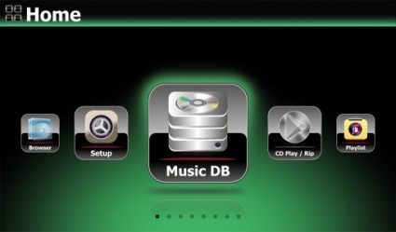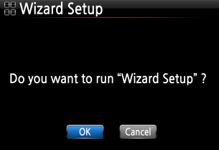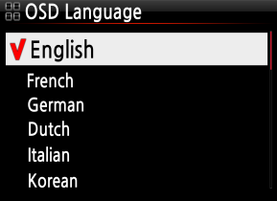
<NOTICE> It will ask for OSD language, Audio Ripping Format, Network Setup, Time setting, HDD format.
【 TIP ① 】 You will be asked about formatting the HDD only if the HDD installed has NOT been formatted.

3-2. Turn ON for normal use
Switch the unit on at the rear of the X45. The power LED will be ON with green color. Power it on using the remote control or the power button on the front of the X45. The power LED color will be changed to blue and start booting – The X45 should take about 30~40 seconds to boot up as it is looking to see if a network is connected.

After the X45 is powered ON, the below screen will show up in sequence.
- Booting image 2) Booting completed and ready for use
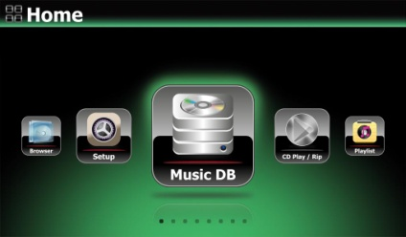
- FM Radio/DAB+: Play FM or DAB+
- Browser: See all storages such as hard
disk of X45, USB host and networked storages.
- Group Play: Set Group Play
- Setup: Change settings
- Music DB: Play loaded(ripped) music in
X45 Music DB folder.
- CD Play/Rip: Load(rip) CD or play it
- Playlist: Make Playlist and play it.
- i-Service : Play i-Radio or online music
service
- Input: To select Input source

3-3. When using X45 as an USB Digital to Analog Converter (DAC)
- Install USB Audio 2.0 Driver Software to your Windows PC(Refer to 2-4 on page 30)
- Install a special software(Player) like foobar2000 if you want to play DSD file in your PC(Refer to 2-4 on page 30)
- Connect X45(USB Audio IN) and your PC(USB Host port) via USB cable
- Remaining procedures will be understood easily

※ NOTICE
(In case that 352.8Khz and 384Khz files goes into X45 via its USB Audio Input and goes out via its Digital Outputs, there may be some noises. So, we recommend that you should not use X45 digital outputs when using X45 as USB DAC

- SETUP

Go into SETUP menu with remote controller.
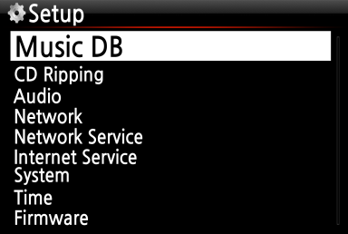
You can select each item with the arrow key and confirm it with the OK button.

4-1. Music DB
Select the Display Mode and confirm with the OK button.
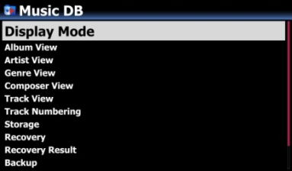

4-1-1. Display Mode
You may set one of fourteen (14) options, see below. For example, if you set Title, the Music DB will display the title (song) list when you go into the Music DB. (※ default: Album)
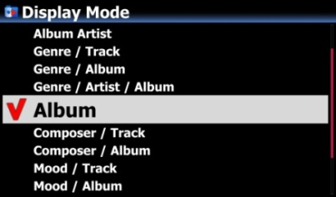※ Default : Album
※ For example
- Artist/Track : Artist list → Title(song) list
- Artist/Album : Artist list → Album list of the artist → Track (song) list of the album

4-1-2. Album View

You can set the list to show albums in the Music DB by its album name (text) or album cover art using this setup.( ※ default : text mode )
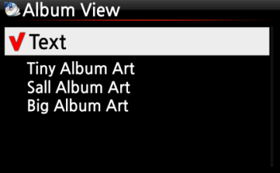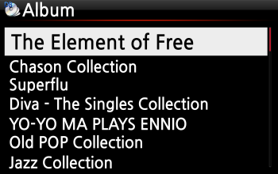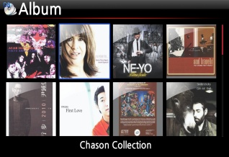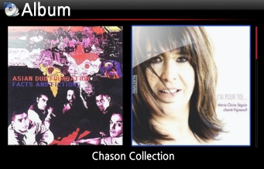
- Artist view, Genre view, Composer view, Mood view, Track view and Playlist view are also available.
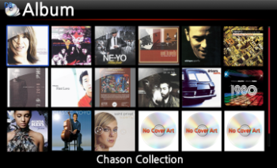

4-1-3. Track Numbering
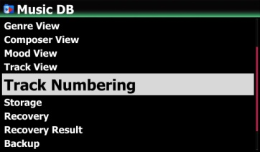
With the Track Numbering option at SETUP, you may decide whether you allow the track number to be added at the front of title for each track when you rip CD. (※ Default: Enabled)

4-1-4. Append Artist in Album View
If you set this option as ON, Album name will bring Artist name at the end of album name
※ Default: ON
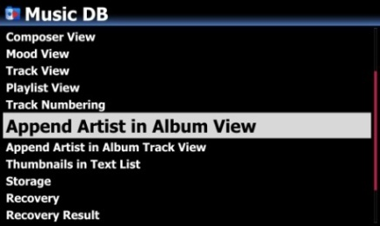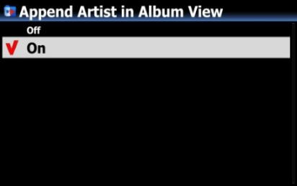

4-1-5. Append Artist in Album Track View
Track Artist will be added at the end of each track in Album if this option is set as ON
※ Default: ON
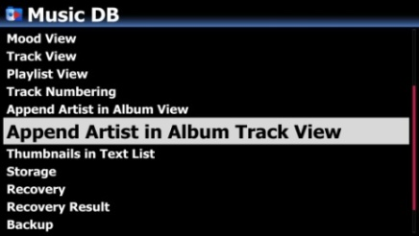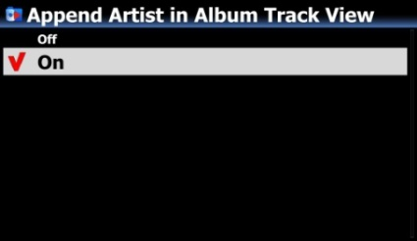

4-1-6. Thumbnails in Text List
Option to enable/disable 'Thumbnails at the front of each text list is added at SETUP
※ Default: OFF
※ NOTICE: If this option is set as ON and Thumbnails are displayed, the speed to list up will be slower a little
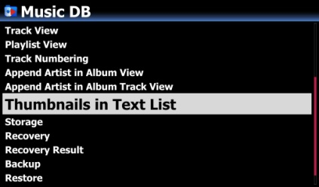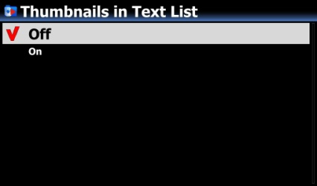

4-1-7. Storage for Music DB

You can select a HDD(SSD)1, USB or NAS (Network attached storage) for Music DB storage. If one of them is selected as Music DB storage (Main storage), its color on the Browser mode will be green.
※ Default is HDD1
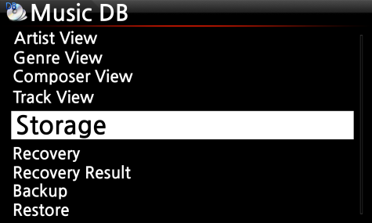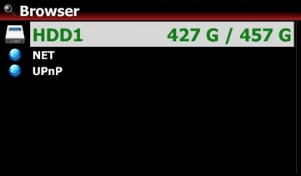
※ NOTE:
The ripped files of CDs will be stored in the ‘My Music’ folder in the main storage (green colored storage). The album cover art of all albums in the Music DB will be stored in the main storage. So, if you remove the main storage, album cover art may not be listed properly on the album cover art list mode for the Music DB.

4-1-8. Music DB Scan Status
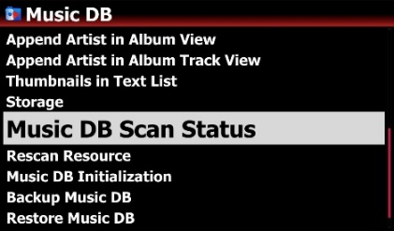
If you want to see scanning status, go to SETUP > Music DB > Music DB Scan status

4-1-9. Rescan Resource
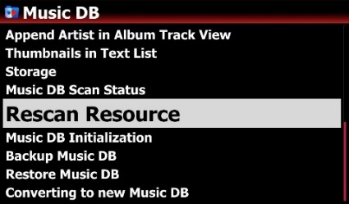
To synchronize contents in Music DB and in folders of storages already scanned to Music DB, please go to SETUP > Music DB > Rescan Resource
- For more detailed information, refer to 5-8. Rescan Resource (folders) function (Page 73)

4-1-10. Music DB Initialization

Music DB Initialization will remove all scanned index of music files and Playlist, and will rescan(register) all music files in the ‘My Music’ folder only to Music DB again.

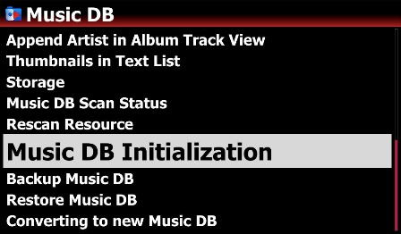
③ Select OK icon and confirm it with OK key to start clearing the Music DB
※ After initializing the Music DB, the device will reboot by itself to complete Music DB initialization, and will rescan ‘My Music’ folder only.
※ NOTE: This function will remove all scanned index of music files and Playlist. However, it has no effect on the original music files
① Go to SETUP > Music DB > Music DB Initialization
② Select 'Music DB Initialization' and confirm it with OK key to open the below screen

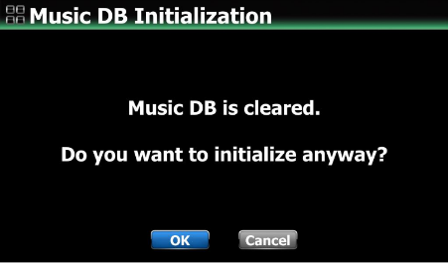

4-1-11. Backup Music DB

You can backup original music files (albums or songs) registered(scanned) to Music DB.
- You need an external USB storage which has a bigger capacity than the Music DB.
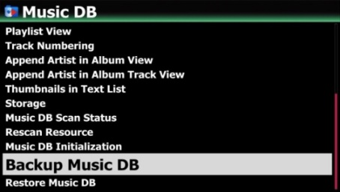
- Go to “SETUP > Music DB > Backup Music DB” and click it

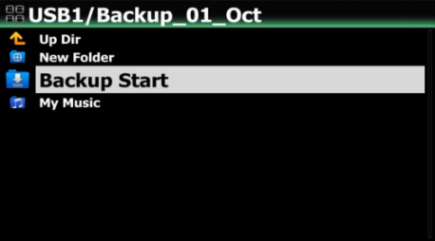
② Select a storage or folder for backup
③ Click 'Backup Start' to start back up

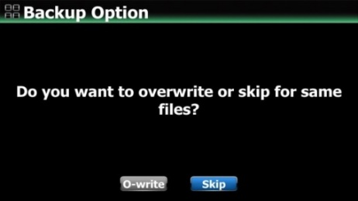
- Select backup option (Overwrite or Skip)
-. Overwrite: It will overwrite the same existing file. -. Skip: Same files will be skipped

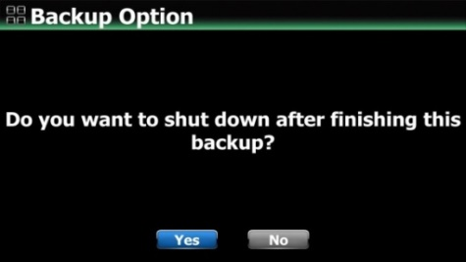
- Select option after backup (Shutdown or On)
-. Yes: Device will be shutdown automatically after backup
-. No: Device will stay as 'ON' after backup
- You can backup in the back-ground mode. You can do other works like playing music even in backup processing.
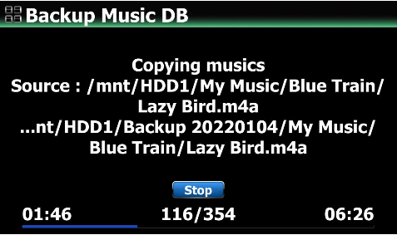
- If you want to go back to the backup status screen from the background backup mode, go to ‘Setup’ and click the ‘Backup Music DB’ menu again.
- If you want to stop backup during the backup processing, just click the ‘Stop’ icon

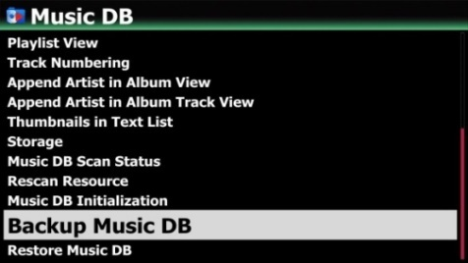

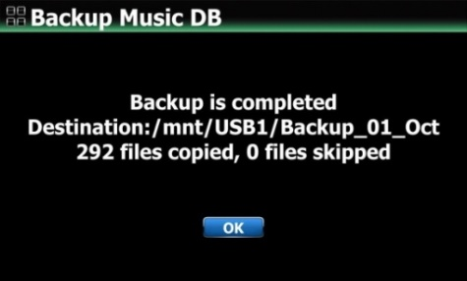
※ Backup result will be shown after backup
-. Backup will be done by folder unit
-. Each folder will be backed up including its all sub folders while maintaining its own tree structure

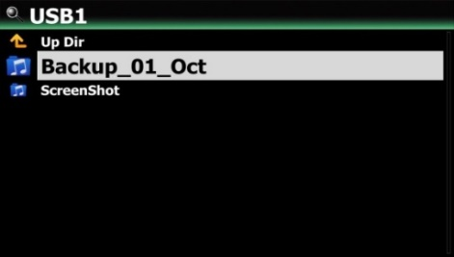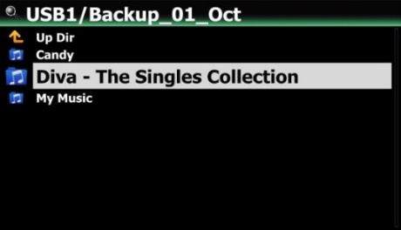

<CAUTION>
1) While backup in progress, if you do CD ripping or file importing to DB, these ripped files and imported files will not be backed up.
2) While backup in progress, device response will be delayed slightly when try using other function.

4-1-12. Restore Music DB

You can restore the backup data in the Music DB. Connect the backup storage to the X45

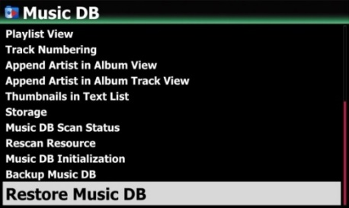
- Go to SETUP > Music DB > Restore Music DB and click it
- Select one of Full or Partial Restoration
※ Full restoration:
-. All backup sub-folders in the selected storage (folder) will be restored to main storage (green colored storage)
-. Data in My Music folder of backup storage will be restored to My Music folder in the main storage (green colored storage)
-. Device will re-boot after full restoration

1) In case of selecting Full Restoration
- Select backup (source) storage and folder
- Click 'Restore Start' to open option window of Overwrite or Skip

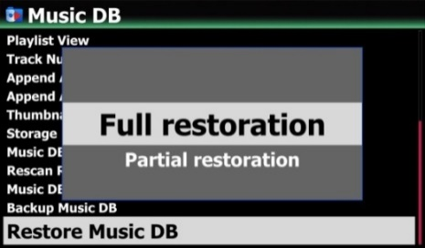

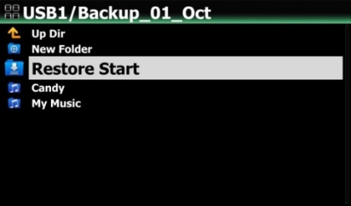

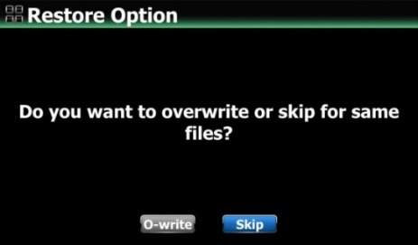
- Select 'O-write' or 'Skip' to start restoring
※ Device will re-boot by itself after full restoration
※Restore result
-. All backup folders will be restored to the root directory of main storage (green color)
-. Each folder will be restored in the same tree structure including its own sub folders just like backup

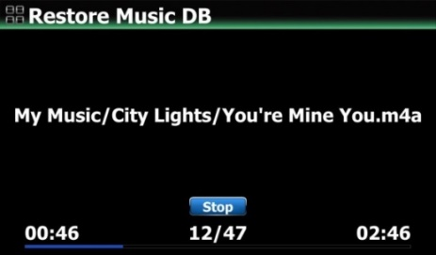

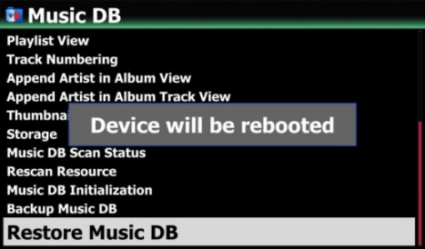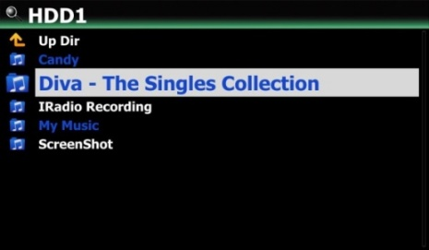

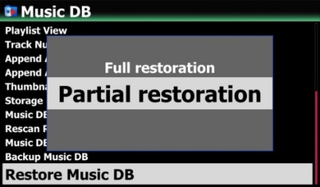
※ Partial Restoration :
-. Selected folder in the backup storage will be restored to selected folder in the target storage.
-. No device re-boot after partial restoration

2) In case of selecting Partial Restoration
① Select the folder you want to restore from the backup storage

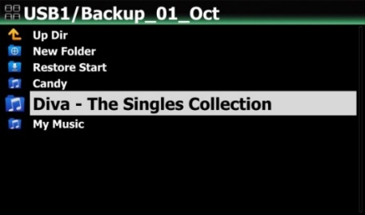
- Select a destination storage or folder to restore and click 'restore Here'.

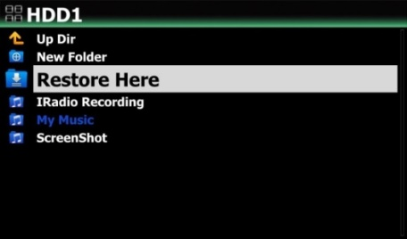
- Select 'O-write'(Over-write) or 'Skip' to start restoring

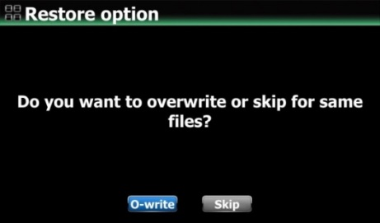

4-1-13. Converting old Music DB to new Music DB
If you have an USB storage where old Music DB data(.DB) exists and the USB storage is not set as Music DB storage (Main storage) at SETUP, you can convert the old Music DB data to new Music DB data easily.
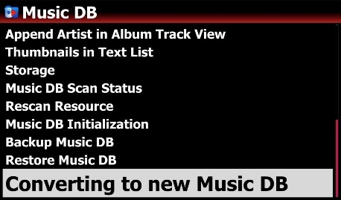
- Insert the USB storage (old Music DB data), then the device will show up message like below.
- Go to SETUP as the screen says, and click 'Converting to new Music DB'

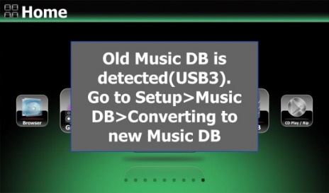

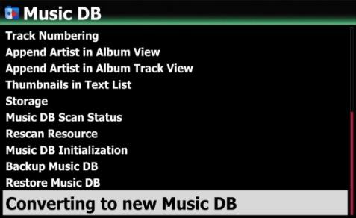
- Device will ask you if you want to overwrite or skip for the same file
- Select one of O-write and Skip to start converting like below picture.
- Converted files from old Music DB will be stored in the 'My Music' folder of the main storage.
※ Note: Main storage means the storage set as MusicDB storage at SETUP. The main storage looks green color at the Browser

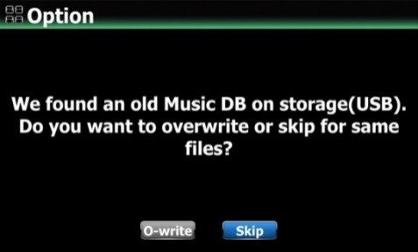

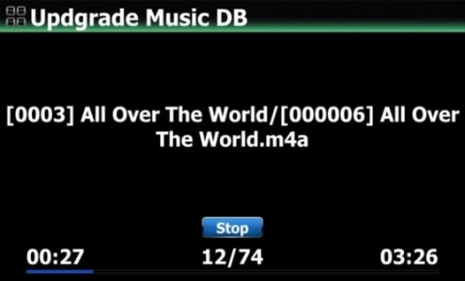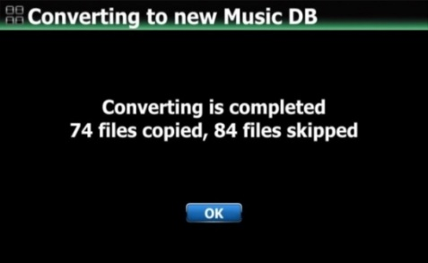

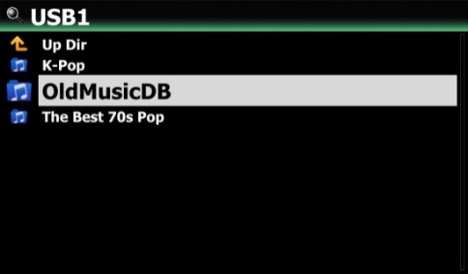

4-2. CD Ripping

Select CD Ripping and confirm it with the OK button. The below items will be displayed.
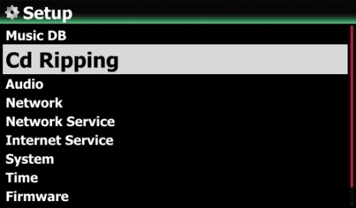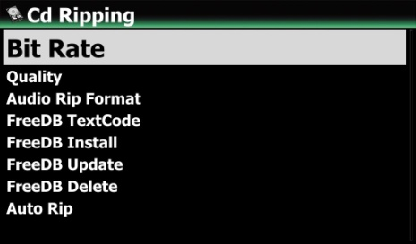

4-2-1. Bit Rate and Quality

You can select bit rate and the quality level for ripping to MP3 files.

There are two (2) items.(This is for ripping a CD to an MP3 file)
- Compressed Rate : 128K / 192K / 320K [default] 192K
- Quality level : Excellent / Best / Good / Fast / Very fast [default] Very fast

Select one of the above options and confirm with the OK button on the remote control.
【 TIP ① 】 The time required to rip a CD to MP3 format based on each quality level option is shown below.
Option of quality level | Normal playing time | Required time to convert to MP3
Excellent | The time required to play music in CD normally. | X 1.5 (150%)
Best | The time required to play music in CD normally. | X 1.08 (108%)
Good | The time required to play music in CD normally. | X 1 (100%)
Fast | The time required to play music in CD normally. | X 3/4 (75%)
Very fast[Default] | The time required to play music in CD normally. | X 1/3 (33.3%)
- Quality level affects on the MP3 and Ogg ripping in view of sound quality, and on the FLAC ripping in view of file size.

【 TIP ② 】 Estimated Storage capacity
CD Ripping option |  | 500GB HDD | 1 TB HDD | 2 TB HDD | 4 TB HDD
WAV(uncompressed) |  | 650 CDs | 1,300 CDs | 2,600 CDs | 5,200 CDs
MP3 / OGG | Compressed Rate
MP3 / OGG | 128K | 7,500 CDs | 15,000 CDs | 30,000 CDs | 60,000 CDs
MP3 / OGG | 192K | 5,000 CDs | 10,000 CDs | 20,000 CDs | 40,000 CDs
MP3 / OGG | 320K | 3,000 CDs | 6,000 CDs | 12,000 CDs | 24,000 CDs
These figures may vary slightly according to the number of tracks on a CD

4-2-2. Audio Format (Audio Rip Format)
You can select one of the following audio formats for CD Ripping;
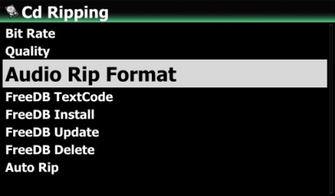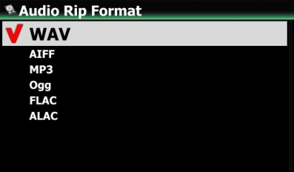※ default is WAV

4-2-3. FreeDB TextCode
In the case that the FreeDB text is broken, you may try changing the FreeDB TextCode as shown below.
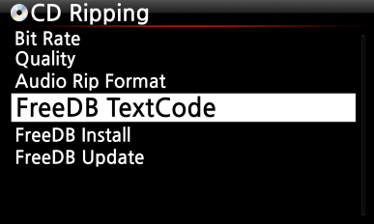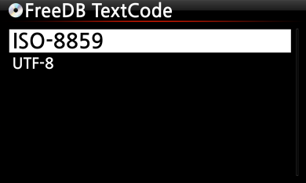
4-2-4. FreeDB Install

You can install the FreeDB data to the storage of the X45 as a FreeDB data (DVD) is supplied by the manufacturer. Once you install the FreeDB data to the X45 the inserted CD information (metadata like title, album name, artist, etc) will be displayed on the X45 screen without network connection.

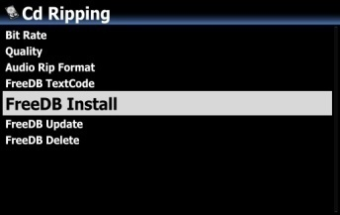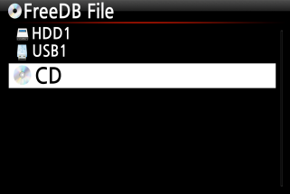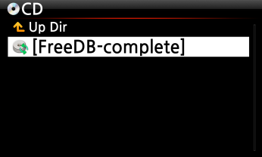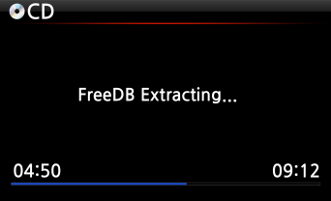

To install the FreeDB data to the X45 hard disk, insert the FreeDB data DVD into the CD slot of the X45 and go to SETUP and select FreeDB to install. You will see the CD, select and confirm with the OK button. The X45 will shut down and reboot to start installing the FreeDB data automatically.

<NOTICE> When using X45 with network(internet) connected, you don't need to FreeDB data because it's useless when X45 is connected to network(internet)

4-2-5. FreeDB Update

You can get a FreeDB update from the Cocktail Audio website (www.cocktailaudio.com).
To update your copy the FreeDB load the file downloaded from www.cocktailaudio.com to a memory stick and insert the memory stick into the USB host port of the X45. Navigate to SETUP and select FreeDB Update. Press the OK button. You can see the USB memory and select it with the OK button to find the FreeDB update file. Confirm with the OK button to begin the installation.

4-2-6. FreeDB Delete
You can delete FreeDB data if you don't like it after installing it into X45
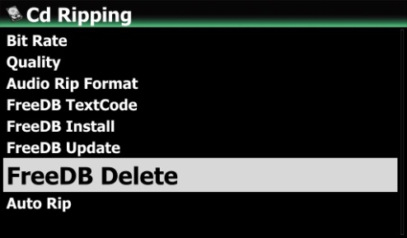

4-2-7. Auto Rip
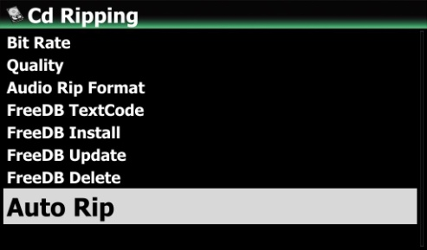
When ripping many CDs at one time, this function will be useful. If Auto Rip is set as ON, X45 will rip CD by itself if you insert CD, and eject CD by itself after finishing ripping without pressing any key
※ Default: OFF

4-3. Audio

Select Audio and confirm it with the OK key
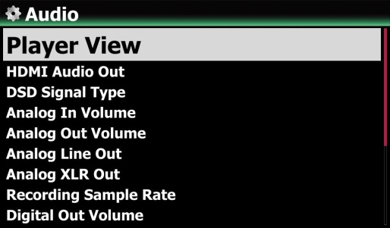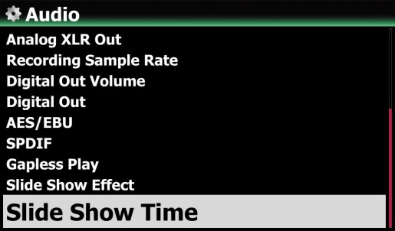

4-3-1. Player View

You can set one of the following; Cover & List, Music Info or List Only.
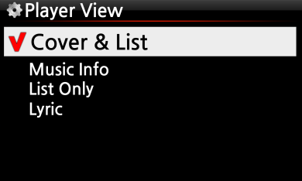
※ NOTE: Using INFO button of remote control, you can change player view to Cover & List, Music Info or List Only like below.
※ Default: Cover & List

[ Cover & List ] [ Music info ] [ List Only ]
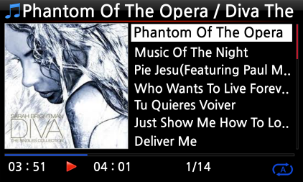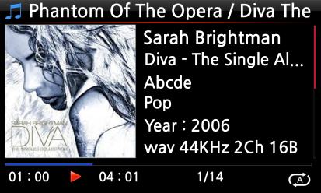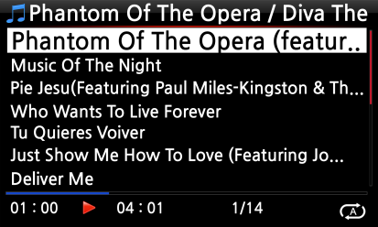

4-3-2. USB/HDMI Audio Out
When USB DAC or HDMI audio device is connected to X45 USB Audio Out, the connected devices will be listed here. You may select it here.
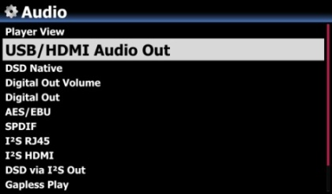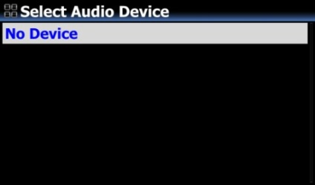
4-3-3. DSD Signal Type
There are many kinds USB DAC(Digital-to-Analog Converter) in the market, which can be connected to X45 USB Audio Out. But, some of these DAC can receive 'DSD Native signal', others can receive 'DoP signal' only instead of 'DSD Native signal'. So, we added 'DSD Signal Type' option at SETUP, which gives three (3) options like below. You need to select proper option according to your USB Audio DAC spec.
-. DSD(DoP): This is for the USB DAC which receive 'DoP signal' instead of 'DSD Native signal'
-. DSD(Native): This is for the USB DAC which can receive 'DSD Native signal'
-. PCM : This is for the USB DAC which can receive 'PCM signal' only.

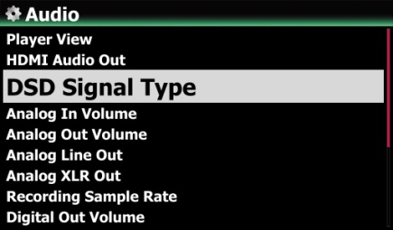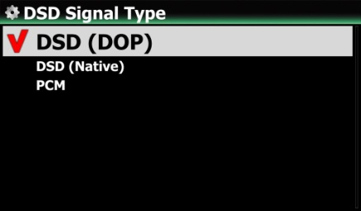
※ Default: DSD(DoP)

4-3-4. Analog In Volume
You can control volume level of Analog IN/AUX IN/PHONO IN
※ Default: 0
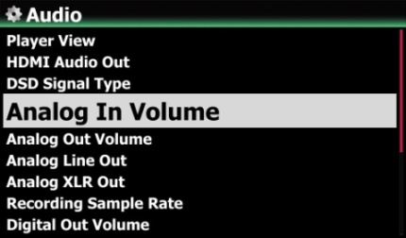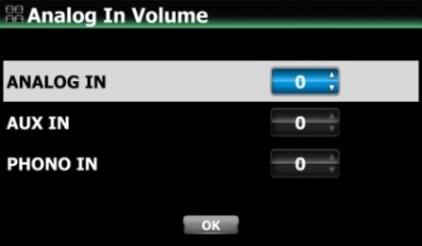

4-3-5. Analog Out Volume
You can set Analog Out Volume as Variable or Fixed
※ Default: Variable
※ Fixed: X45 volume will be set as 0dB (Max). You can’t control volume with X45

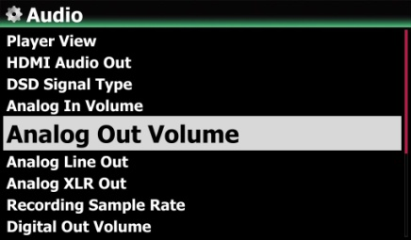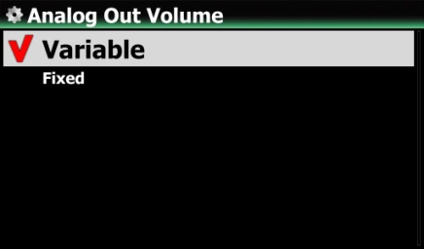

4-3-6. Analog Line Out
Analog Line Out can be set as OFF or ON
※ Default: ON
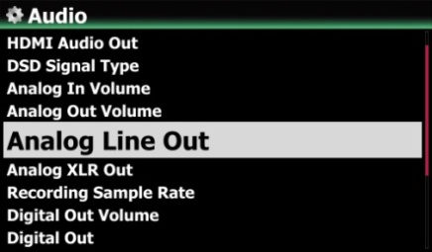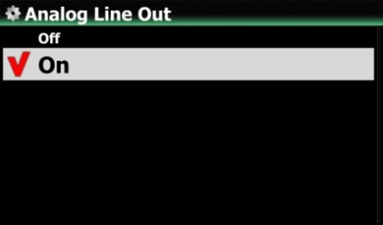

4-3-7. Analog XLR Out

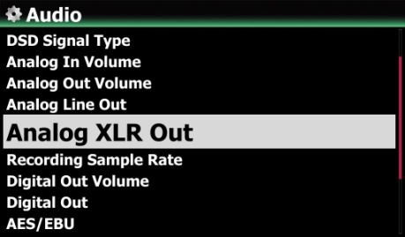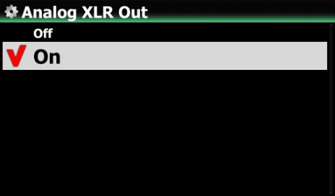
Analog XLR Out can be set as OFF or ON
※ Default: ON

4-3-8. Recording Sample Rate
When recording, you can set Recording Sample Rate as one of three (3) options like 48KHz, 96KHz, 192KHz.

※ NOTE: The higher sample rate, the more recording space is needed.
※ Default: 48Khz
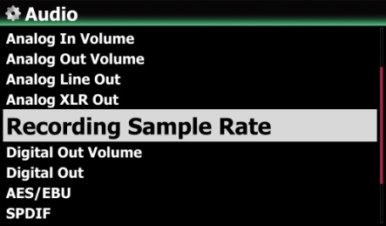

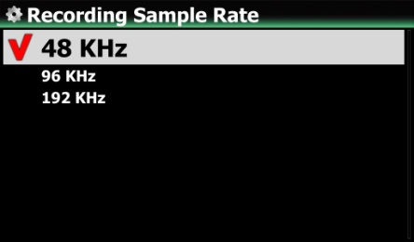

4-3-9. Digital Out Volume
※ Variable: You can control volume for Digital Out with X45

※ Fixed: X45 volume will be set as 0dB (Max). You can’t control volume for Digital Out with X45

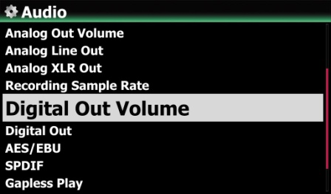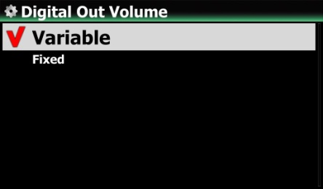
※ Default: Variable

4-3-10. Digital Out

You can set one of three (3) options like 48KHz, 96KHz and 192KHz
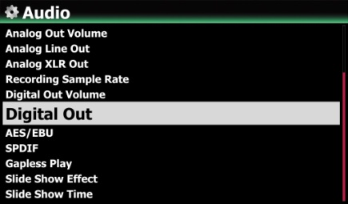
- 48Khz : Max 48KHz frequency
- 96Khz : Max 96KHz frequency
- 192Khz : Max 192KHz frequency
- Passthrough

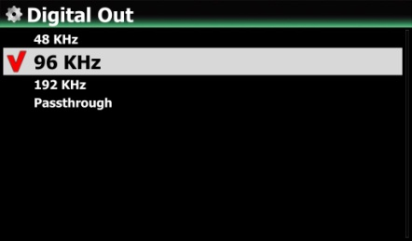
※ Default: 96KHz

4-3-11. AES/EBU
You can set as ON or OFF for AES/EBU digital output
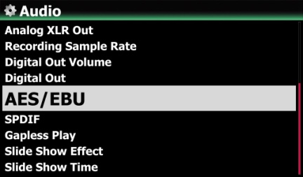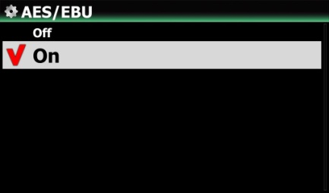
※ Default: ON
4-3-12. SPDIF
You can set as ON or OFF for SPDIF digital output
※ Default: ON
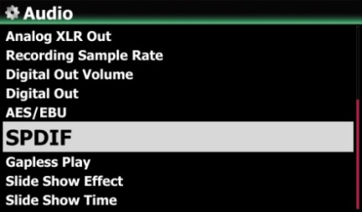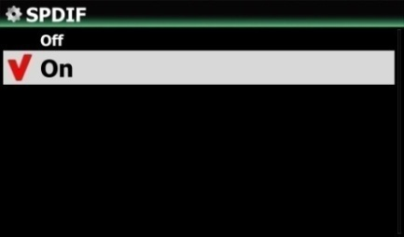

4-3-13. Gapless Play

The X45 supports gapless playback function for MP3 files, WAV, FLAC and DSD files only.
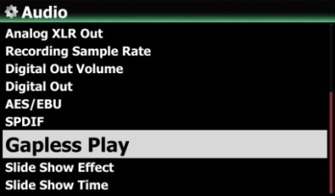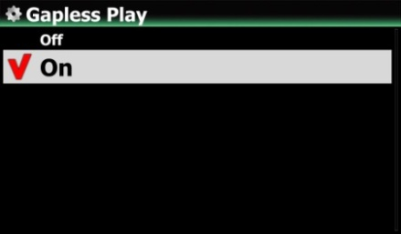 ※ Default: ON
【 TIP 】
- LAME-encoded MP3 files only supported
- The Gapless play function works properly on ‘Repeat All’ and ‘Normal’ modes only. For example in ‘Shuffle’ mode Gapless play is not supported

4-3-14. Slide Show Effect
Six (6) options are available like All, Fade in & out, Transition, Rotation, Flip and None.

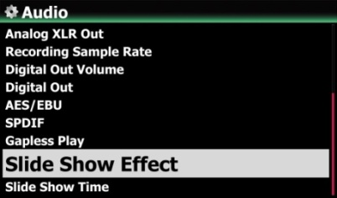
- NOTE: For detailed explanation, refer to 19-3. Photo Slide Show (Page 114)

4-3-15. Slide Show Time
You can set show time and effect time according to your taste.
※ Show time: The time required to show one photo
- Effect time: The time required to transit one photo to other photo
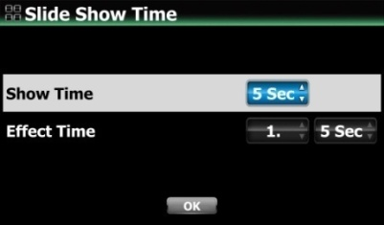
- NOTE: For detailed explanation, refer to 19-3. Photo Slide Show (Page 114)

4-3-16. Replaygain

4-3-16-1. What’s the Replaygain function
It allows X35 to equalize and normalize loudness for individual track or album. This avoids the common problem of having to manually adjust volume levels between tracks when playing audio files from albums that have been mastered at different loudness levels. ※ Default: OFF

4-3-16-2. Premise for the Replaygain function
1) Replaygain function is valid for music files stored in local HDD(MusicDB, Browser), USB and NET(NAS: network attached storage)
2) You have to set Replaygain as ON at SETUP(Setup>Audio>Replaygain ※Default : OFF
3) +(-)#.## dB will be displayed at 6th line of File Player Info when playing a file which has Replaygain info
4) DSD file can work with Replaygain function in only case that the DSD file play out by PCM data
5) MQA file can't work with Replaygain function

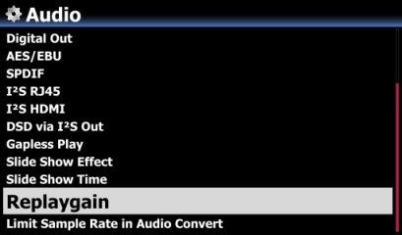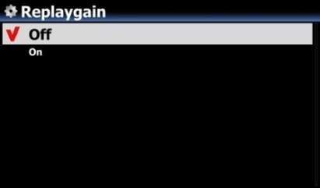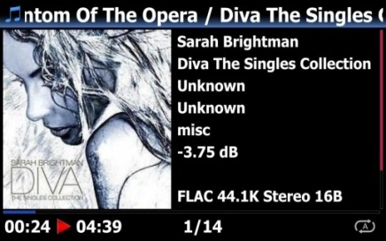
4-3-16-3. How to write(add) ‘Replaygain info’ into metadata of each music file(track)
① Place the cursor on the target album or track list. You may select multiple list by RIGHT ARROW key
② Press MENU key and click 'File Operations > to get Replaygain started
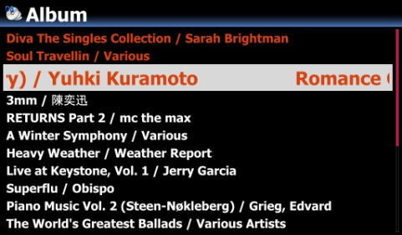

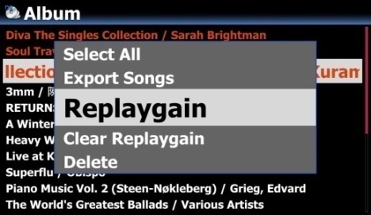
③ To start writing 'Replaygain info', click 'Skip' or 'No'
If Skip is clicked, the device will skip the file which has already Replaygain info without overwriting Replaygain info.
If No is clicked, the device will write newly Replaygain info to all music files selected.

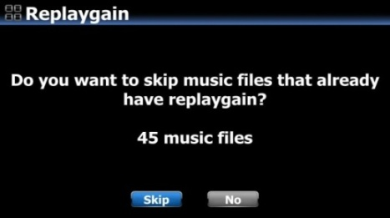

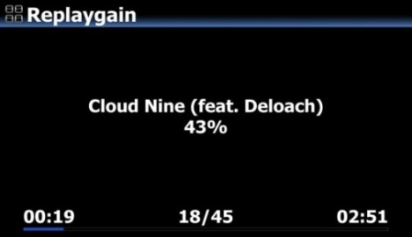
④ Writing is finished and return to list screen
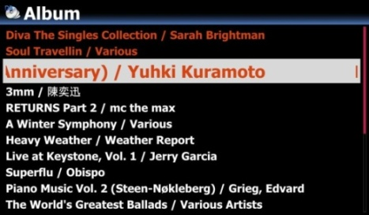

4-3-16-4. How to clear ‘Replaygain info’ from metadata of each music file(track)
① Place the cursor on the target album or track list. You may select multiple list by RIGHT ARROW key
② Press MENU key and click 'File Operations > to get Clear Replaygain started

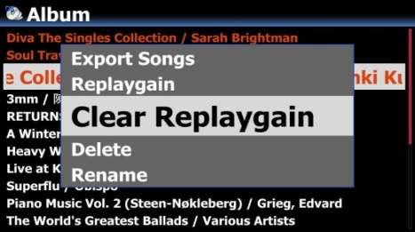

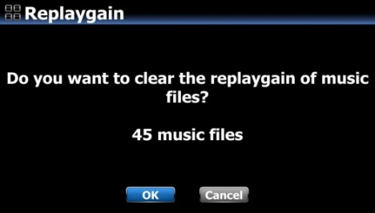
③ To clear 'Replaygain info' from metadata of all files, click 'OK'
If you click 'Cancel' or press RETURN key, this process will stop

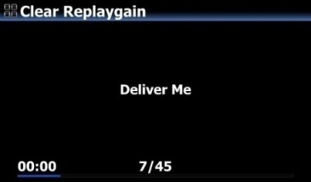
④ Clearing is finished and return to list screen
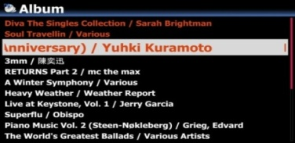

4-3-17. Limit Sample Rate in Audio Convert
When converting music file into different file format, you may select maximum sample rate.
※ Default: OFF
※ OFF means that original sample rate will be applied to the converted file.
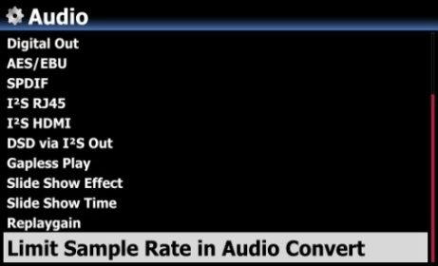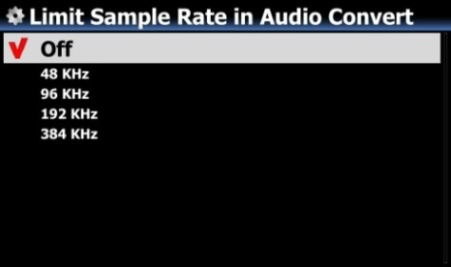

4-3-18. Power On Volume
This is option to set volume level after booting up. Default is ‘Last played volume’. If you select ‘Volume Selection’ option, you can set volume level from 0dB to 100dB.
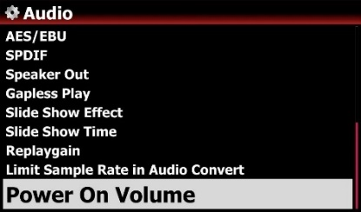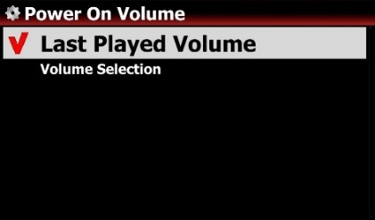

4-4. Network

※ Make sure your Ethernet cable or a USB WiFi dongle is connected.

Select Network and press the OK button.
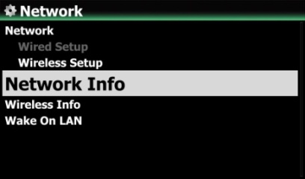
- Select Network and confirm with the OK button.
- Select Wired Setup or Wireless Setup and confirm it with OK button.
【 TIP 】 To check network information, press Network Info.

4-4-1. Wired Setup

4-4-1-1. DHCP (Auto IP)

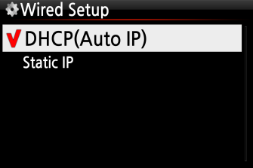
③ Select DHCP(Auto IP) and confirm with the OK button. There is no need to enter any values.
④ Select OK and confirm with the OK button.

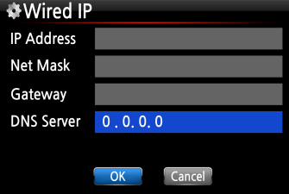
⑤ The screenshot shown on the left will be displayed if the network is connected successfully.
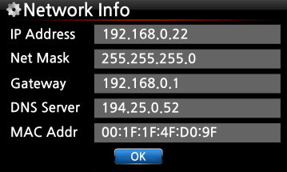

4-4-1-2. Static IP
- Select Static IP and confirm with the OK button.
- Enter the values such as; IP Address, Subnet mask, etc.
- Select OK and confirm with the OK button
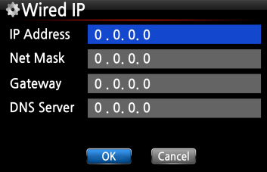

④ The screen to the left will be shown if the network is connected successfully.

4-4-2. Wireless Setup.

The X45 offers two kinds of method for wireless network connection

4-4-2-1 Open SSID
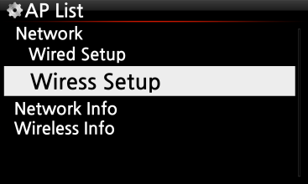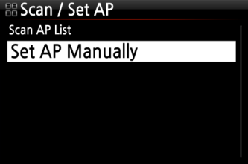
- Select ‘Wireless Setup’ and confirm with OK key.
- Select ‘Scan Ap List’. All AP available will be listed up.
- Select proper AP and confirm with OK key.
- If the AP has a password, enter it and select OK and confirm OK key.
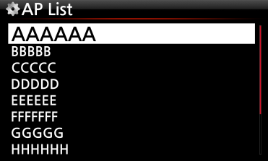

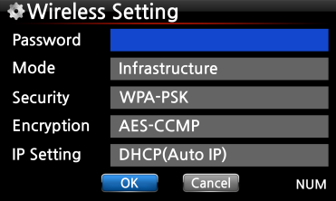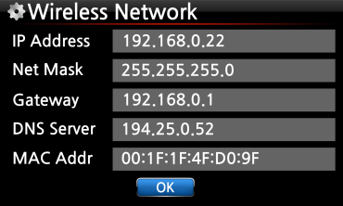
The screen to the left will be shown if the network is connected successfully.

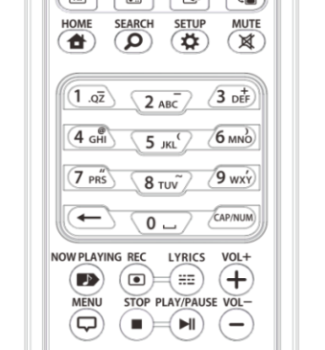
※ With CAP/NUM key of remote control, you can toggle number, capital, small alphabet or symbols for typing.
- Select 'Set AP Manually' to open the window for AP name input like left.
- Input AP name and select OK and confirm it.
⑤ The window for the password input will show up. The follow procedure is same as ‘Open SSID’

4-4-2-2 Hidden SSID

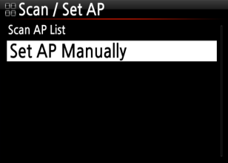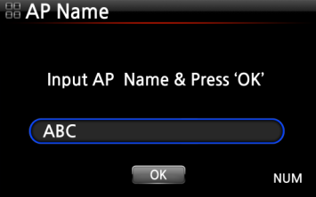
4-4-2-3 WiFi Repeater Roaming function
In case that signal strength of the connected AP goes down -45db, the X45 will be connected to the AP which has same SSID and better signal strength if it is detected

4-4-3. Network Info

Select Network Info and confirm with the OK key. You can see the network information displayed as shown below.

4-4-4. Wireless Info

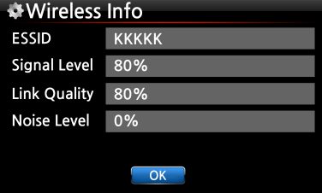
Select Wireless Info and confirm with the OK key. You can check the Wireless LAN signal strength, see below screen shot.

4-4-5. Wake ON LAN
If Wake ON LAN is set as ON, X45 can be powered ON by a signal from outside via network.
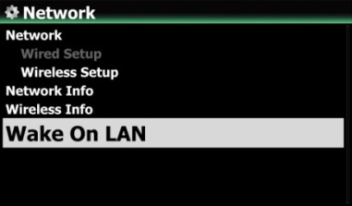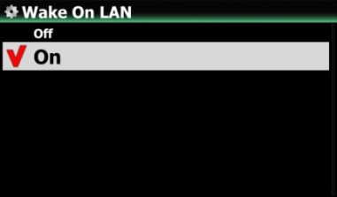
※ Default: OFF
<NOTICE> In case that Wake ON LAN is set as ON, X45 Power LED on the front will stay as Blue even though you power it off by remote control or front power button.

4-5. Network Service
Select Network Service and confirm with the OK key. There are several items like Samba Server, Web Server, UPnP Server and FTP Server and Shareplay(Airplay)

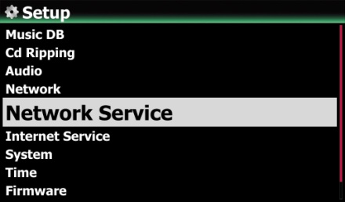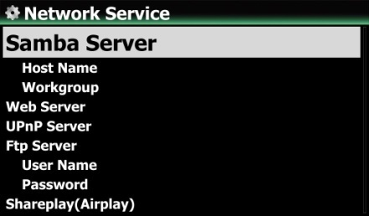

4-5-1 Samba Server

If you would like to see the folders on the X45 hard disk through your network connected PC you can set up the following:

- Select Samba Server and confirm with the OK key. Set Samba Server as ON, see below
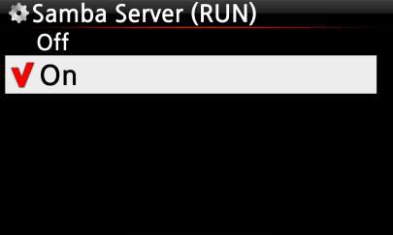 ※ default: OFF

- Select Samba Server and confirm with the OK button.
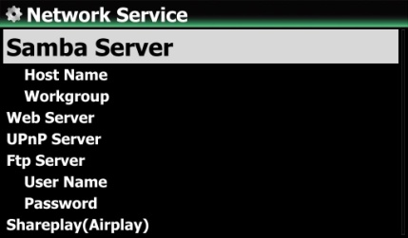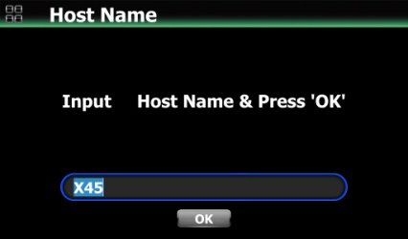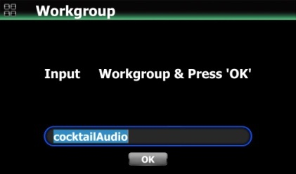
- Select Host Name and Workgroup.
- Enter host name and workgroup name and select OK and confirm with the OK button.
- How to see the folders of the X45 hard disk on your PC screen (based on Window 7 )
- Click the ‘START’ icon on the left/bottom on your monitor.
- Select ‘Computer’ and click it.
- You may see ‘Network’
- Click ‘Network’, then you may see all servers (The X45 default host name is X45) connected to local network.
- Select ‘X45’ and click it.
- You may see the two folders, LocalStorages and MusicDB.
- WARNING: You must NOT access to the MusicDB folder related to database. If you delete or edit something inside of the folder, it will make MusicDB serious trouble.

4-5-2 Network Sharing (Samba Client)

You can connect the X45 and the storage devices in the same network. If you want to stream the file in remote devices and play it with the X45, you need to do ‘network sharing’ first as below.

- How to add ‘shared folder’

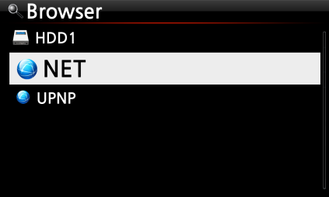
① Go to Browser and click NET
② ‘Add Share’ will be showed, then click it

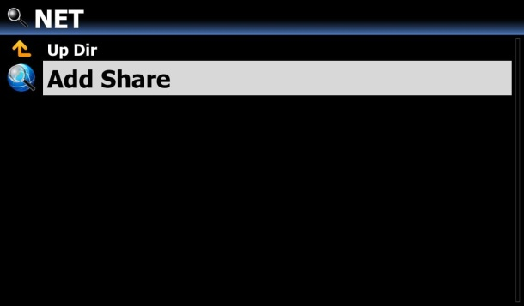
③ Place the cursor on the ‘Server’ and confirm it with OK key
④ Connected Server list will be displayed like below picture.

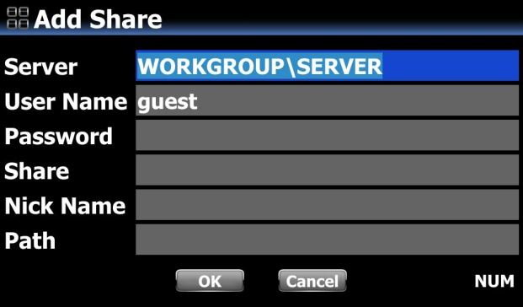
⑤ Select right one and click it

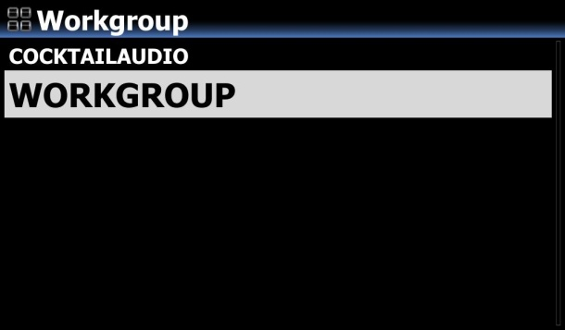
⑥ Then, IP address will be shown up in the path
※ In case that IP address doesn’t show up, please insert it by keyboard. You can connect USB Keyboard into the X45

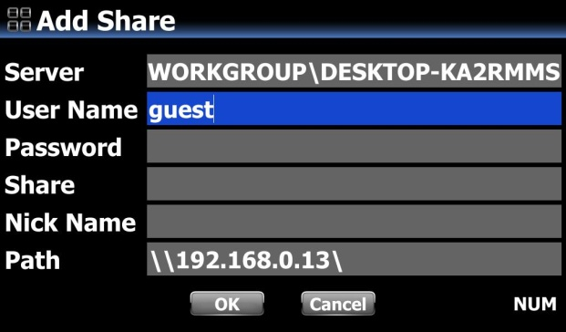
⑦ Place the cursor on the IP address, and click it
⑧ Then, Shared folder will be shown up in the Share.
- If ‘Requires authentication for Share’ message come out, you need to set it on Windows
⑨ Place the cursor on the OK and confirm it to finish
⑩ If you want, you can change Nick Name as you want

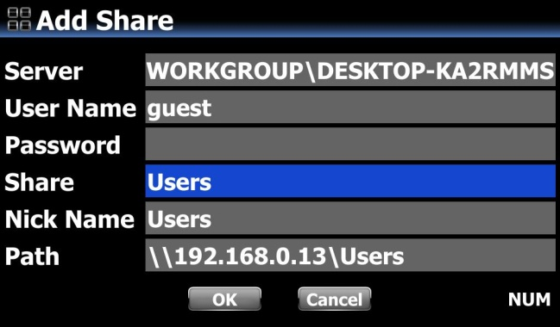

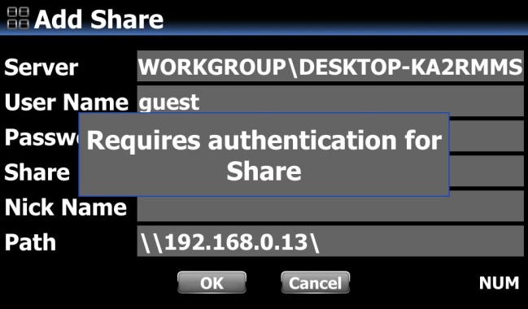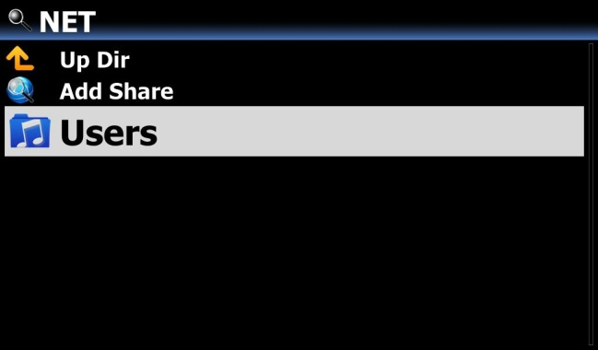

- How to edit and remove ‘shared folder’

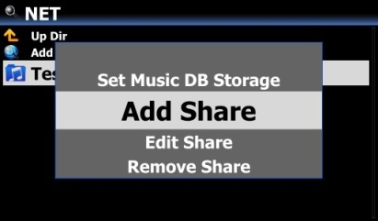
- Place the cursor on any folder listed on the screen.
- Press MENU key to open popup menu as the picture on the left. You may add or edit here.

- Convenient method to input the user name that you input previously

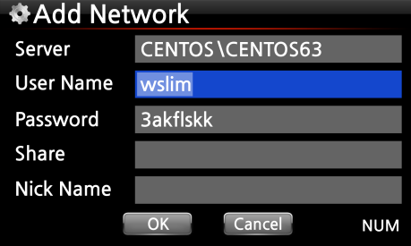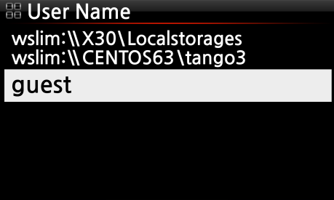
Place the cursor on the User Name and click it. Then, you may see the user name that you input previously

4-5-3 UPnP Server

If you have a device (like a PC) which supports UPnP client protocol, you can play music stored in the X45 Music DB through the UPnP device.

Default setting for UPnP Server is ON, see below.
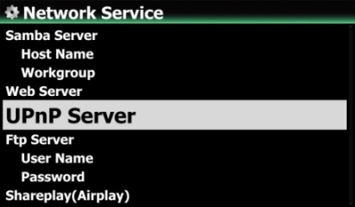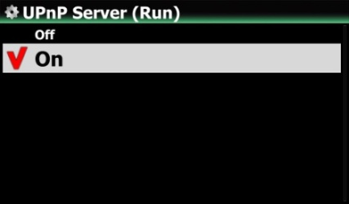

4-5-4 FTP Server
Select FTP Server and confirm with the OK key. Set it to ON. User Name is fixed as Guest. Default password is 0000. You may change password should you wish to.
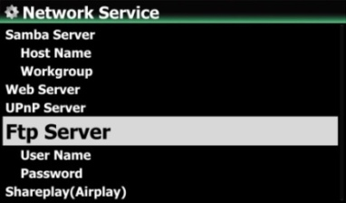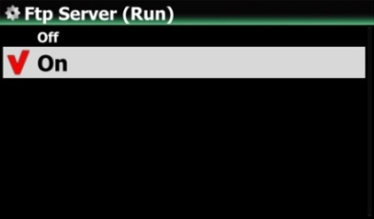

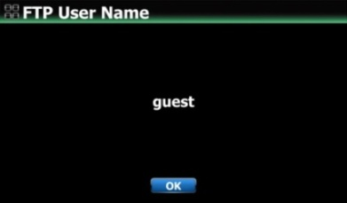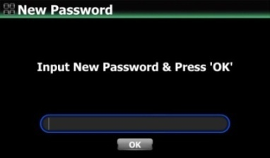
【 TIP 】 You may use the FTP software like ‘File Zilla’. The character should be set as ‘UTF-8’.

- What you can do with FTP Server function?
After installing FTP software like ‘File Zilla’ onto your PC, you can copy, delete or move files or folders between X45 hard disk and your PC hard disk.

4-5-5 Shareplay(Airplay)
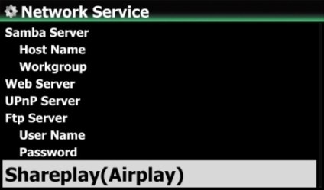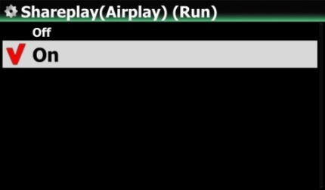
You can set Airplay function as OFF if needed
※Default: ON

4-6. Internet Service
X45 integrated Online Music Services into its software. So, you can play Qobuz, TIDAL, Deezer, Napster, Amazon Music and HighResAudio with X45 directly if you subscribe for those services and put their user name and password here properly.
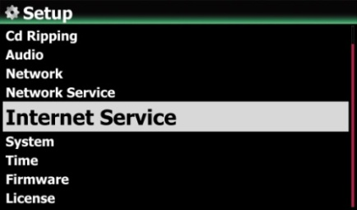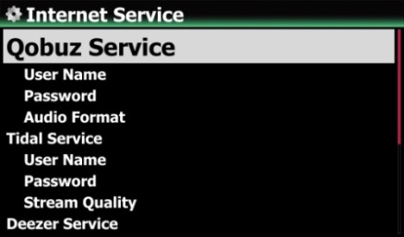

4-6-1. List View
You can display lists by Text or Cover art according to this setup.
※ Default: Text
※ You can toggle this option by TEXT/ART key of remote control

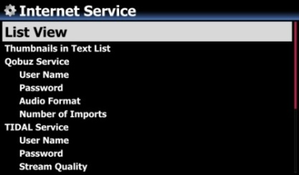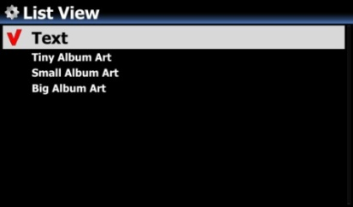
Option to enable/disable 'Thumbnails at the front of each text list
※ Default: OFF
※ NOTICE: If this option is set as ON and Thumbnails are displayed, the speed to list up will be slower a little
4-6-2. Thumbnails in Text List

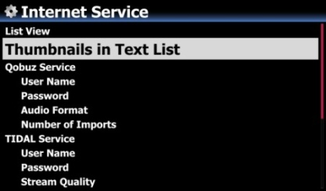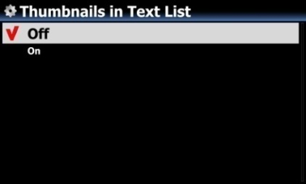

4-6-3. Qobuz, TIDAL, Deezer, Napster, HighResAudio are available
X45 integrated Qobuz, TIDAL, Deezer, Napster, Amazon Music, HighResAudio, so you can play them with X45 directly if you subscribe for those services and put their user name and password here properly.
※ NOTE
You have to do ‘double log in’ at device SETUP and MusicX NEO app for TIDAL and Amazon Music
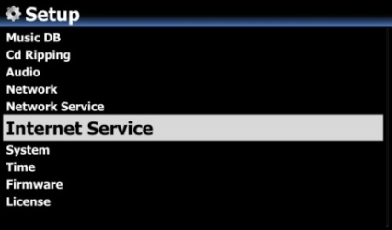

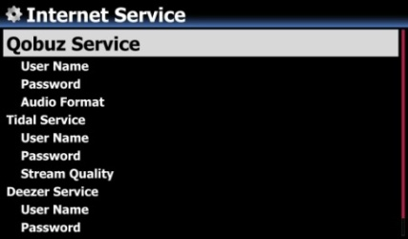

4-7. System
- Select System and confirm with the OK button.
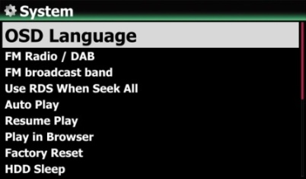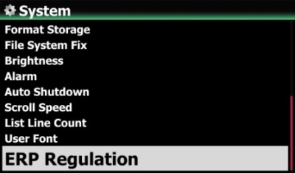

4-7-1. OSD (On Screen Display) Language.
② Select OSD Language and confirm with the OK button.
Supported languages will be displayed.
③ Select your preferred language and confirm with the OK button.
【 TIP ③ 】 Default is English.
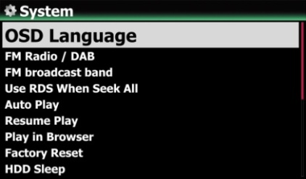

4-7-2. FM Radio / DAB+ selection
You can select FM Radio or DAB+ at this setup
※ Default: DAB+
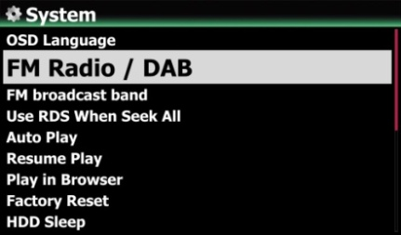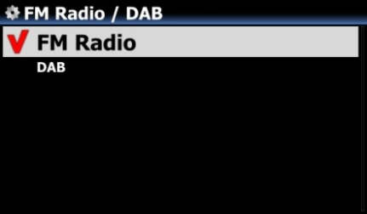

4-7-3. FM Broadcast Band
You can select your area for better signal receive
※ Default: Europe and North Asia
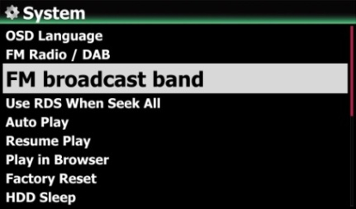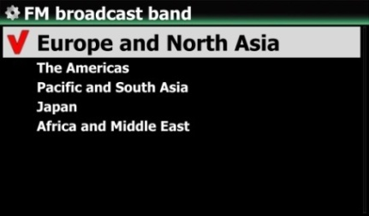

4-7-4. Use RDS When Seek All

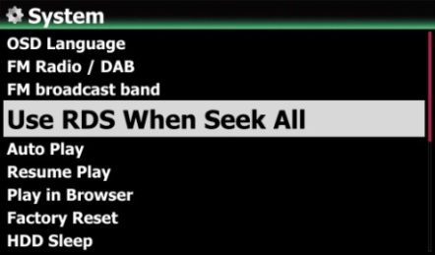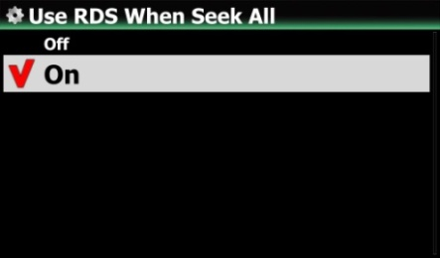
To speed up for station seeking, you can set RDS function as OFF
※ Default: ON

4-7-5. Auto Play
Select Auto Play and confirm with the OK button. You can set it to ON or OFF.
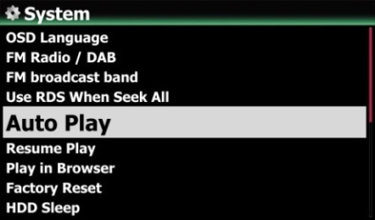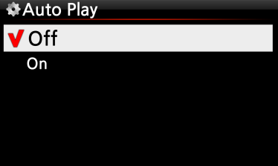
※ Default : OFF
【 TIP 】 For detailed explanation of Auto Play function, refer to 19-13 Auto Play (Page 119)

4-7-6. Resume Play

When you boot up the X45, it will automatically resume playing the music in the Music DB, Browser or i-Radio from where it was last stopped.
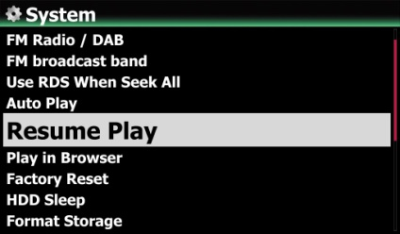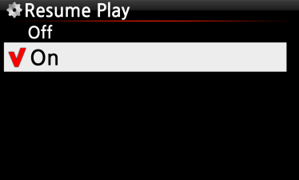
Select Resume Play and confirm with the OK key.
Set it as ON as shown left.

※ Default is OFF
【 TIP 】
- This function does NOT work in the case that the ‘Alarm’ function or ‘Auto Play’ function is enabled.
- Function priority : Alarm function ---- Auto Play function ----- Resume Play function

4-7-7. Play in Browser
1) Including Sub-Folder : All songs in sub-folders also will be played.
2) Excluding Sub-Folder : Any song in sub-folders will not be played
※ Default: Excluding Sub-Folder
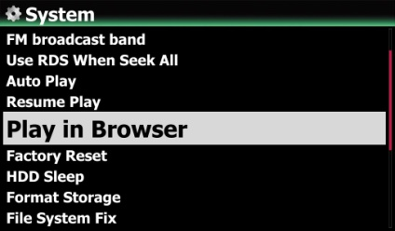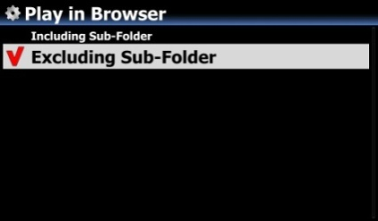
You can play all files in multiple folders or in single folder.
① Select folders with RIGHT arrow key.
② Press MENU key to open popup menu
③ Select 'Start Playing' to start playing.
⑤ All songs in the selected folder will be played

4-7-8. Factory Reset
To restore changed values of setup, select Factory Reset and confirm with the OK button.
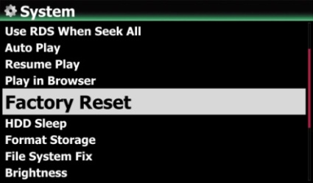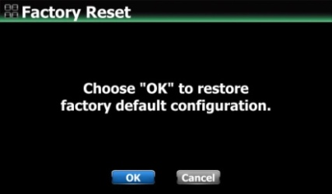
<NOTICE> When you boot up after Factory Reset, it will ask for Wizard Setup

4-7-9. HDD Sleep

You can make X45 HDD go to sleep mode by this setting. There are five (5) options like OFF, 10 Min, 20 Min, 30 Min and 1 Hour. During the selected time, if no access to HDD, the HDD goes into sleep mode.
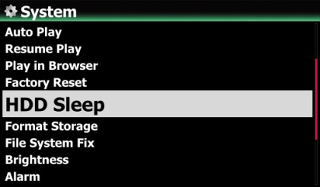
※ For the X45 to wake up from HDD sleep mode, it takes 3~4 seconds. During this time, the X45’s response to the input signal from remote control will be delayed.

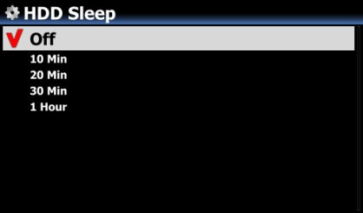

4-7-10. Format Storage

※ NOTE: HDD Format function of the X45 does not support multi-partitioning. If you would like to make two (2) partitions on the HDD we recommend this is done using your computer.

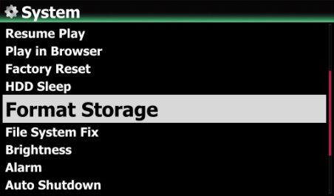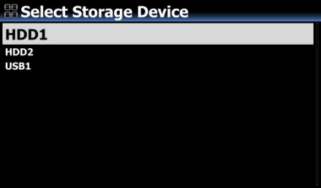
※ NOTE: The X45 offers the function to format internal hard disk and external USB devices also. The format procedure is same for the both storages.
<NOTICE> If you format HDD, all data in the HDD will be lost

4-7-11. File System Fix

When you suspect there is some problem in the file system of storages like internal HDD or connected USB storage, you can try this function to remove some error in file system of storages.

Select File System Fix and confirm with the OK key.
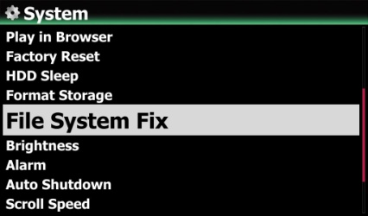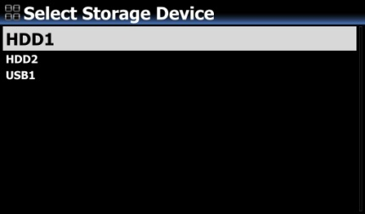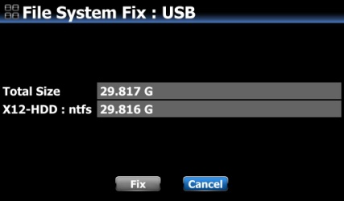
【 Caution 】 We recommend you NOT to run this function if the file system of the X45 hard disk has no problems.

4-7-12. Brightness

You can control the brightness level of the LCD.
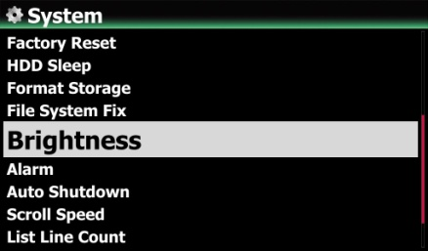
Select Brightness and confirm with the OK key. You can set the brightness using the LEFT/RIGHT arrow key on the remote control. ※ Default: 10

4-7-13. Alarm

You can set six (6) alarm settings on the X45.
- Go to Alarm at SETUP, and confirm it with OK key.
The following screen will appear.
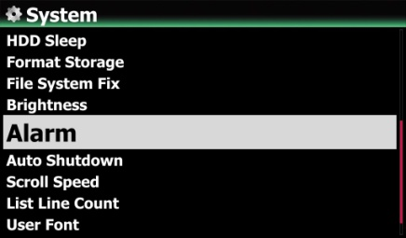
- Select the line you require and press the OK button.
The following screen will appear.
※ NOTE: The time should be set minimum 10 minutes later than current time.

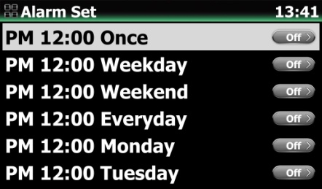
- Set time, cycle and sound source.
- Set Snooze ON.
- Select OK and confirm it with OK button.

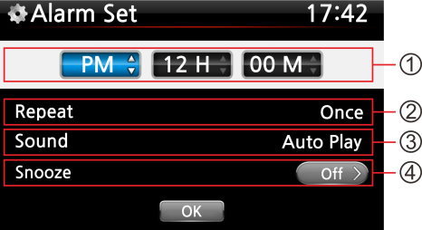
- Selecting time with up/down button.
- Selecting cycle with OK button
- Selecting sound source from Playlist or iRadio (My Favorites)
- Selecting snooze ON/OFF

- NOTE: In case that Alarm is set, the below icon will show up on the playing screen.
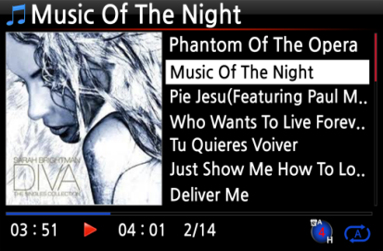
- NOTE
A : Alarm
2 : Two
D : Day
Alarm is set as ‘after 2 days from now’.

4-7-14. Auto Shutdown

The X45 will be powered off automatically at the assigned time and date.
- Go to SETUP and select System.
- Select Auto Shutdown and confirm with the OK key
- Select from the list and confirm.
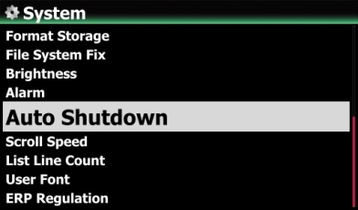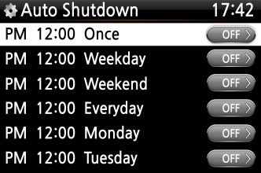

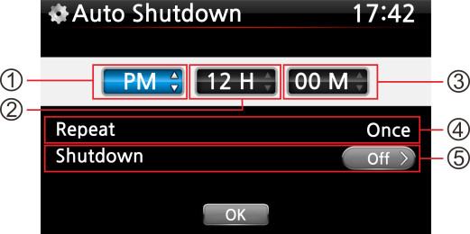
- You can set the time on the X45
- Once the time is set move cursor onto the OK icon and confirm with the OK key.
※ NOTE: Use the arrow key (UP/Down) to change the values. Use the arrow key (left/right) to move the cursor. Press the OK key to change ‘Repeat’. Use the arrow key (left/right) to set ON/OFF.
- The left screen will show. Press the RETURN key to save the setting and exit this setup.
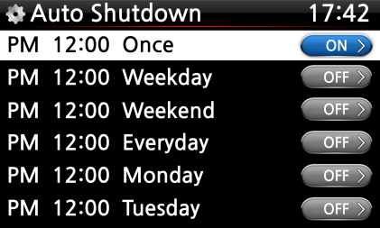
※ NOTE: Auto shutdown does not work properly if you set the shutdown time ‘within 3 minutes of the power

- NOTE: In case that Auto shutdown is set, the below icon will show up on the playing screen.
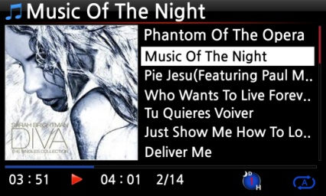
- NOTE
D : Auto Shutdown
3 : three
H : Hour
After 3 hours, X45 will shutdown

4-7-15. Scroll Speed

Long text is scrolling on the screen. You can set its speed like below.
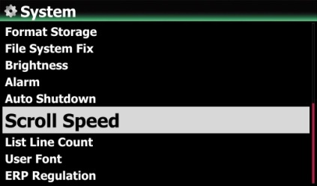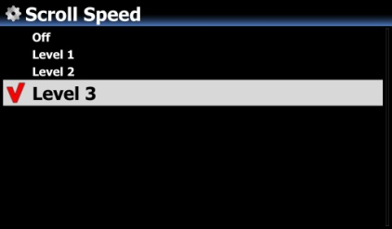※ Default: Level 3
4-7-16. List Line Count
The number of text lines displayed on the screen is selectable according to your taste like below.
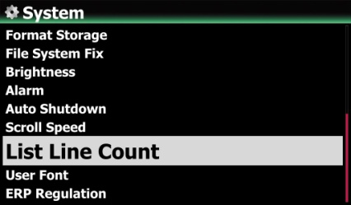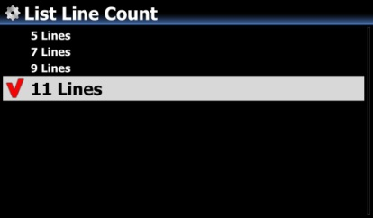
※ Default: 11 lines

4-7-17. User Font

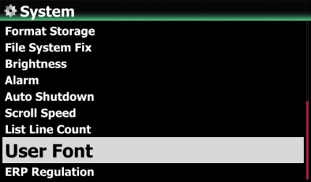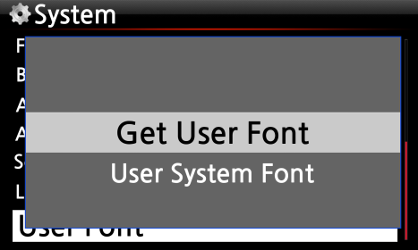
※ Various fonts are available in Windows PC (C:/Windows/Fonts). You can get one of them and use it for X45 via this function.
① Copy preferred fonts file into USB memory stick or local hard disk of X45.
② go to SETUP > System > User Font: Confirm it with OK key to open menu window like above
③ Select 'Get User Font' to look for the fonts files and load it.
※ To return to 'X45 original system font, select 'User System font' and confirm it with OK key.

4-7-18. Browser View
You can display browser list by text or cover art
※ Default: Text
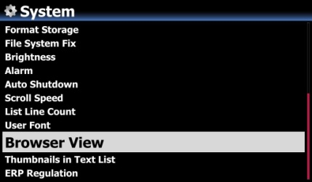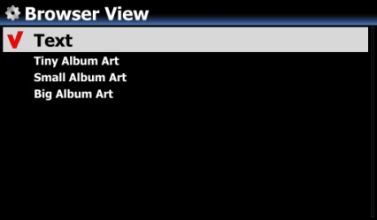

4-7-19. Thumbnails in Text List
Option to enable/disable 'Thumbnails at the front of each text list
※ Default: OFF
※ NOTICE: If this option is set as ON and Thumbnails are displayed, the speed to list up will be slower a little

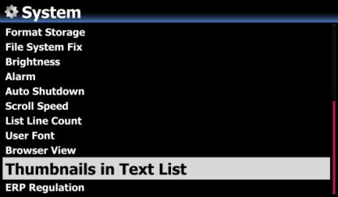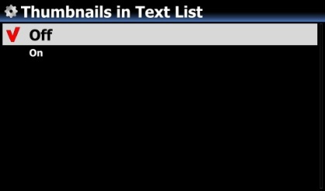

4-7-20. ErP Regulation
According to CE Regulation (ErP/Energy Efficiency Regulation), X45 will enter into Power Off mode or WOL mode automatically after 20 minutes without any working or input signal. You can set this function as ON or OFF
※ Default: OFF
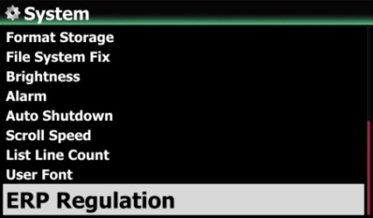

4-7-21. R1 and R2 Keys of 2nd Remote control

We are selling the full aluminum remote control separately as the 2nd remote control, which has 17keys only to be used frequently

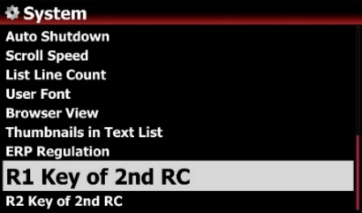
There are two reserved keys (R1 and R2) on the 2nd Remote Control. You can set them for preferred functions

Go to SETUP>System. You can set it as one of all keys on the original remote control

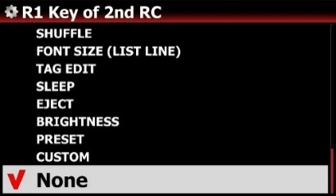

4-8. Time

You can set time format and time via internet or by manual here.
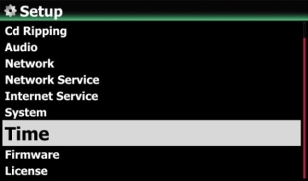

4-8-1. Time Format
X45 displays the time while playing the internet radio. Pressing the CLOCK key displays time.
X45 can display one of two ways, AM/PM or 24Hours. You can select which here.

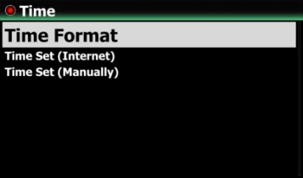
4-8-2. Time Set (Internet)
- Select Time Set (Internet) and confirm it with the OK button. All the time options will be displayed as below.
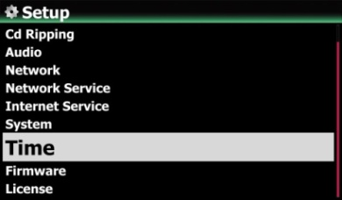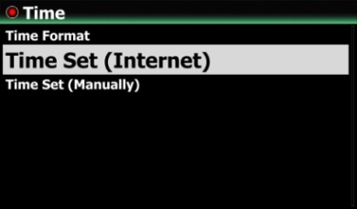
【 TIP 】 Make sure that the X45 is connected to network (internet) before you try time setting by Time Set (Internet).
② Select your preferred time and confirm it with OK button.

【 TIP 】 Default: GMT+00 London
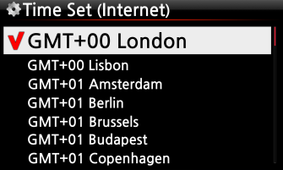

4-8-3. Time Set (Manually)

Without a network (internet) connection, you can set time manually.
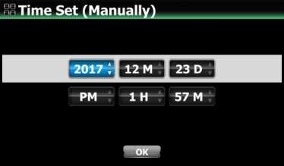
- Select Time Set (Manual) as in the above picture and confirm it with the OK button.
- Input your time manually and select OK to confirm it with OK button.

4-9. Firmware

You can check the current firmware version of your X45 and install the updated new firmware.
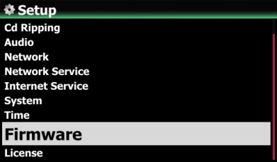
Select Firmware and confirm with the OK key.

4-9-1. Current Version

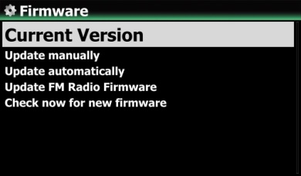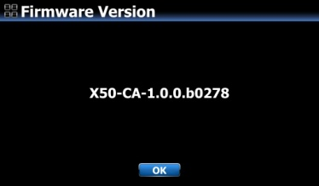
You can check the current firmware version as shown below. Select Current Version and confirm with the OK key.

4-9-2. Update manually (Firmware update manually)
- Obtain the new firmware first and put it onto the root directory of USB memory stick or the HDD of the X45.
- Plug the USB memory stick into the USB host port of the X45.
- Go to SETUP and select Firmware Update and confirm with the OK key.
- Select the storage device containing the new firmware.
- Select xxxxxxxxxx.pkg file and confirm with the OK key
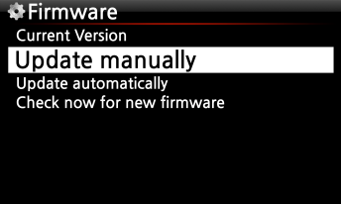

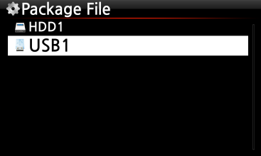

Select OK and confirm with the OK button. The X45 will reboot automatically to update the X45.
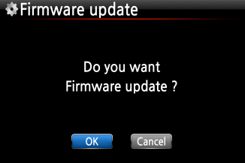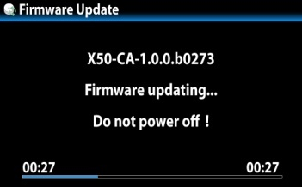

4-9-3. Update automatically (Automatic Firmware Update by network)
The X45 will automatically update the firmware through the network. If you don’t wish this done automatically you can change the setting to OFF, see left.
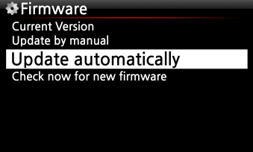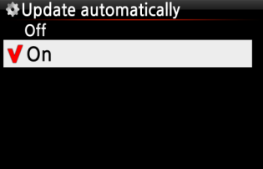
※ Default: ON

4-9-4. What is Automatic Firmware Update by network?

This function is available only when X45 is connected to a network (internet). In the instance that a higher version of the firmware exists at our server system, your X45 will check it automatically when the X45 boots up.
- NOTE: If CANCEL is selected, the folder [New Firmware] is created automatically in the internal hard disk (or USB), then the X45 will not ask for a Firmware Update when booting up. If you delete [New Firmware] through Browser, it will ask again.
※ NOTE: There is no actual data in the [New Firmware] folder.

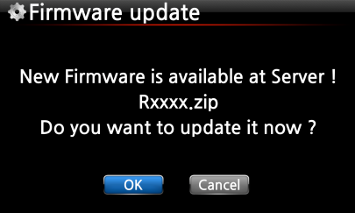
If OK is selected the X45 will try downloading and extracting it automatically. The X45 will reboot automatically to update the firmware, see sequence below:
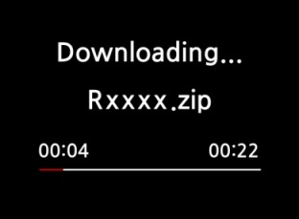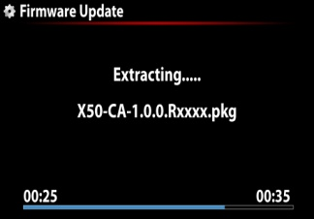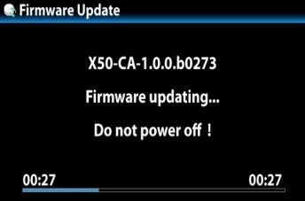

4-9-5. Check now for new firmware
When you want to check if your X45 has the latest firmware installed, please use this function. If there is higher version of firmware in our server, the dialog window will show up when you click this option.
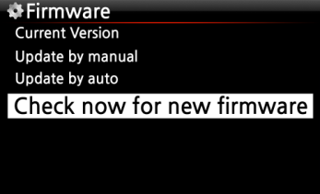

4-10. License for Gracenote Service

4-10-1. Limited Gracenote service
X45 provides Gracenote service to retrieve CD metadata and Album cover art for CD Ripping.
※ NOTICE
But, Gracenote service is free for two (2) years. After two (2) years, if you want to keep using Gracenote service, you need to pay five (5) EURO per service for one year.
Of course, if you don't like to Gracenote service with payment, CD metadata from freedb server and album cover art from Google, Amazon, Bing, etc are available in the X45

4-10-2. How to activate license for Gracenote service

※ NOTICE
You need to taka a simple process to activate ‘Gracenote Service’ first like below.
① Go to SETUP>License.
② Click 'License', then below screen will show up
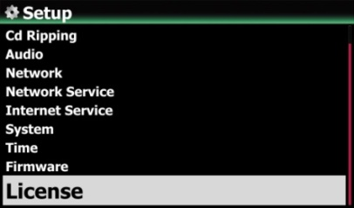
※ Two(2) services are available. One is CD metadata(Cd), the other is Album coverart(Cover)
③ Click one of them. For example, click 'Gracenote(Cd)
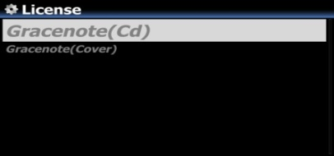

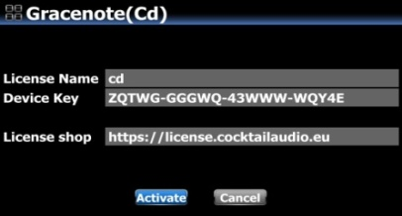
There will be License Name and Device Key, which are needed to activate license
④ Click 'Activate'

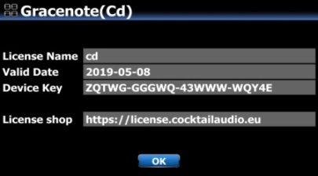
⑤ Click 'OK' to finalize 'license activating'
※ After two(2) years, you can take a similar process to buy license

- What is the Music DB (Music database) of X45

The Music DB is a database created with only index (tag info, metadata and cover art) of music files stored in each folder of the storages connected to X45. The music files themselves will remain in their original locations. Users can easily register(scan) music files to the Music DB by folder unit, and remove it from the Music DB easily. If you do CD ripping with X45, ripped files will be stored in the ‘My Music’ folder of main storage (green colored storage in the Browser mode), and index data of the ripped files will be registered(scanned) to the Music DB automatically.

Once creating Music DB, it will be very helpful for you to enjoy your music collection with various functions like search, display, editing, classify, making playlist, export song and various view modes, etc.

5-1. Making the most use of Music DB

Just like PC, you’d better classify your music files by folder unit and store it to the storage connected to the X45. And then, you can select a folder and run ‘Scan Music DB’ function to register(scan) music files in the selected folder to the Music DB.

5-2. Music DB storage (Main storage) Selection and ‘My Music’ folder

You may connect multiple storages to the X45 such as local HDD, USB1, USB2, and NAS. You can set one of these storages as main storage at SETUP(Setup>Music DB>Storage). If you try CD ripping or running ‘Scan Music DB’, ‘My Music’ folder will be automatically created on the main storage. The ripped files will be stored in the ‘My Music’ folder.

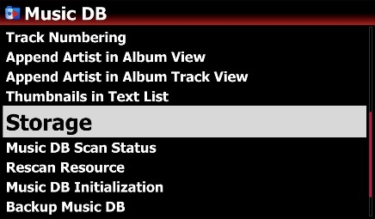
※ NOTE
1) The main storage will be shown as green like left screen
2) If you do CD Ripping, the ripped file will be stored in the My Music folder of the main storage
3) The album cover art of all albums in the Music DB will be stored in the main storage. So, if you remove the main storage, album cover art may not be listed properly on the album cover art list mode for the Music DB.
4) All files in the My Music folder of green colored storage will be scanned to the Music DB automatically

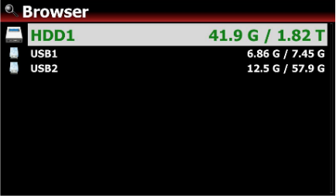

5-3. How to add music to the Music DB
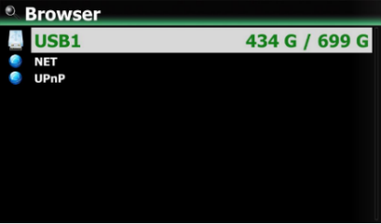
③ Click ‘Scan Music DB’ to start scanning the music files in the folder
① Go to Browser and place the cursor on the folder containing the music you want to add to the Music DB
② Press MENU key to open menu window like below

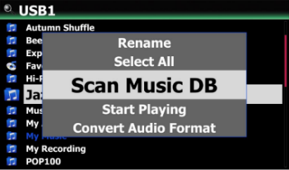
④ The folder scanned for Music DB will be changed to blue color like left screen
⑤ In case that the folder has sub folders, all sub folders also will be scanned together automatically
- NOTE: If you copy files or folders to the ‘My Music’ folder, those copied files or folders will be scanned automatically then added to the Music DB

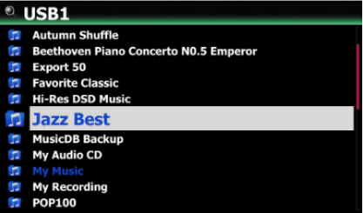

5-4. How to remove from the Music DB
① Go to Browser and place the cursor on the blue-colored folder you want to remove from the Music DB
② Press MENU key and select 'Remove from Music DB'
③ Click it to start removing!
④ The color of the folder will be changed normal color from blue.
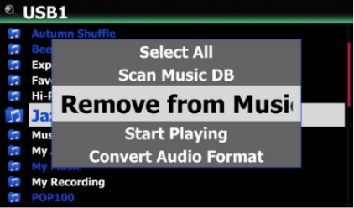

- NOTE: Original music files are remaining in the folder. You can’t use ‘Remove from Music DB’ function on the ‘My Music’ folder.
5-5. How to initialize the Music DB
① Go to SETUP > Music DB > Music DB Initialization
② Select 'Music DB Initialization' and confirm it with OK key to open the below screen
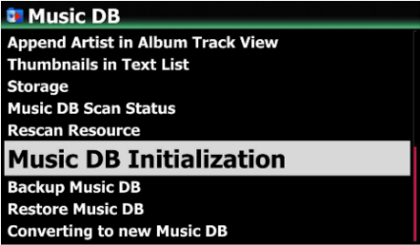
③ Select OK icon and confirm it with OK key to start clearing the Music DB
※ After initializing the Music DB, the device will reboot by itself to complete Music DB initialization, and will rescan ‘My Music’ folder only.
※ Warning: Music DB initialization will remove all Playlist
※ NOTE: This function will remove all scanned index of music files only. However, it has no effect on the original music files

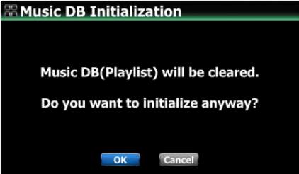

5-6. Automatic Indexing (Registration to Music DB)

If you add (copy) music files into the scanned folder (Blue colored), the added(copied) music files will be automatically indexed to the Music DB. If you edit music file in the folder, the edited contents will be automatically reflected to the Music DB. Of course, editing in Music DB will be reflected for original files in the folder.

5-7. Music DB Scan Path Overview
This feature shows you path information of Music DB files which were scanned from multiple folders and storages. You can find the origin of scanned files and scan-related information with this function.
- Enter the Music DB on the home screen and press menu key, then left screen will show up
- Select ‘Music DB Scan Path Overview', then it will show up the folder path of all connected storages and track numbers of scanned storages like below screen.
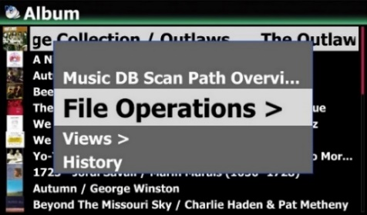

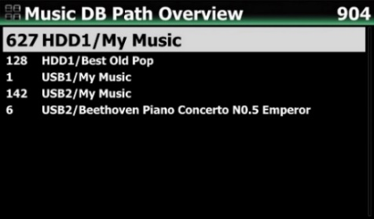
Total tracks of Music DB
Tracks of each path on the Music DB

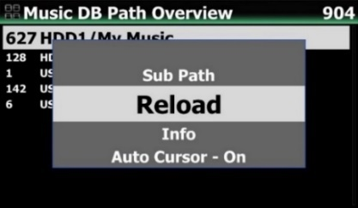
- Place the cursor on the target path list to see its detailed information, and press Menu key. Then, left screen will show up.
-. Sub Path: will show the list of albums and sub folder under the root path(folder).
-. Reload: will read again the path to update information.
-. Info: will show detailed information such as the total number of tracks, albums, and the date of the last scanned like below screen.
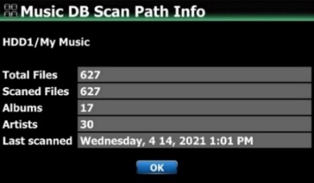

-. Auto Cursor: If you set ‘Auto Cursor’ as ‘On’, the cursor is automatically positioned as the path you are currently scanning. The path you are currently scanning for will be displayed in blue color like below screen.
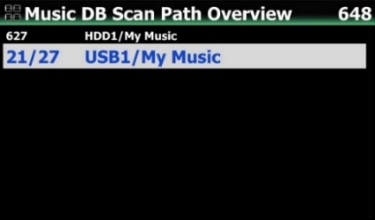

5-8. Rescan Resource (folder) function

To synchronize contents in Music DB and in folders of storages already scanned to Music DB, please go to SETUP>Music DB>Rescan Resource. Or, place the cursor on the target list (path) on the ‘Music DB Path Overview’ and press MENU key to run ‘Rescan Resource’ like below;

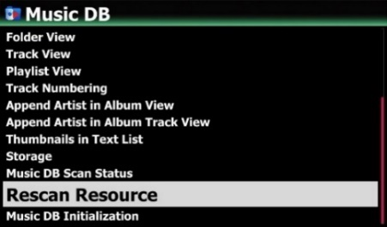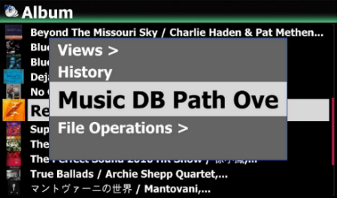

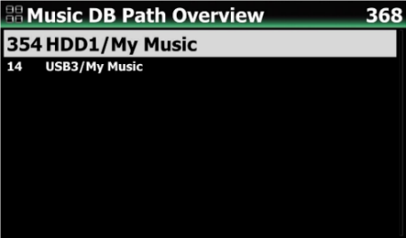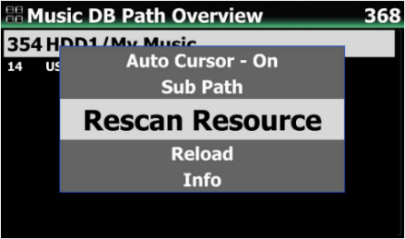
Then, it will update the Music DB data of all storages, if any changed
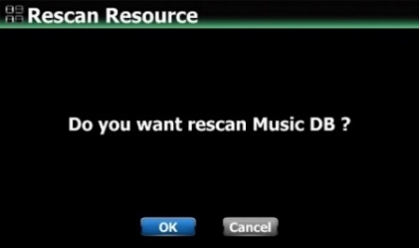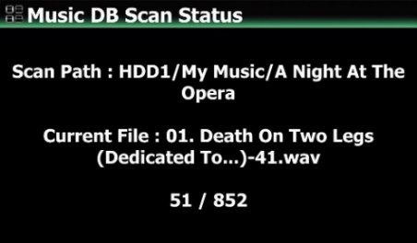

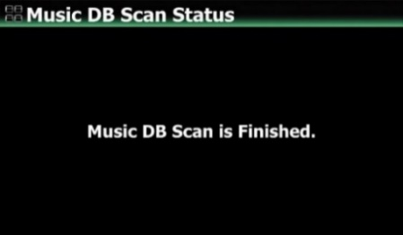

5-9. How to delete album/song and others in the Music DB

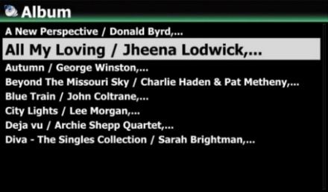
- Go into Music DB and place the cursor on the album or song you want to delete
- Press MENU key to open menu window
- Select 'Delete' to go next step and delete it
※ You can select multiple albums with 'Right arrow key'
※ NOTE
If you try deleting albums (folders) in the Music DB, inside files(songs) will be deleted, but albums (folders) names will remain in the Browser mode, because there is still cover art files in the albums (folders). If you want to delete them also, you can run ‘Delete Files’ function on the Browser mode.

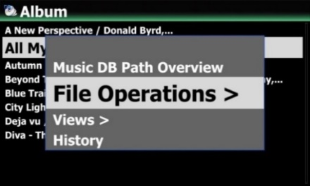

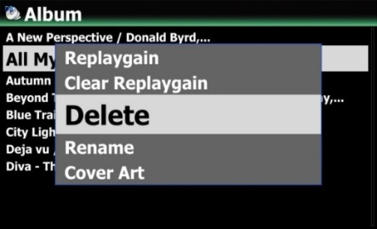

- CD Loading (Ripping)

6-1. Ripping format and converting

The X45 offers seven (7) ripping formats such as CAF, WAV, AIFF, MP3, Ogg, FLAC and ALAC. You can choose one of them. No matter which format is selected during ripping procedure, once the X45 will rip the CD to WAV format first, and then as background job, It will be converted to the selected format. Converting lead-time will be almost same as actual playing time. Files that have not been converted are not visible when you click the folder or album. The name of album or folder containing the file that has not been converted is displayed in blue color.

6-2. Where ripped files are stored

All music that you load (rip) onto the X45 will be stored in the ‘My Music’ folder of main storage (green colored storage on the Browser mode).

6-3. How to register (scan) ripped files into the Music DB

Index of the ripped files will be registered (scanned) into the Music DB of the X45 automatically.

【 TIP 】 It is recommended that you should connect to the internet to make use of the CD metadata server when loading (ripping) CDs. For CD metadata and cover art, we offer Gracenote service. Please refer to 4-10. License for Gracenote (Page 68)

6-4. When the X45 is connected to network (Internet)

Make sure to connect X45 to network (Internet) before inserting CD into X45.
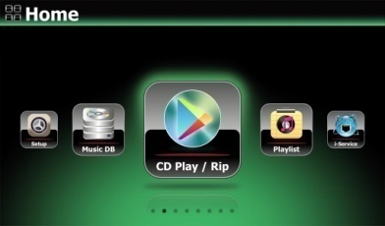
- Insert CD into X45, then all tracks will be listed on the screen.

【 TIP ② 】 If the X45 is connected to the Internet, but displays the track lists instead of the actual music titles, eject the CD & re-insert it into the optical drive again.

② For CD loading (ripping), press the MENU button.
Then the below popup screen is displayed showing “Ripping All”.

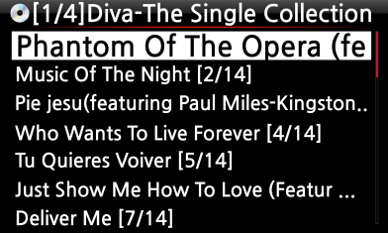
6-4-1 Ripping All

This procedure is for loading (ripping) a whole CD.
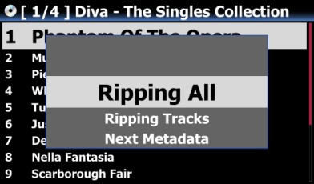
④ Select one of five (6) options (WAV, ALAC, AIFF, MP3, OGG, FLAC) and press OK button.
Then, the below screen is displayed.
③ Select Ripping All and press OK button.
Then the below screen is displayed.

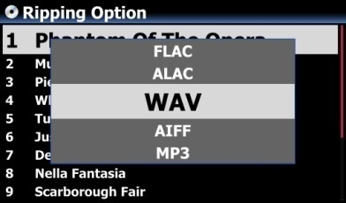
The X45 retrieves each information (title, artist, etc) from the CD metadata server

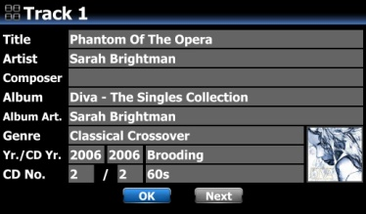
- Press OK to start CD ripping

※ NOTE: In case that multiple CD metadata exist, you can select other metadata for the CD with the NEXT icon, and click Album cover art if you want to change album cover art

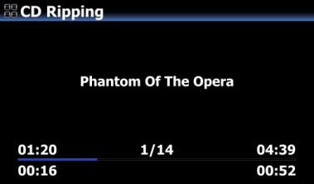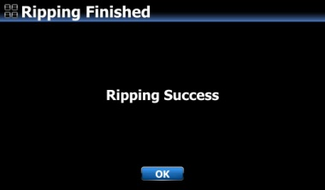
- Now, it's ripping

6-4-2. Ripping Tracks

This procedure is for loading (ripping) individual tracks.
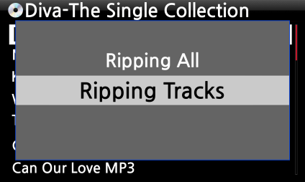
- Select Ripping Tracks and confirm with the OK button.
The below screen is displayed.

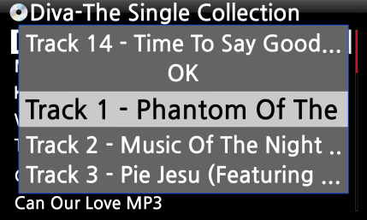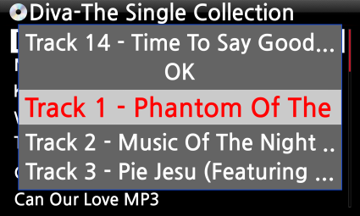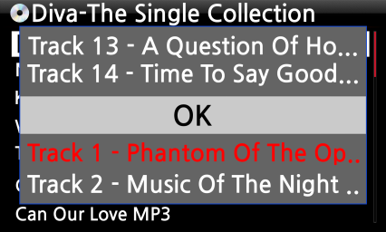
- Select the track(s) you want to load (rip) with RIGHT ARROW key, the selected tracks will change to red. After finishing selecting, select OK and confirm with the OK button.

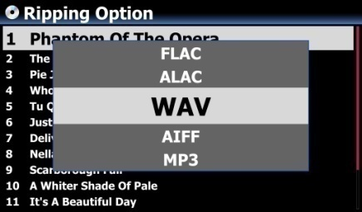
- Select one of the 6 file type options and confirm with the OK button.
From here, next procedures are same as the ‘Ripping All’

【 TIP ③ 】 When a CD is inserted into the optical drive, the X45 loads (rips) the CD to a WAV format first, even if the MP3 option was chosen. The X45 then converts the WAV file into MP3 format afterwards in the background. The X45 continues to convert the files if it is turned on. The X45 will pause the conversion process during ripping.

【 TIP ④ 】 Explanation of each item on the ripping screen.
- Title of track being ripped
- Number of tracks to be ripped/ total no of tracks in CD.
- Title of playing time
- Total time for playing
- Equivalent play time
- Ripped time
- Equivalent play time
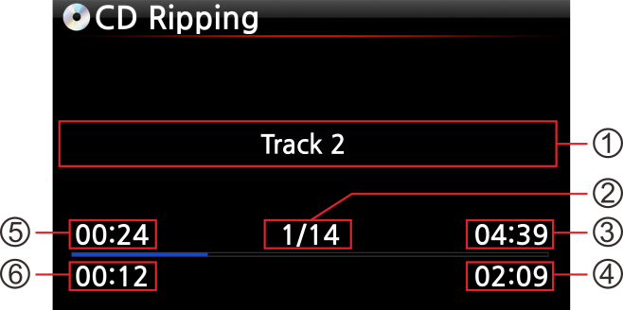

6-4-3. Structure of ID3 Tag Edit Dialog Screen in CD Ripping

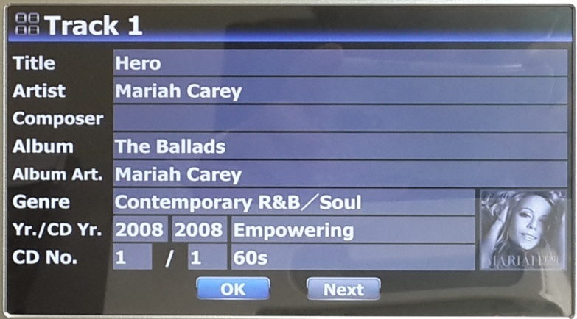
Tempo
Mood

This 'Next' key will show up in case that metadata for this CD exists in CD metadata company server with multiple number

6-4-4. How to merge all tracks of Multi-Album into one folder (one album) when ripping multi-album CDs
For multi-album, you can rip all tracks of multi-albums into one folder(one album)

For example, you have Multi-Album, The world's Greatest Ballads, which is composed of three(3) CDs. You already ripped CD1
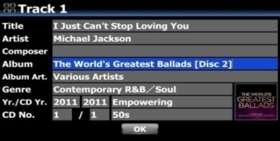
① Insert CD2 and try ripping procedure. You will meet Tag Edit screen like left. Place the cursor on the Album name and press OK

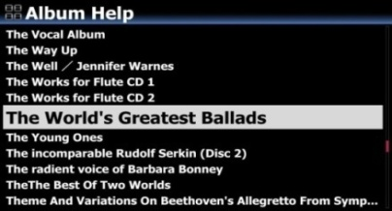
② Then, you will see 'Album Help' screen like left, and the cursor will be placed on the album which has same 1st alphabet as CD2's album name. This will help you to look for the CD1 easily.
③ Place the cursor on the CD1 album and press OK.

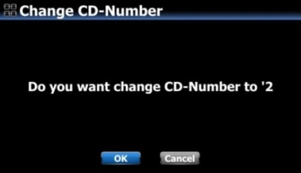
④ Please select OK to change CD number to '2'

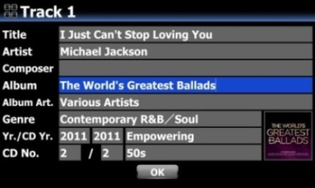
⑤ CD1's album name will be inserted into CD2's Tag Edit screen like left. Confirm OK
⑥ Select OK and confirm it
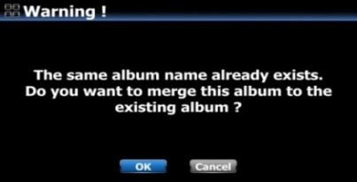

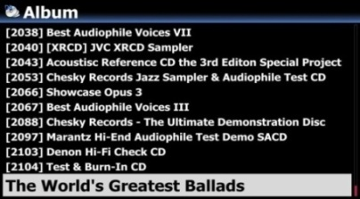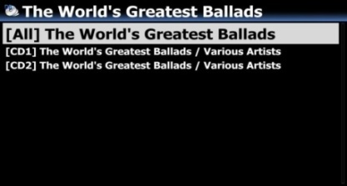

6-4-5. How to merge all tracks of Multi-Album into one folder(one album) after you already rip multi-album CDs to separate folders(albums)
For example, you have multi-album, The world's Greatest Ballads, which is composed of three(3) CDs. You already ripped them separately
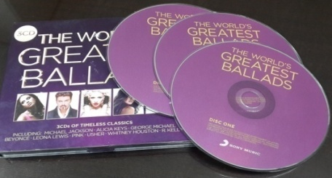
① Completing CD ripping for all three CDs, go to MusicDB. There will be three(3) albums like left picture.

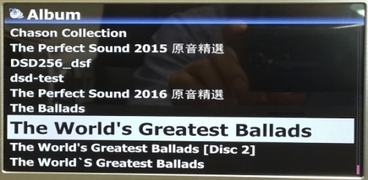
CD1
CD2
CD3

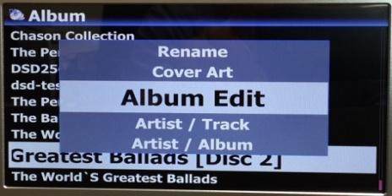
② Place cursor on the CD2(2nd Album) and press MENU key
③ Confirm 'Album Edit' to open Tag Edit screen like below picture.
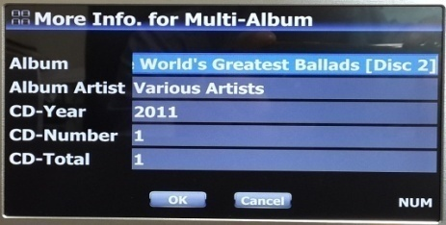
④ Cursor will be on Album name like left picture. Press OK key to open 'Album Help' screen like below.

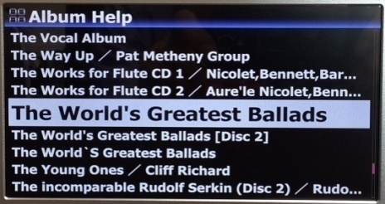
⑤ Look for the Album of CD1 and select it with OK key

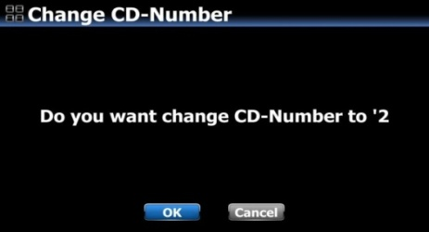
⑥ Left screen will show up to get CD number. Select OK and confirm it.

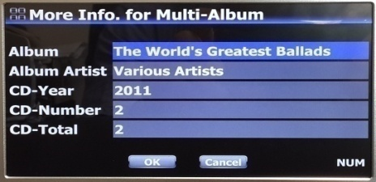
⑦ Then, Tag Edit screen of CD2 will get proper Album name and CD number like Left.
⑧ Select OK and confirm it.
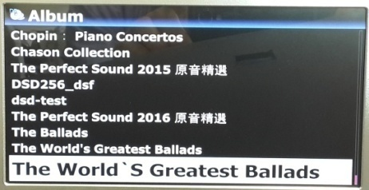
⑨ CD2(2nd Album) was merged to CD1(1st Album. There will be just two Albums(CD1 and CD3) like left screen.

※ For CD3(3rd Album), you may send it to the CD1(1st Album) by the same procedure as above.

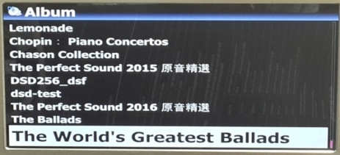
⑩ Finally, there will be only one Album like left. Click it. There will be four folder like left. There will be all tracks in the [All] folder(Album)

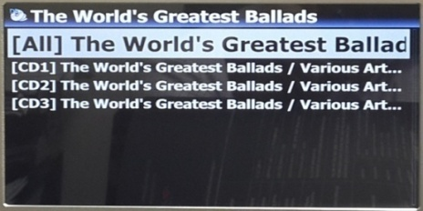

6-4-6. Automatic Ripping (Auto Rip) function
When you want to rip many CDs, this function will be helpful.
① Go to SETUP>CD Ripping> Set it as ON (※ Default: OFF)
② Insert CD into CD drive
③ X45 will start CD ripping and eject CD by itself after finishing ripping without pressing any key

※ NOTICE
1) If CD ripping is not successful, X45 will show up 'error message' and will wait for your confirmation.
2) After ripping, you don't like metadata or album cover art missing, you can edit the album tag info and get new album cover art through 'Album Edit' and 'Cover Art' functions
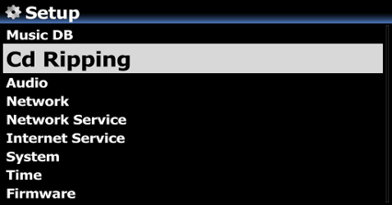

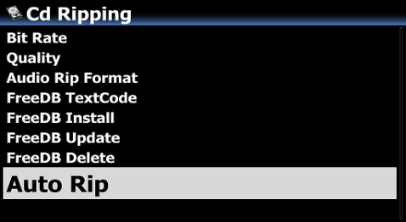

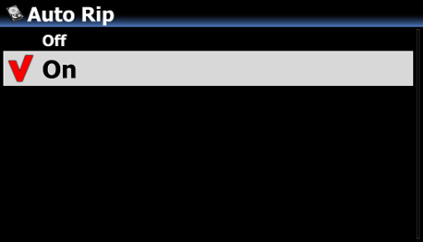

6-5. In the case that the X45 is NOT connected to a network (Internet).
- Insert CD into X45.
- Select CD Play/Rip icon and press OK.
Track list is displayed as in the screen below.
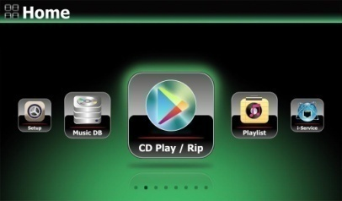
③ For loading (ripping), press MENU button.
The below screen “Ripping All” is displayed.

【 TIP 】 Without a network (Internet) connection, the inserted CD will get metadata (tag info) if you installed FreeDB onto X45 storage. The FreeDB data CD is bundled in the X45 package.
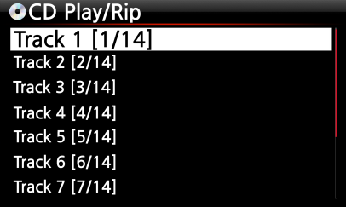

6-5-1. Ripping All

This procedure is for loading (ripping) all the tracks on CD.
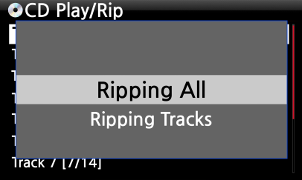
④ Select Ripping All and confirm it with OK button.

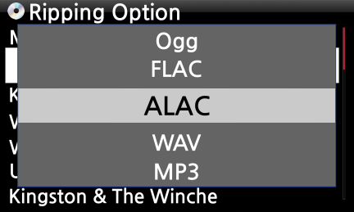
⑤ Select one of the 5 file type options and confirm by pressing the OK button. The below screen will be shown.
⑥ Enter the info manually with remote controller or USB keyboard.
You must enter Album name to go to next step.

【 TIP ⑥ 】 To use USB keyboard, ensure to connect a USB keyboard into the X45 before you boot the unit.

⑦ Select OK to confirm the entry. Then, loading (ripping) will start as in the picture below.
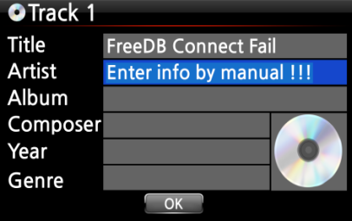

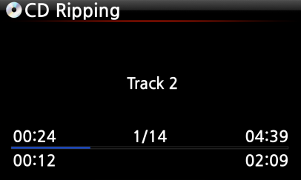
Now loading (ripping).

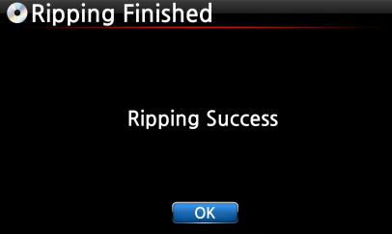
- If you did not enter info for title, artist, year or genre on the previous step, you can enter all the info here.
- After entering the info, select OK and confirm it by pressing the OK button.
⑧ Loading (ripping) has finished. Select OK and confirm by pressing OK. The screen below will be displayed.

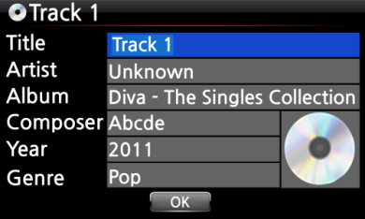
※ NOTE: You can edit tag information for loaded CDs in Music DB of the X45 easily through MusicX NEO app for Desktop PC(Windows or Mac)

6-5-2. Ripping Tracks

This procedure is almost the same except you are required to select the track you wish to load (rip).

6-6. If the FreeDB is installed onto the storage of the X45

If you installed the FreeDB database onto the storage of the X45 via the supplied DVD it will work as if the X45 is connected to network (internet). The X45 will display the CD information from the FreeDB database installed onto the storage.

6-7. To check the status of CD ripping and converting.

You can check the status of CD ripping and converting by using this function.
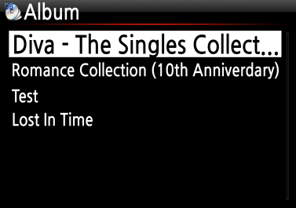
- Place the cursor on the album you want to check.
- Press INFO key
- The status information will show up like left.
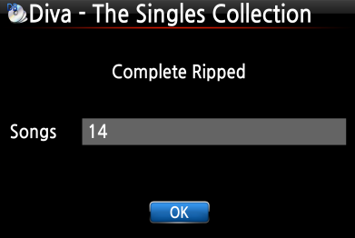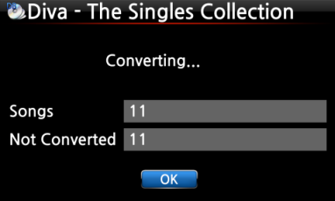
※ NOTE: If you wish to check the information and the status of the conversion process for the whole of the Music DB of the X45, go to the home screen. Place the cursor on the Music DB icon and Press the INFO key.
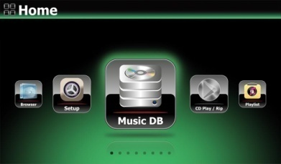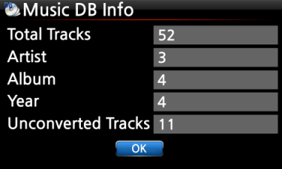

- How to use the Music DB (database)

7-1. Play music loaded (ripped) onto the X45.

The Music DB contains loaded (ripped) music.

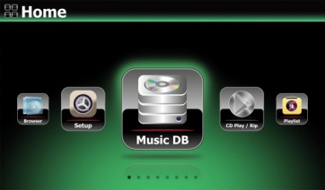
- Select Music DB icon, confirm with the OK button.
The album list is displayed as shown below.

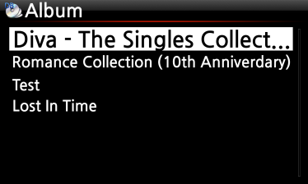
② Select the album you wish and confirm with the OK button.
All the music in the album is displayed, see below.

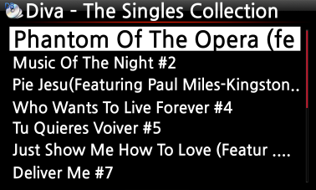
③ Select from the music list and confirm with the OK button to start playing the music.

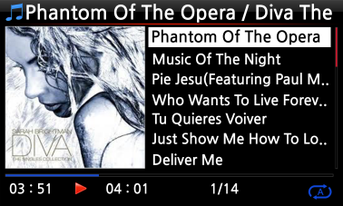
Now playing.

【 TIP ② 】Pressing the INFO key will change the screen as follows;
[ Playing Screen ] [ INFO Screen ] [ Title List Screen ]
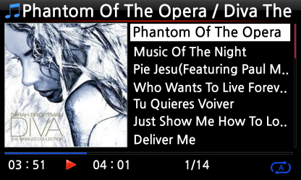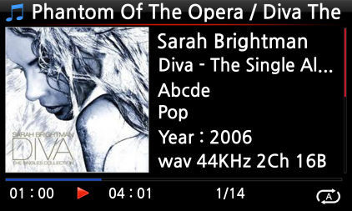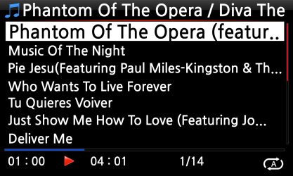
【 TIP ③ 】 On the album list screen, press the MENU button on the remote control, to show other categories such as artist/track list, artist/album list, genre/track list, genre/album list or titles, see below
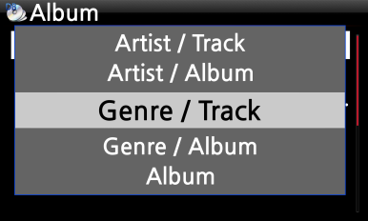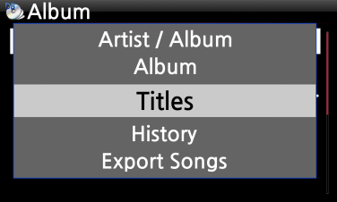

【 TIP ④ 】 Playing screen ------- press INFO button ------- Detailed info of current music

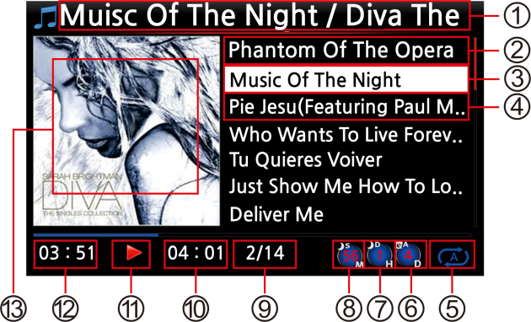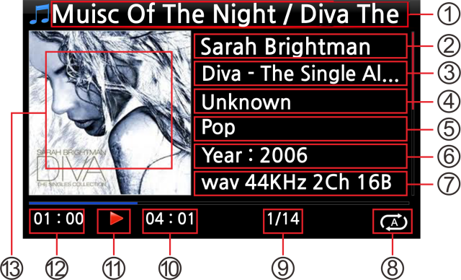
- Title / Album of current music.
- Artist
- Album
- Composer
- Genre
- Year
- File format/Frequency/Bit rate
- Play mode
- # of music playing / Total music#
- Total time of current music
- Play icon
- Played time of current music
- Album art of current music
- Title / Album of current music
- Title of previous music
- Title of current music
- Title of next music
- Play mode
- Alarm set icon
- Auto shutdown set icon
- Sleep set icon
- # of music playing / Total music #
- Total time of current music
- Play icon
- Played time of current music
- Album art of current music

7-2. SEARCH function.

In the case that there are many album lists in Music DB, the search feature can be useful.

SEARCH function
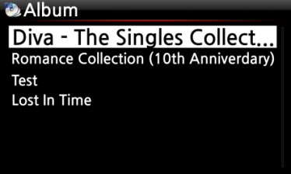
- On the album list screen, press SEARCH button to display the left/below screen.
- Enter the album name or part of the album name into the album name field using the remote control.

- NOTE: To view corresponding lists type the first few characters of the album

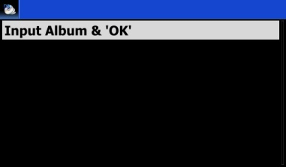
【 TIP ⑤ 】 You can run the SEARCH function by artist from the artist list screen, by genre on the genre list screen or by title on the title list screen, see below.
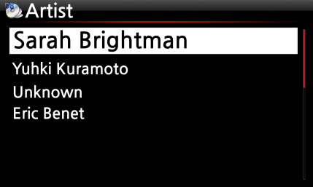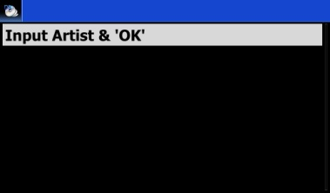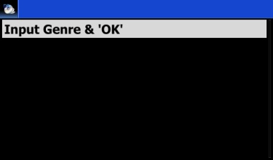

7-3. How to manage Music DB

The X45 allows you to manage the Music DB. You can delete or rename albums, artists and genre. You can export music from other storage devices (USB memory sticks or other hard disks) to Music DB folder.

7-3-1. Deleting or renaming music in the Music DB.

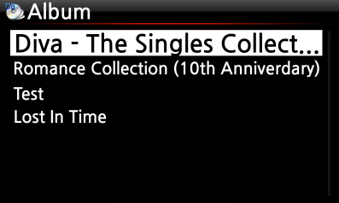
- Open the album list, artist list or genre list.
- Place the cursor on the list you would like to delete/rename.
- Press the MENU button. The menu screen is displayed as shown below.

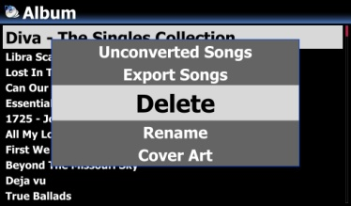
④ Select Delete or Rename and confirm with the OK button.
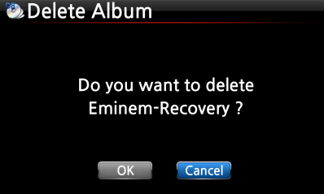
- Select OK and confirm with the OK button.

【 TIP ⑥ 】 You can also run this function for the artist list and the genre list by using the same procedure.

7-3-2. Cover Art
You can add album cover art for an album in MusicDB
① Place the cursor on the album list to which you want to add album cover art.
② Press MENU key to open menu window like left. Then, you can follow up as the window guides you.
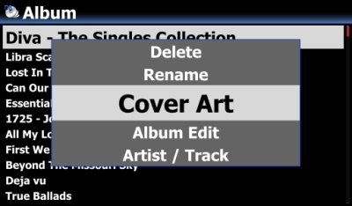

7-3-3. Album Edit for Multi-Album

There is a Multi-Album which is composed of several CD like C1, C2, C3, C4, etc. You can merge C1, C2, C3 and C4 into folder(album)

For example,
※ The 60 Jahre Bravo Hits is a multi-album, which is composed of four(4) CDs. You can merge all tracks of four CDs into one album name(60 Jahre Bravo Hits)
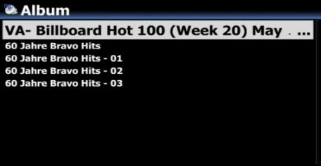
① Place the cursor on the 60 Jahre Bravo Hits -01(This is CD2), and press MENU key
② Select Album Edit to show up the below screen
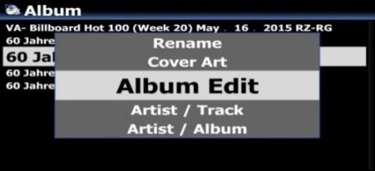
③ You can edit Album name(60 Jahre Bravo Hits - 01) to target one(60 Jahre Bravo Hits) including other items.
※ If you press OK key when the cursor is in album name, the 'Album Help" screen will show up. You can select target album here
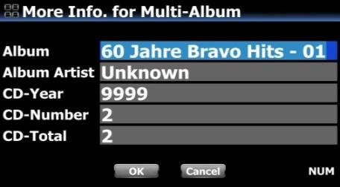
④ After finishing editing the screen, please confirm with OK button.
※ You can merge other CD2, CD3, CD4 like above.
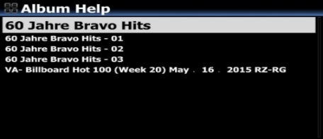
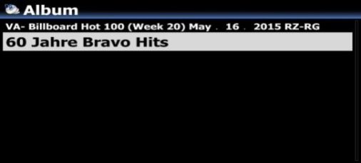
After finishing merging all CDs, the album looks like left screen.

Select it and press with OK key. Then, it looks like below screen. There will be five(5) folders like [All], [CD1], [CD2], [CD3], [CD4]

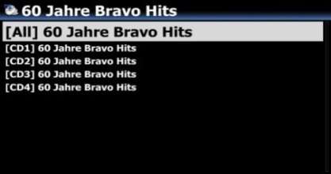

7-3-4. How to export music from the Music DB to other storage devices (HDD or USB).

You can export music from the Music DB to other storage devices such as; an external HDD or USB by following the steps below:
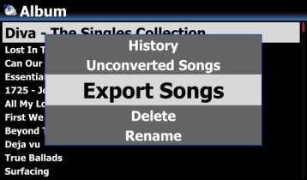
- Go into the Music DB using the remote control. You can see the Album list. Select the folder (Album) or the music you wish to export.
- Press the MENU key and select Export Songs, see screen shots shown on the left
- Confirm with the OK key, to display the next screen, shown below.

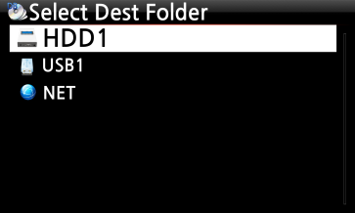
- Select the destination; HDD or USB and confirm with the OK key. Then the below screen is then displayed.

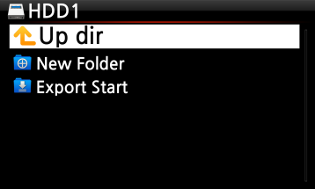
⑤ Select New Folder and confirm with the OK button to create a new folder. The screen below is then displayed.
⑥ Titled the input folder and select OK and confirm with the OK key

⑦ For example, if you input Diva – The Singles Collection and confirm, the screen below is then displayed.

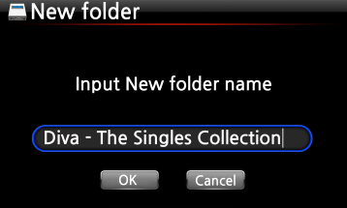

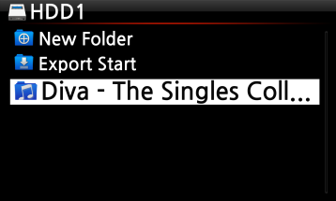
⑧ Place the cursor on Diva – The Singles Collection and select using the OK button. The screen below is then displayed.

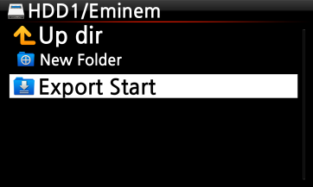
⑨ Select Export Start and confirm with the OK key. The Export function will commence.
Now exporting music.
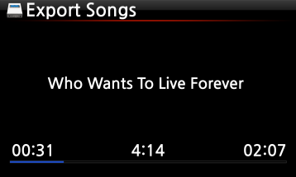

7-3-5. Creating .M3U and .PLS files when exporting

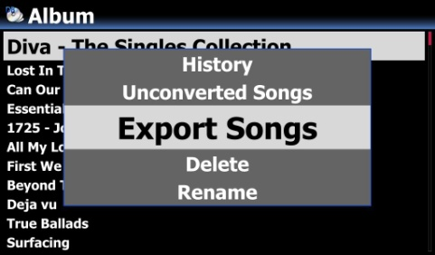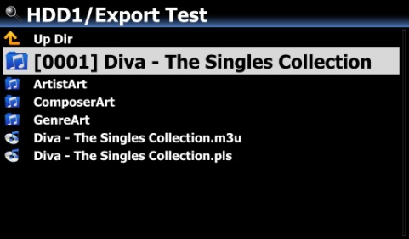
When you run 'Export Song' function, X45 will create .M3U file and .PLS file also in the target folder. For playlist icon on the home screen, you can export it to outside like USB

7-3-6. History function

You can list a maximum of 10 recently played songs from the Music DB using this function.

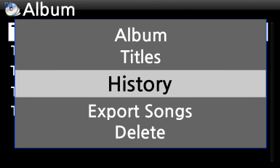
- Go into the Music DB
- Press the MENU key
- Select ‘History’ and confirm with the OK key, as shown in the screen shot on the left.

7-3-7. Set ‘Playing Section’ to play it repeatedly

[Playing Screen]
- On the Playing Screen, if you press LEFT ARROW key at a certain point, the point will be 'starting point'.
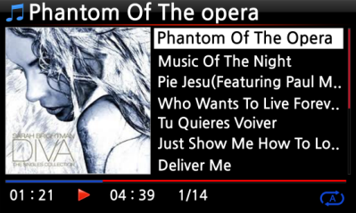
② If you press RIGHT ARROW key at a certain point, the point will be 'ending point'.
※ NOTE
1) If the 'Playing Section' is set, it will play repeatedly on the playing section
2) Numeric key of remote control (jump function) or -15/+15 SEEK key will be helpful to set 'playing section' easily.

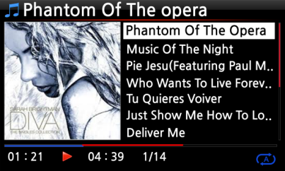
※ In case that 'playing section' is already set, each key works like below.
* -15(SEEK) Key: Pressing the -15 Key one time makes 'Playing Point' move backward by 15 seconds playing time.
* +15(SEEK) Key: Pressing the +15 Key one time makes 'Playing Point' move forward by 15 seconds playing time.
* LEFT ARROW Key: When 'Playing Point' is below 50% of total playing time, LEFT ARROW key will make 'Starting Point' move backward by 0.25 seconds
* RIGHT ARROW Key: When 'Playing Point' is below 50% of total playing time, RIGHT ARROW key will make 'Starting Point' move forward by 0.25 seconds
* LEFT ARROW Key: When 'Playing Point' is over 50% of total playing time, LEFT ARROW key will make 'Ending Point' move backward by 0.25 seconds
* RIGHT ARROW Key: When 'Playing Point' is over 50% of total playing time, RIGHT ARROW key will make 'Ending Point' move forward by 0.25 seconds
* PREVIOUS key: 'From current point to end' will be playing section.
* NEXT key: 'From beginning to current point' will be playing section.
* STOP key: Playing section will be cleared.

- Editing the TAG information of the music in the Music DB

You can edit the TAG information of music such as the title, artist, album, year or genre by following the steps below:
- Place the cursor on the music you wish to edit.
- Press the MENU button and select TAG Edit and confirm with the OK button. The screen below is then displayed.
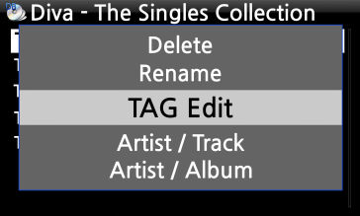
③ Using the remote control or USB keyboard you can edit the information.
④ Select OK and confirm with the OK button.

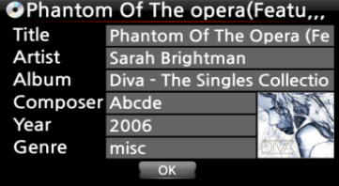
【 TIP 】 You can edit contents in the Music DB of the X45 easily using the MusicX NEO app for Desktop PC (Windows and Mac)

- Audio CD direct play

9-1. If the X45 is connected to a network (Internet)
- Insert a CD into the X45.
- Then, all tracks will be displayed automatically

【 TIP ② 】If the X45 is connected to CD database server through the network, the below screen will be displayed.
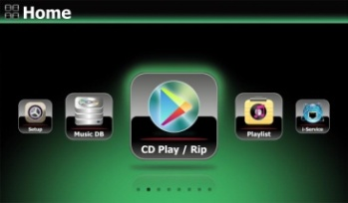

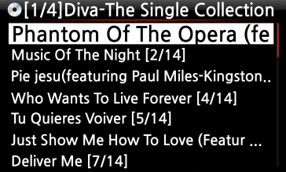
③ Select the music you would like to play and press the OK button.

The playing screen is shown below

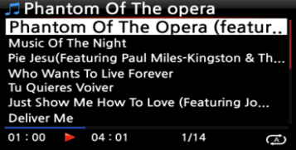
Now playing.

【 TIP ③ 】 If you press the INFO button on the above Playing Screen, you can see detailed information for the music currently playing, see screen shot below.
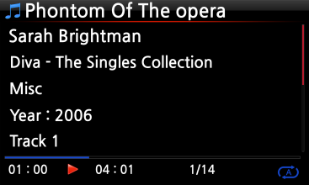

9-2. If the X45 is NOT connected to a network (Internet)
- Insert a CD and select CD Play/Rip icon and confirm with the OK button.
The track list is displayed as shown below
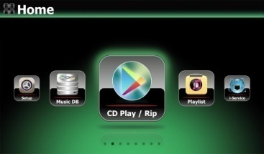
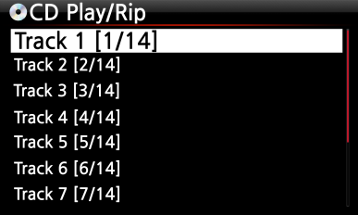
② Select the track you wish to play and confirm with the OK button. The track will then start playing

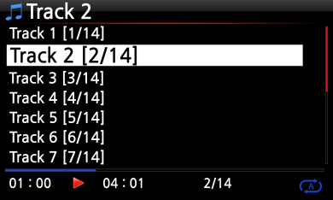
Now playing.

9-3. In the case that you have installed the FreeDB data onto the storage of the X45
If you installed the FreeDB data onto the storage of the X45, it will work just like the X45 is connected to a network (Internet). The X45 displays the CD information from the FreeDB data installed on the storage.

- Data CD direct play
The X45 will support music files burned to CD R/RW or DVD R/RW discs
      - Insert the data CD into the X45 and navigate to the Browser using the remote controller.
      - You will see the CDROM.
      - Select and confirm with the OK button and select the music to play.
【 TIP 】 If you wish, you can add music files into the Music DB. First, you need to copy music files in the CD into a folder in the storage. Then, run ‘Scan Music DB’ function for the folder.

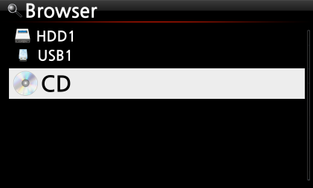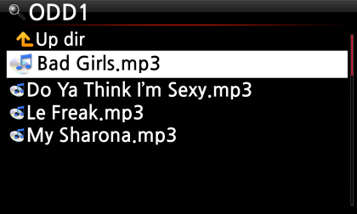

- Playlist

The X45 has three (3) kinds of playlist. The 1st one is just the normal Playlist function, the 2nd is ‘My Playlist’, and the 3rd is ‘Advanced My Playlist’. The normal Playlist does not disappear by stopping or powering off. However, My Playlist and Advanced My Playlist are virtual playlists. The virtual playlist is removed by stopping or powering off.

※ NOTE: If you run ‘My Playlist function’ or ‘Advanced My Playlist function’, the My Playlist is created automatically in the Playlist folder.
11-1. Playlist
11-1-1. How to make a Playlist
Ensure there are music files in the Music DB before making a Playlist.
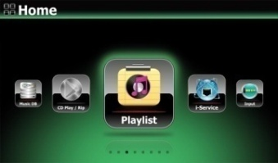
- Select the Playlist icon and press OK.
The screen below is then displayed.

【 TIP ① 】 The Auto Play folder is created automatically and it can't be removed by the user.

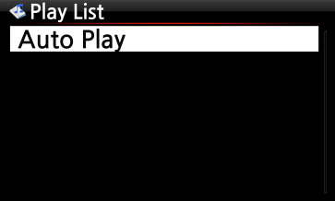
② Press the MENU button to show a popup menu, see screen shot below.

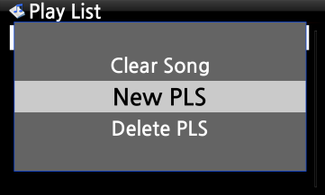
④ Enter a playlist name and select OK. Confirm the selection with the OK button.
The album list is then displayed in the Music DB, as shown below.
③ Select New PLS and confirm with the OK button.
The screen below is then displayed.

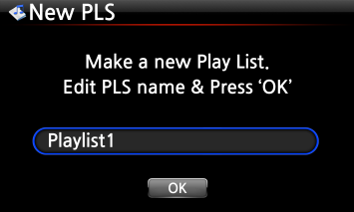
【 TIP ② 】 You can add music to a playlist by track or by album.
⑤ You may see + icon at the end of the cursor on an album. Press the PLAYLIST key to add the album to the playlist.
※ NOTE: You can move the cursor by using the arrow key (UP/DOWN)
- Press the OK key if you would like to go down the track list of an album

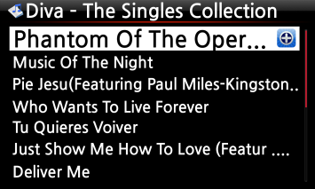

- You can add more music (tracks) or albums using the above procedure.
- After adding a track or album, press RETURN to go to the screen shown below.
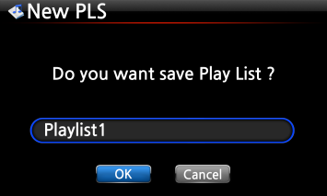
- Select OK and confirm with the OK button.
Then, the playlist 1 is stored in the Playlist folder, see below. You can view the playlist if you go into the Playlist folder through the Playlist icon on the home screen.

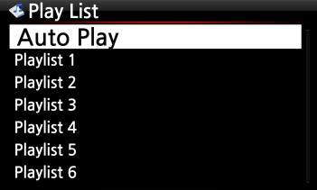
Playlist has been created
※ NOTE: To add more songs or albums to the playlist you have created, move the cursor onto the intended playlist and press the MENU key.

11-1-2. How to make a Playlist with whole tracks in album, Genre, or Artist
① For example, go to Album list and place the cursor on the target album
② Press PLAYLIST key of remote control
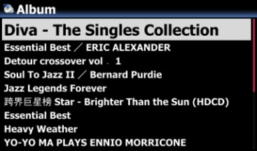
③ Edit Playlist name as you want, and press OK. Go to Playlist and there will be the playlist like below picture.
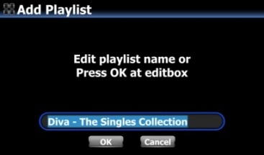

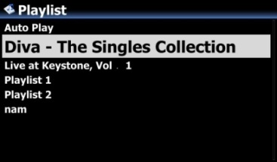

11-1-3. How to add songs to a Playlist whist playing music

When you are enjoying music from the Music DB and you come across a track you would like to add to a playlist, you can add it to an existing playlist in the Playlist folder by following these steps:

[ Playing Screen ]
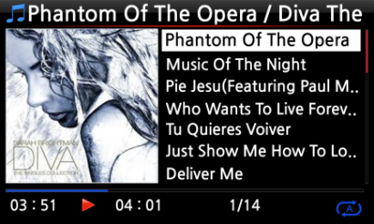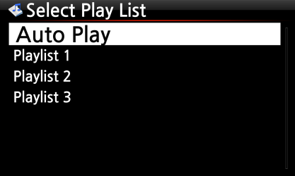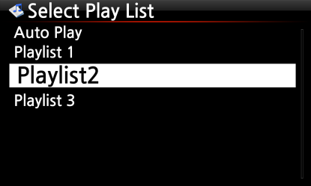
- Press the PLAYLIST key whilst in ‘Playing Screen’ mode as shown above.
- Select the playlist you would like to add the song to.
- Confirm with the OK key and the song will be stored in the selected playlist.

11-1-4. Shortcut to add song(s) in MusicDB to existing playlist

① Place the cursor on a title, album, genre or artist in the MusicDB that you want to add to an existing playlist
② Press 'PLAYLIST' key of remote control
③ Select the playlist where you want to add the song(s), album, etc
④ Press 'OK' key to start adding

11-1-5. How to play a Playlist
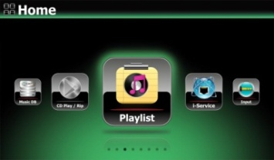
- Select the Playlist icon on the remote control or press the PLAY LIST hotkey on the remote control. The following screen is then displayed.
② Select the Playlist you would like to play and confirm with the OK button.
You will then see the music in the playlist as shown below.

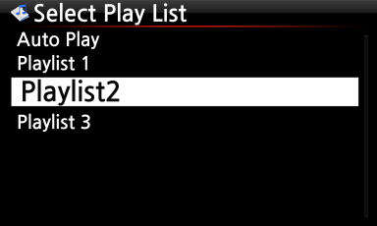
③ Select the music you would like to play and confirm with the OK button to play the selected music.

【 TIP ③ 】 If you set the play mode as Repeat All, all music in the selected playlist will be played continuously in sequence.

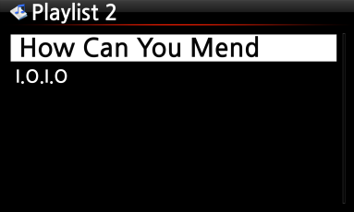

11-1-6. How to change song position in a Playlist
- In a Playlist, select a song or songs with RIGHT arrow key.
- Move the cursor with UP/DOWN arrow key to the place where you want to move the selected song/songs.
- Press LEFT arrow key to paste the selected

11-1-7. How to edit a Playlist
Go to the Playlist screen. Press the MENU button on the remote control. You can delete existing playlists, add music to existing playlists or clear music from an existing playlist.
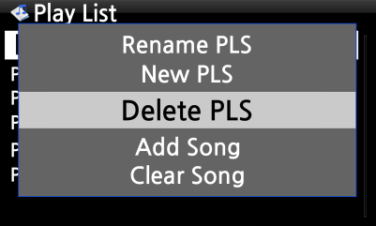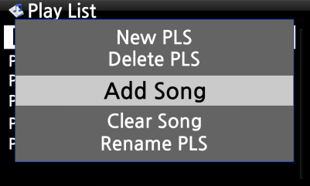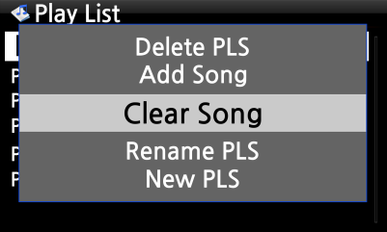
11-1-8. How to export Playlist

You can export Playlist to outside like USB memory stick to use it in your car or for other devices
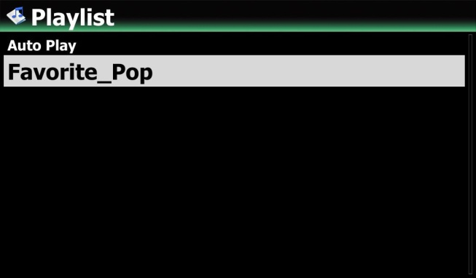
① Select playlist you want to export
② Press MENU key to open menu window
③ Select ‘Export Songs’
④ Select target storage and folder
⑤ Click ‘Export Start’ to go next step
⑥ Select ‘Overwrite’ or ‘Skip’ to start exporting

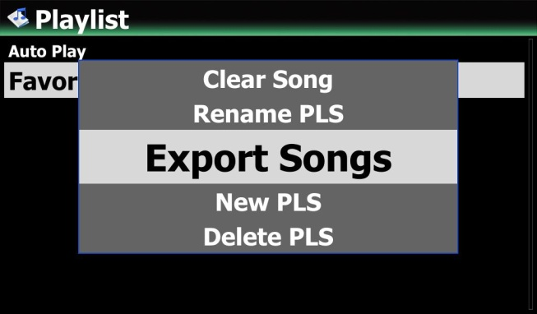

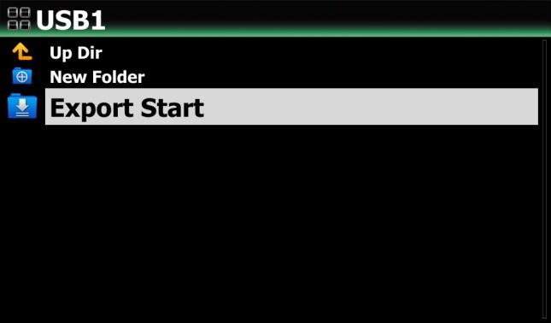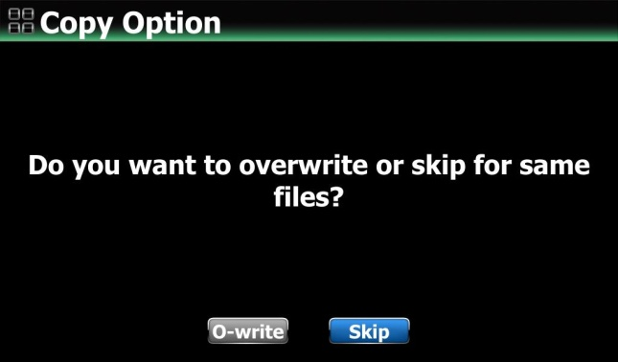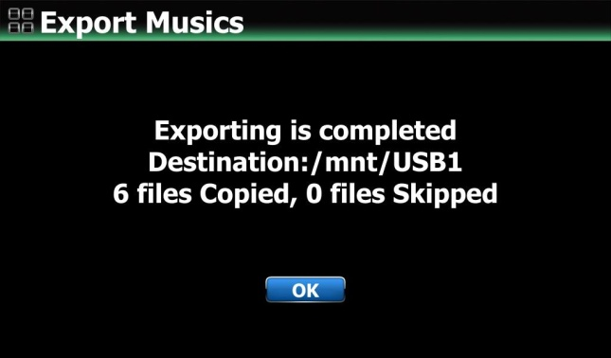

11-2. My Playlist (Virtual Playlist)

This is a virtual playlist function. After you have made a My Playlist, it will be removed if you stop playing or power off. This function works only in the Music DB. It will not work in the Browser.
- Place the cursor on the list of songs, albums, artists or genres.
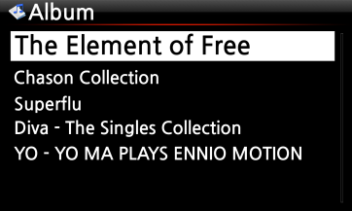
- Press the MY PL key on the remote control.
- The selected album will be played after showing [Creating Playlist ‘My Playlist’] as shown below.
- If you go into the folder of Play List with the RETURN key, there will be My Playlist displayed

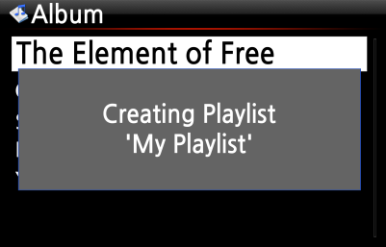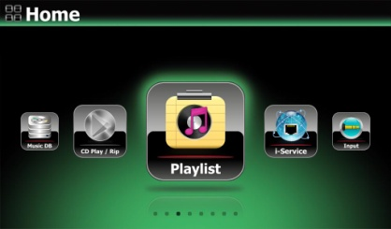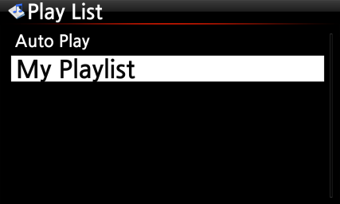
【 TIP 】 When My Playlist is being played, you may look for more albums or songs with RETURN key to add them into the current My Playlist. Place the cursor on the album or song, and press MY PL key. The below picture will show up.

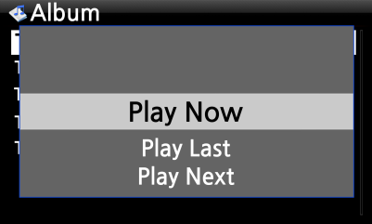
- Play Now: If you select Play Now and confirm, the selected album will start playing.
- Play Last: The selected album will be added to the currently playing list (album) as the last entry.
- Play Next: The selected song will be added to the next of the current playing song.

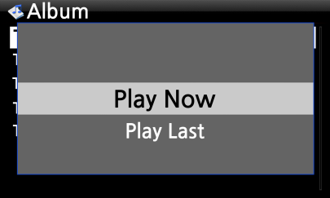

11-3. Advanced My Playlist (Virtual Playlist)

You can create a Advanced My Playlist (Virtual Playlist) when you come across a track you would like to add by its artist, genre or album.

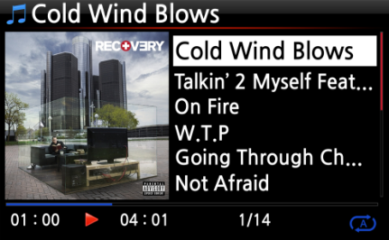
- The popup menu will appear as shown on the left.

- Select one choice and confirm with the OK key

- The selected song will start playing, and will be stored as My Playlist.
- When you come across the track, press the AD MY PL key at the ‘Playing Screen, see left.

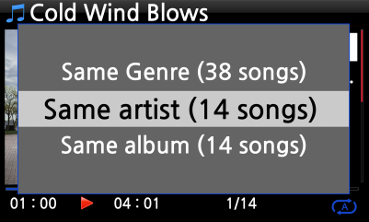

- The Music Streaming function

As the X45 supports various network protocols such as; UPnP Server/Client/Renderer and Samba Server/Client, you can enjoy various Music Streaming functions with the X45.

12-1. UPnP Server/Client and Samba Server/Client function

You can use the X45 together with various kinds of devices that support UPnP Server/Client or Samba Server/Client. If the devices are connected to the X45 through the same network, you can see the devices through the Browser, see below;
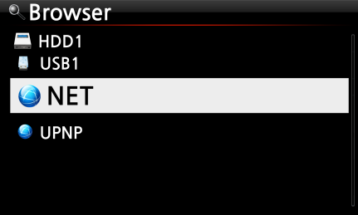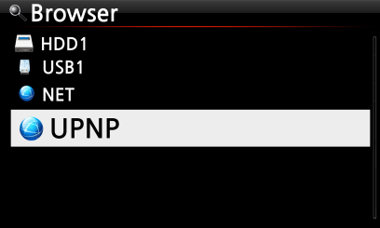

※ For connecting to the shared folders of networked devices, refer to 4-5-2 Network Sharing (Samba Client) (Page 55)

12-2. Multiple X45’s on the same network.

Place the X45 with the storage (music server) in your living room. A second X45 (without storage) is placed in room #1 or room #2. You can then play files from the X45 (music server) on the X45’s without storage, see schematic below.
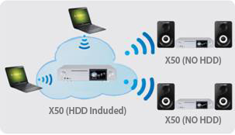

12-3. The X45 works as a Music Server with Sonos.

Sonos users can use the X45 as a music server with their Sonos device.
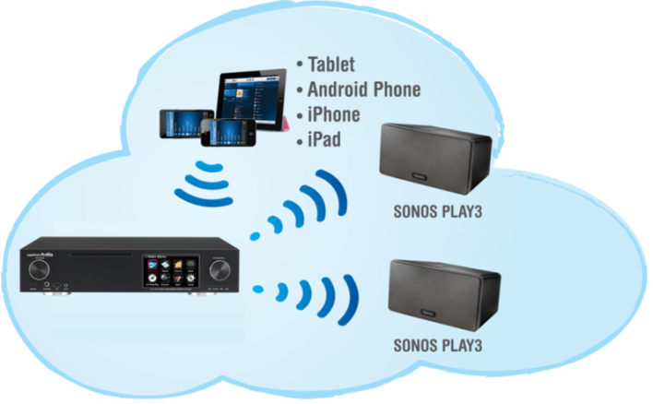
12-4. Shareplay(Airplay) function

This is the same function as Apple ‘Airplay’
You can play the song files in the iOS devices through the X45.
① Start music player in your iOS devices like left picture.
② Click the red circled icon
③ The right picture will show up
④ Select the X45 to play it via the X45.

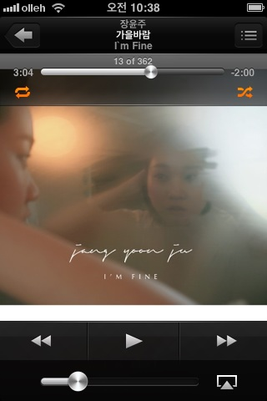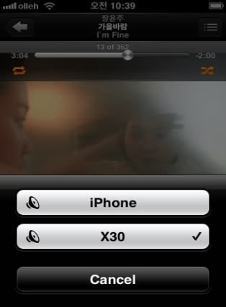

- i-Service

Ensure the X45 is connected to the network (Internet) before using the i-Service.
【 TIP ① 】 There might be a slight delay when tuning i-radio stations (buffering). This delay may occur due to the network (Internet) connection.

13-1. Internet Radio

13-1-1. How to play the Internet Radio.

You can enjoy many internet radio stations. The X45 Internet radio is based on the Airable server. It provides many stations by genre, by country, etc.

【 TIP 】 When the i-Service icon is highlighted the X45 is successfully connected to the network.
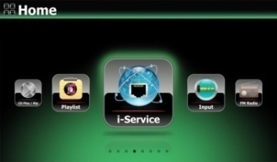
- Select the i-Service icon and confirm with the OK key. The below screen is then displayed.

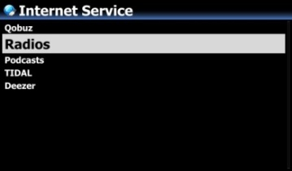
- Select the Radios and confirm with the OK key. The below screen is then displayed.

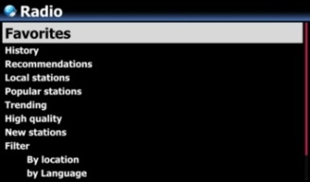
- Here you can select an item you want
- There will be station lists in each folder.
- Select a station and confirm it with OK key to start playing

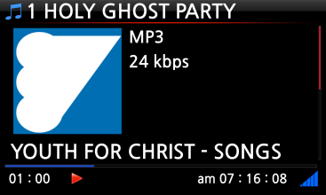
Now playing.

13-1-2. How to add your favorite stations into Favorites.
Whilst playing a station press the FAVORITE button on the remote control to add the station to Favorites.
The station will then appear in Favorites folder, as shown left.
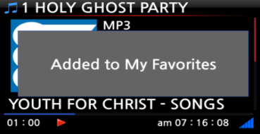

13-1-3. How to a run search function on the Internet Radio

You can search for a station on the Internet Radio as follows; on the Internet Radio screen, press the SEARCH button on the remote control, the left screen will then be displayed. Input the first few alphabetical characters of the station and select OK and confirm with the OK key. Similar named stations are also displayed.
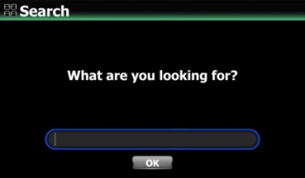

13-1-4. Recording from the Internet Radio

- NOTE 1: We recommend NOT to record continuously for over three (3) hours.
- NOTE 2: Space required for recording in MP3 format: 1 hour(54MB)/2 hours(108MB)/3 hours(162MB)
- NOTE 3: X45 will record i-Radio by the formats like MP3, AAC or ASF according to the station’s streaming format.

13-1-4-1. How to record

- While the I-Radio is playing, press the REC button to start recording.
- Press the STOP button to stop recording
[ Playing ] [ Recording ] [ Playing ]
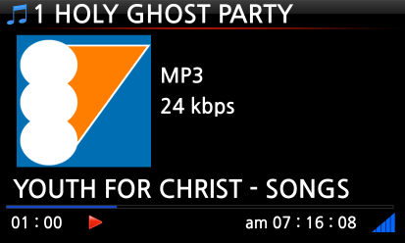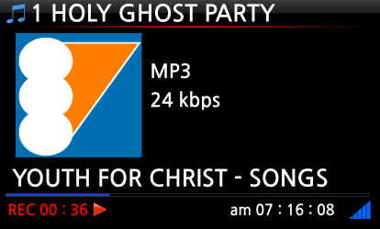

13-1-4-2. Where is the recorded file stored?

The X45 creates a [IRadio Recording] folder on the hard disk automatically when recording has started. All recorded files are stored in the IRadio Recording folder, see below.
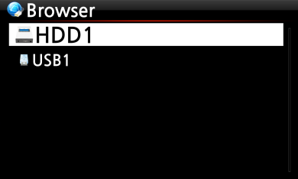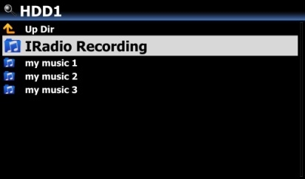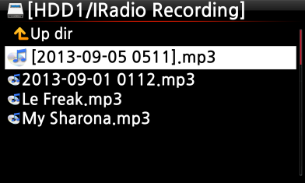

13-1-4-3. The recorded file name structure

The station will show the music title, see below, the recorded file name will be the music title.

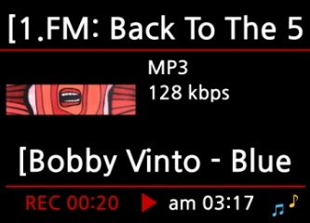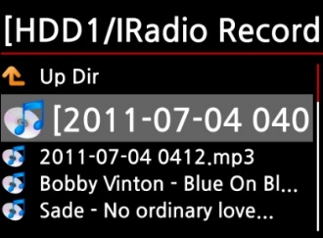

If the station does not show any title, see screen shot below, the recorded file name will be ‘year-month-day-time (minute/second).
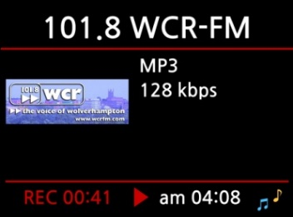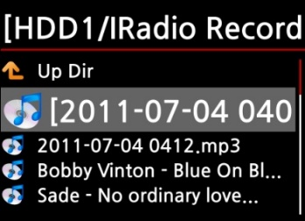

13-1-4-4. How to edit the recorded file

You can edit the recorded file easily with the file management function. Place the cursor on the recorded file and press the MENU button to run the following functions:
[ TAG Edit ]
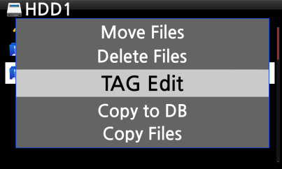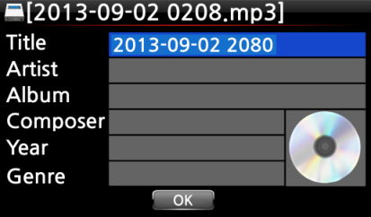

[ Import to DB ] [ Copy File ] [ Move file ]
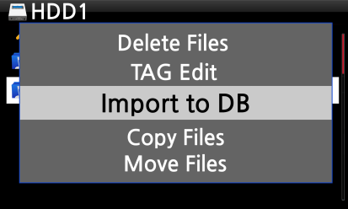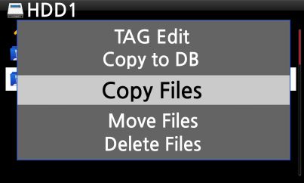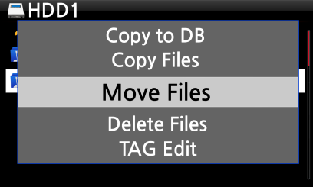

13-1-5. Reservation Recording
This function works for the stations stored in Favorites folder.

13-1-5-1. How to set reservation recording
- Open ‘Favorites’ folder of Radios.
- Place the cursor on the station you want to set
- Press MENU key to open menu window like left.
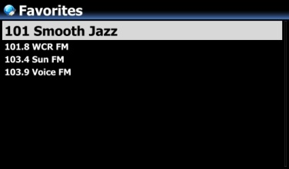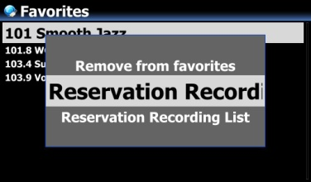

- Input date, time, etc on the setup window like left
- Confirm it with OK key
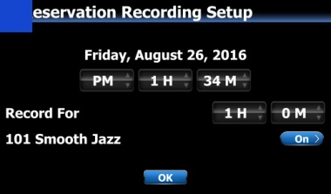
※ To check if Reservation Recording Setting is well done, press MENU key at the Favorites list, and select Reservation Recording List to show recording list like left.
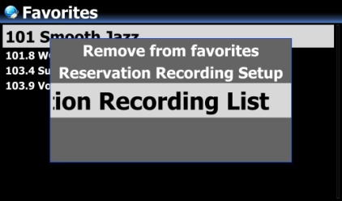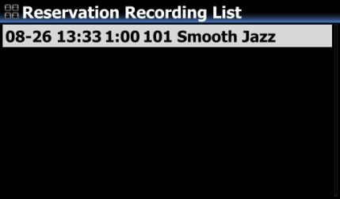

※ The station set as 'reservation recording' will be listed like left picture.
■ Aug 26th, 13:33 ------> Recording start
■ 1:00 -------> It will record for one hour.
■ 101 Smooth Jazz -------> Station name
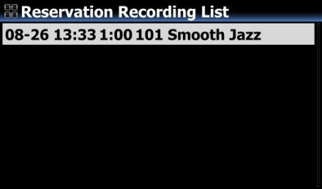

13-1-5-2. How does the reservation recording start

- In case that you powered X45 off after recording setting (e.g. 4:00PM / record for 3 M )

- X45 will start booting up automatically at 3:57PM (3 minutes before set time 4:00PM)
- X45 will start playing the station at 3:59PM (1 minute before set time 4:00PM). Volume is set as ‘Mute’ automatically.
- X45 will start recording the station at 4:00PM and keep recording until 4:03PM.
- X45 will power off automatically by itself as soon as it finishes recording at 4:03PM.

2) In case that you keep X45 powered ON after recording setting (e.g. 4:00PM / record for 3M ).
- X45 will stop current job (playing) and start playing the station at 3:59PM (1 minute before set time).
- X45 will start recording the station at 4:00PM and keep recording until 4:03PM.
- X45 will stop recording at 4:03PM and keep playing the station continuously.

※ Set for multiple stations

You can set reservation recording for multiple stations. But, set time must NOT overlap each other. Of course, you have to consider needed time for each activity described above (How to work). If you do not give interval enough for each station and each activity, this function will not work properly. (e.g. You set recording at 4:00PM, and you powered off X45 at 3:58PM)

※ NOTE: The recorded file will be stored in the ‘IRadio Recording’ folder of hard disk. You can see it through ‘Browser’. You can edit the recorded file with the Tag Edit function.

- FM Radio

14-1. How to play FM Radio

※ NOTE: Make sure to install the FM Radio antenna properly first.
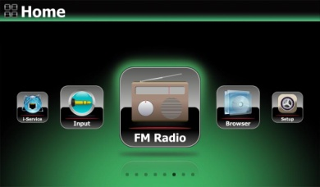
- Select one station and confirm it with OK key.
- It will start playing as below.
- Select FM Radio icon to start FM Radio
- X45 will seek all stations available

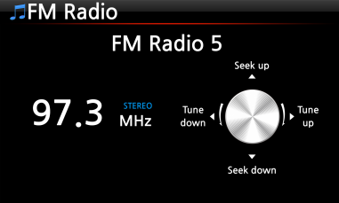
※ NOTE: On the playing screen like above, you can do fine tuning with the arrow (UP/DOWN) keys, and seek station with the arrow (LEFT/RIGHT) keys.

- NOTE: In countries where RDS is available, you may see station name info and text data info in the red square.

- NOTE: Place the cursor on the station list screen, and press MENU key to show up POPUP menu as below.

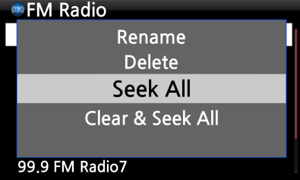
You can run useful functions like Rename, Delete, Seek All, Clear & Seek All

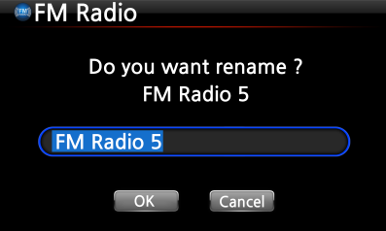
The left screen is for renaming the station

14-2. How to record FM Radio
- When playing FM radio, press REC key on the playing screen to start recording.
- To stop recording, press STOP button of remote control.
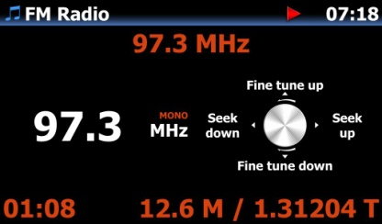
<NOTICE> It will be recorded as WAV format with 44.1Khz

- NOTE: The recorded files will exist in 'FM Radio' folder of 'My Recording' folder in HDD. You can edit the recorded file. Refer to 13-1-4-4. How to edit the recorded file (Page 101).

- DAB+

15-1. How to play DAB+

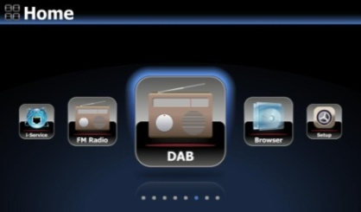
- Select DAB icon to start
- X45 will seek all stations available like below screen
<NOTICE> DAB signal is affected very much and easily by neighboring obstacle like wall. So, you need to remove surrounding obstacle to receive DAB signal better.
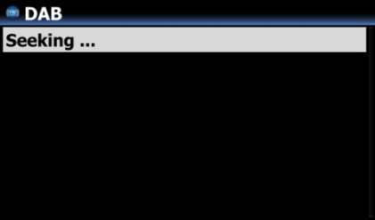

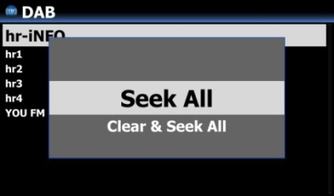
※ If you want to re-scan, press MENU key on the station list. And, select 'Seek All'
- Select a station you want to play, and confirm it with OK
- It will start like left
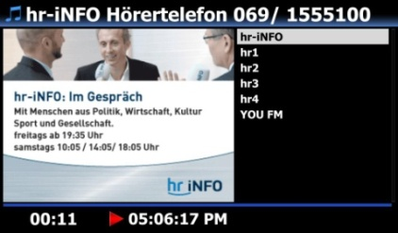

15-2. How to record DAB+
How to record DAB+ is exactly same as FM Radio recording. Please refer to 14-2. How to record FM Radio(Page 104)

15-3. To display more information on DAB+ station
On playing screen of DAB+ station, If you press INFO key of remote control, the screen will show various information like below.
-. Line 1/2/3 : Ensemble, Station name, Program type
-. Line 5/6 : Bitrate, Quality level(Over 80%: Green, Over 50%: Yellow, Below 50%: Red)

- USB host port for USB devices

You can use various USB devices like USB memory stick, MP3 Player, USB external hard disk, etc with the USB host port of X45.
      - Plug the USB device into the USB host port of the X45.
      - Go into the Browser screen. The USB device appears in the browser screen as shown below.

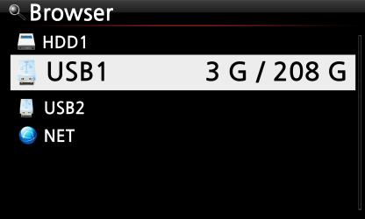

- Browser

If you go to the Browser icon, you can run the following functions.
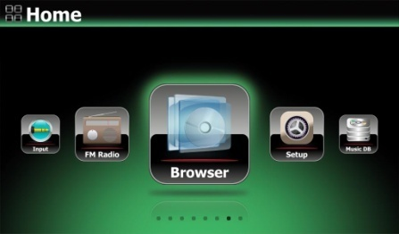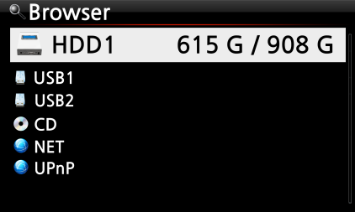

17-1. Play audio file data CDs

The X45 supports data CDs with recorded audio files. The X45 supports various audio files such as; DSD, MQA, ISO, APE/CUE, HD FLAC, HD WAV, MP3, FLAC, WAV, CAF, WMA, M4A, AAC, ALAC, AIFF, AIF, Ogg Vorbis, PCM, PLS, M3U, etc.

- Insert the data CD into the X45. ② Select the Browser icon and confirm with the OK button. You will see the data CD. Select the music you would like and play using the OK button.

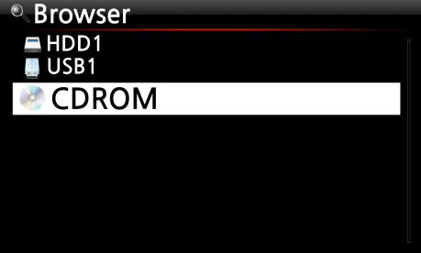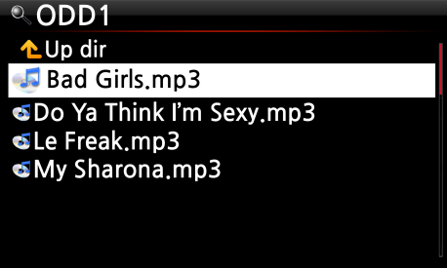

17-2. File Management function

17-2-1. Accessing information on the HDD, USB, folder or file.

Place the cursor on each drive and press the INFO key. The information is displayed as shown below.
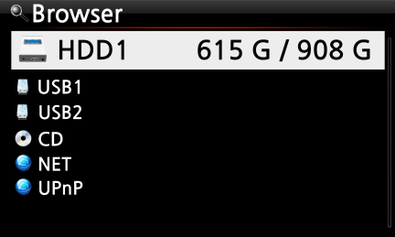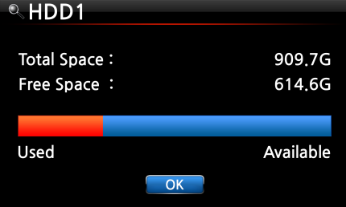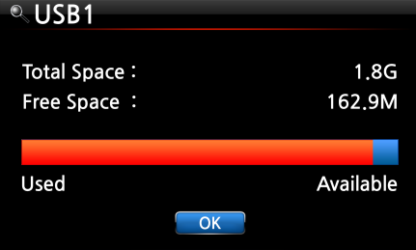

To check the information folder, place the cursor on the folder and press the INFO key.
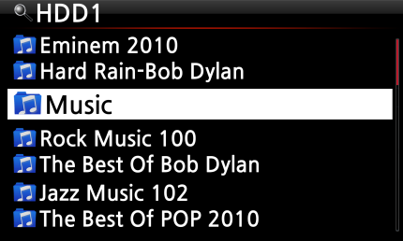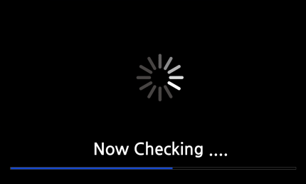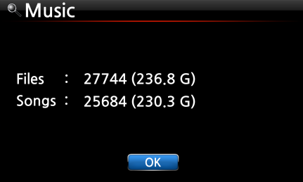

To check the information on a file, place the cursor on the file and press the INFO key.
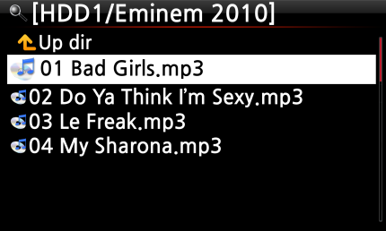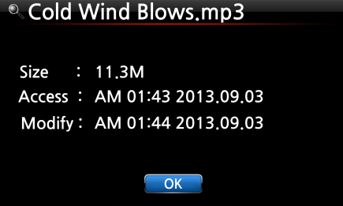

To check the information of a ripping / converting result, place the cursor on the album and press the INFO key.
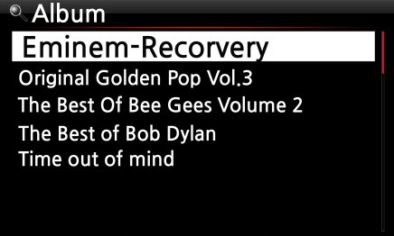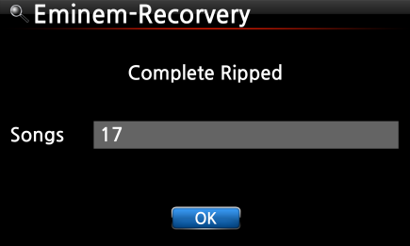

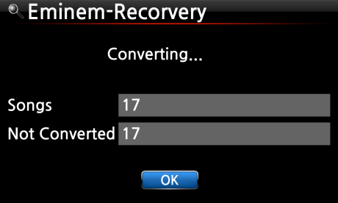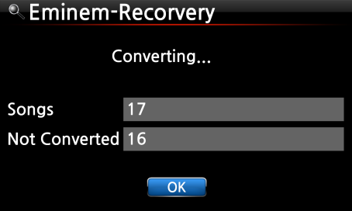

17-2-2. TAG Edit

This function is only valid for files not for folders or disks.
Place the cursor on the file you would like to edit and press the MENU key. Select Edit Tag and the edit screen is displayed, see below.

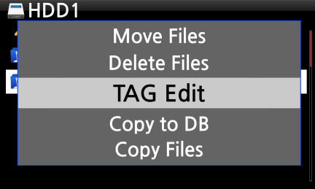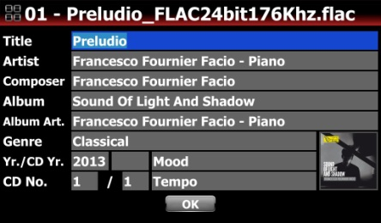

17-2-3. Copy Files

You can copy files or folders by following the procedure below:
- Place the cursor on the file or folder you would like to copy
- Press the MENU key and select Copy Files. The screen below is then displayed.
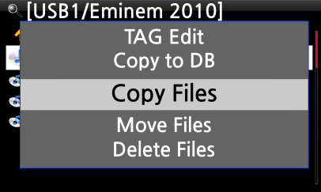

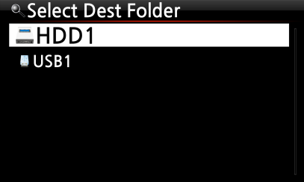
From here, refer to 7-3-4. How to export music from the Music DB to other storage devices (Page 87), as the procedure is exactly same.

17-2-4. Move Files

You can move files or folders using the following procedure:
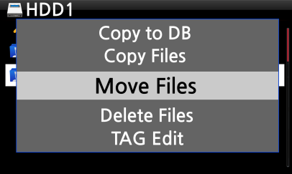
- Place the cursor on the file or folder you would like to copy
- Press the MENU key and select Copy Files. The screen below is then displayed.

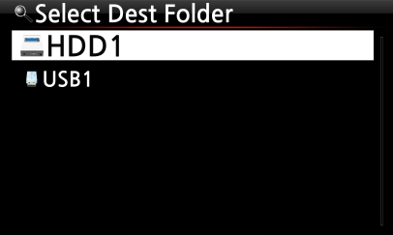
From here, refer to 7-3-4. How to export music from the Music DB to other storage devices (Page 87), as the procedure is exactly same.

17-2-5. Delete Files

You can delete file or folder using the following procedure:
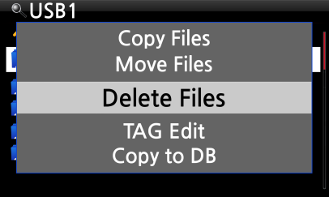
- Place the cursor on the file or folder you would like to delete
- Press the MENU key and select Delete Files. Confirm with the OK button to start deleting.

17-2-6. .PLS or .M3U files with Internet radio stations

If you wish to play an individual internet radio station using the X45, you will need to create a PLS or M3U file and put the file(PLS or M3U) onto the storage or USB host of the X45. Once you have created the file you can play the station through the X45 Browser, see example below.

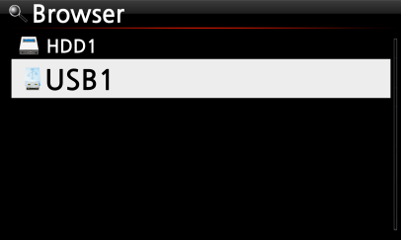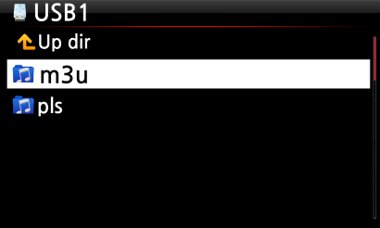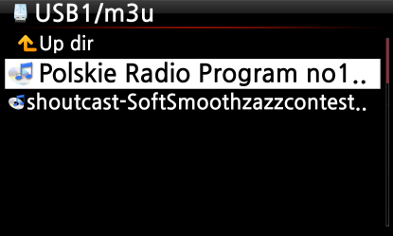

17-2-7. Convert Audio Format

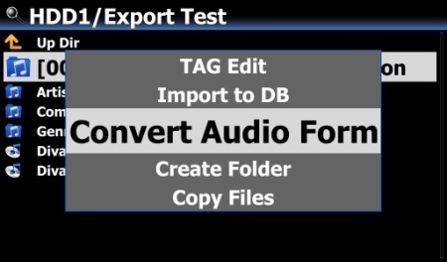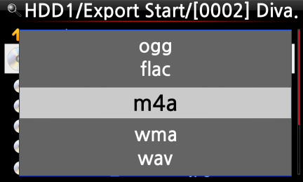
※ This function works on Browser mode only.
- If you want to convert the format of tracks in the Music DB, export them into a certain place of hard disk on the Browser with the 'Export Songs' function.
- Place the cursor on the file or folder, and press MENU key. (※ With RIGHT ARROW key, you may select multiple song files)
- Select 'Convert Audio Format'. The format option like m4a, wma, wav, mp3, ogg and flac will show up.
- Select one format to start converting.
- One folder with the same name as the selected format will be created automatically.
- The converted song files will be stored in the folder.

17-2-8. Cut the recorded file (Cut ‘Playing Section’)

- NOTE: This cutting function works on Browser mode only.
For example, you recorded iRadio like left screen.
① If you go into 'IRadio Recording' folder of HDD1 via Browser, there will be the recorded file (FM - Start It Up.mp3 )
② Play the file
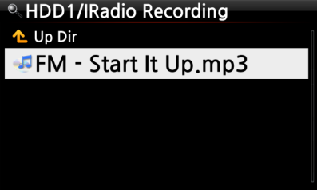

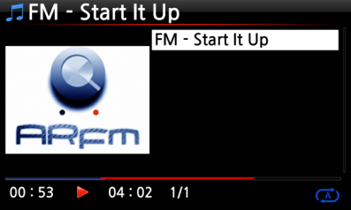
- Set 'Playing Section' as mentioned on 7-3-7. Set ‘Playing Section’ to play it repeatedly (Page 89)

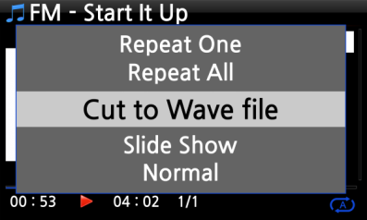
④ Press MENU key to show up POPUP
⑤ Select 'Cut to Wave file' and confirm it with OK key

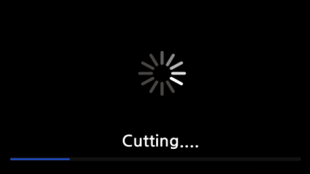
⑥ Progress message

⑦ Go into 'IRadio Recording' folder. There will be same name of Wave file.
※ If you cut a Wave file, serial number will be added at the end of the file name.

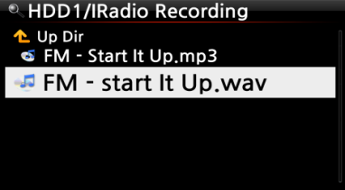

17-2-9. Create Folder

Via this function, you can make a folder in the Browser as you want.
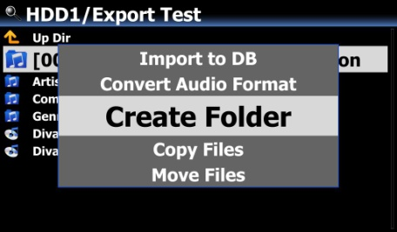
① Go to inside of HDD or USB
② Press MENU key to open menu popup
③ Select 'Create Folder' and confirm it with OK
④ Left screen will show up. You can put folder name and confirm it with OK
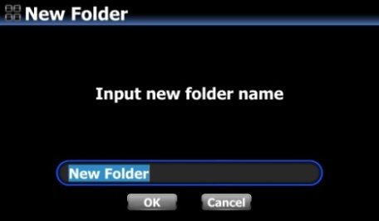

- Input

18-1. How to play an external device via Input

As the X45 has various Input connectors like AUX In, Analog IN, Phono IN and Digital IN (Toslink and COAXIAL), you can connect external devices like TV, player, turntable or etc to the X45 and record the audio (signal) coming from outside device.
- Connect external device to the X45.

- NOTE: When connecting external device to X45, be careful to connect both devices via proper connectors and cables.
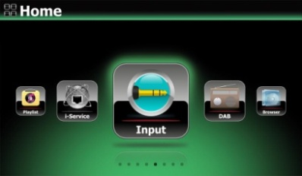

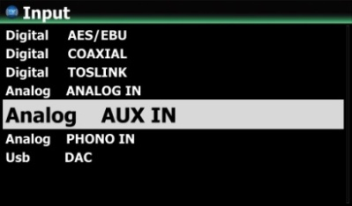
- Play the external device.
- Select the proper input and confirm it with OK key

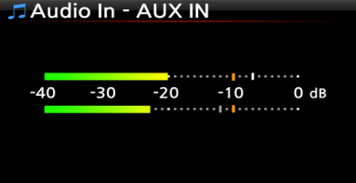
Now playing.

18-2. How to record
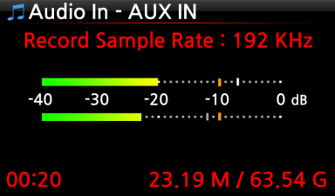
While playing music through the Input of the X45, press the REC button to start recording the music playing, see screen shot to the left. Press the STOP button to stop recording.

※ NOTE: Explanation
1) Record Sample Rate: 192KHz: This is decided according to the setting of the Recording Sample Rate at SETUP.
2) 00 : 20 : Recording time
3) 23.19 M / 63.54 G: File size of the recording file / Total size of the storage

※ Recorded file information according to the Recording Sample Rate
＊1) Recording Sample Rate | Recorded File
＊1) Recording Sample Rate | Size/Recording time | Sample Rate | File name structure | Format
48KHz | 691MB/1 Hour | 48KHz | Year-month-date-time | WAV
96KHz | 1,383MB/1 Hour | 96KHz | Year-month-date-time | WAV
192KHz | 2,767MB/1 Hour | 192KHz | Year-month-date-time | WAV
＊1) Recording Sample Rate : You can set as you want at SETUP

18-3. Where is the recorded file stored ?

If you start recording, the X45 creates the folders automatically where the recorded files are stored.
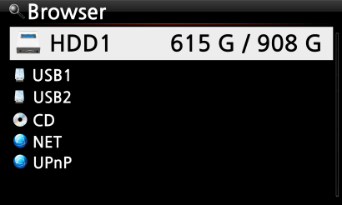
- Select Browser icon on the home screen, and confirm it with OK key.
- Select HDD1 and confirm it with OK key

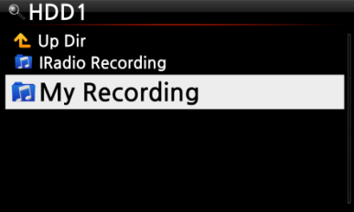
- Select Browser icon on the home screen, and confirm it with OK key.
- Select HDD1 and confirm it with OK key
- There will be folders like ANALOG IN, AUX IN, FM Radio, TOSLINK, PHONO IN
- Select proper folder and confirm it with OK key to see the recorded file.
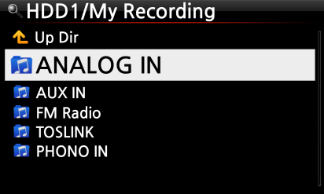
- NOTE: The folder will be named according to the Input for recording.
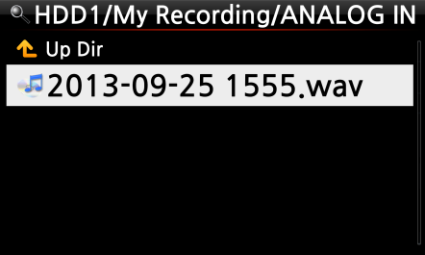

18-4. How to edit the recorded file
- Place the cursor on the Recording folder (like ANALOG IN, AUX IN, FM Radio, TOSLINK, PHONO IN, etc) or on the recorded file in the folder, and press the MENU button.
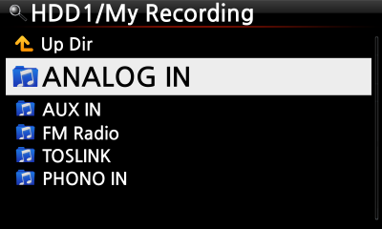
- Select TAG Edit and confirm with the OK key, the edit screen will be displayed as follows.

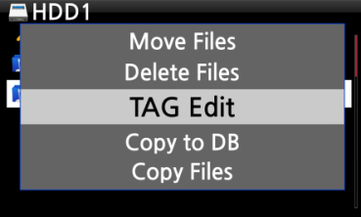
- Put the Title, Artist, Album, Composer, Year or Genre. If you put same album name into each recorded file, all files which have the same album name will be sent(imported) to the same folder (album) in the Music DB when you try ripping (loading) the edited files to the Music DB.

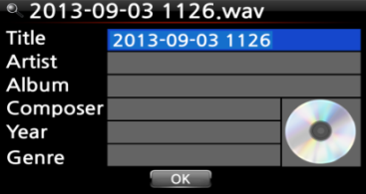
- The edited file name will be changed to [Album name]+Title

18-5. How to use X45 as USB Digital-to-Analogue Converter (DAC)

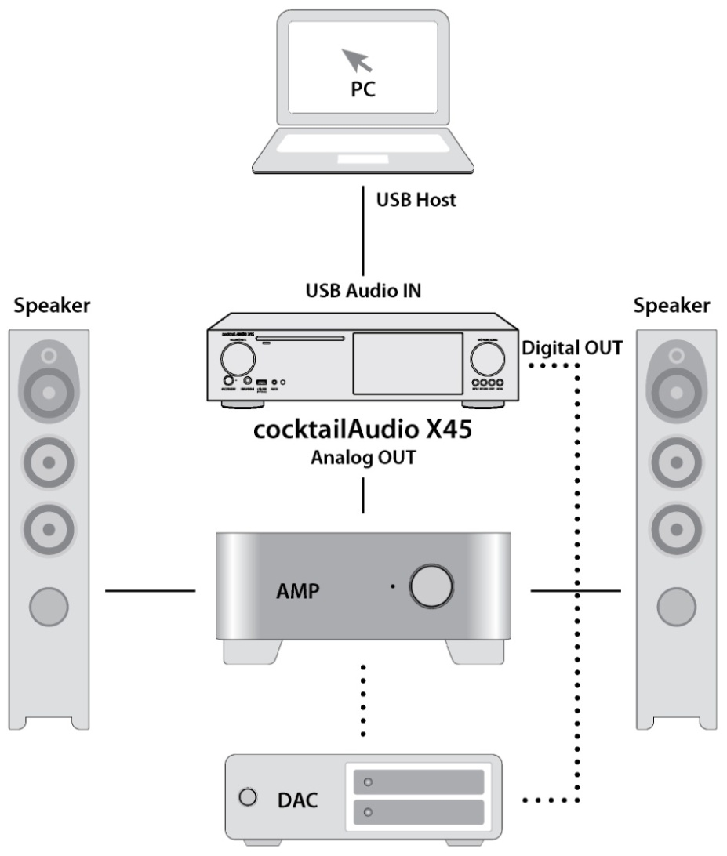
- Install USB Audio 2.0 Driver Software to your Windows PC(Refer to 2-4 on page 30)
- Install a special software(Player) like foobar2000 if you want to play DSD file in your PC(Refer to 2-4 on page 30)
- Connect X45(USB Audio IN) and your PC(USB Host port) via USB cable
- Remaining procedures will be understood easily

※ NOTICE
(In case that 352.8Khz and 384Khz files goes into X45 via its USB Audio Input and goes out via its Digital Outputs, there may be some noises. So, we recommend that you should not use X45 digital outputs when using X45 as USB DAC

- Extra Function

19-1. Volume Balancing
- On the playing screen, press VOL BAL key of remote control to open the screen for volume balancing setting

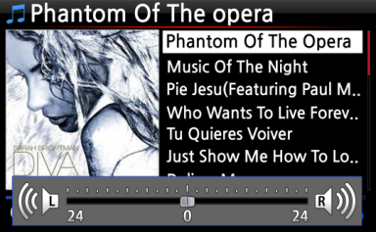
- On the screen of volume balancing setting, you can control Left/Right volume level using the arrow key (LEFT/RIGHT)
- After setting, you may save and exit using any key

19-2. External Screen
If you want to use an external screen like TV, monitor, etc as a bigger screen for X45, please connect external screen to X45 HDMI Out.
※ Default : Both of Internal LCD and HDMI Out are all activated.
※ From Default setting, pressing SCREEN key will change mode like below
Default ----> Internal LCD only -----> HDMI only -----> Default
※ X45 will remember last setting when it is powered off


19-3. Photo Slide Show
- Prepare photo file in the storage of X45 or in USB.
- While playing music, press MENU key on the Playing Screen to popup menu list like below.
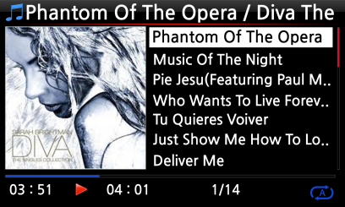
- Select Slide Show and confirm it with the OK key.
- You will be guided to select photo file.
- Select the 1st photo file and confirm it with the OK key. Then, the slide show will start based on all photo files in the same folder.

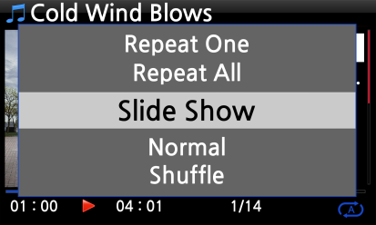

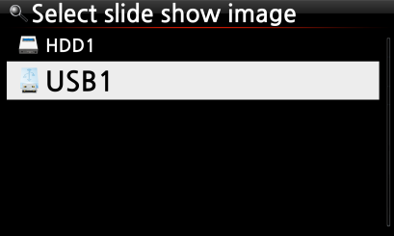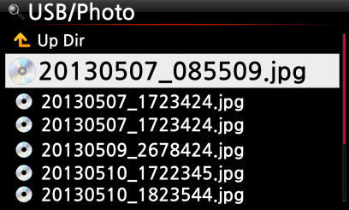
※ NOTE: You can set ‘Slide Show Effect’ and ‘Slide Show Time’ at SETUP
19-4. Listing by Text or Album cover art

You can list up all information (like album, title, genre, artist, etc) on the screen of X45 by text or album cover art. You can select one of text mode and album cover art mode easily using TEXT/ART button of remote control.

[ Text mode ] [ Small album cover art ] [ Big album cover art ]
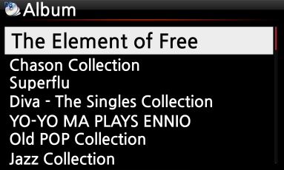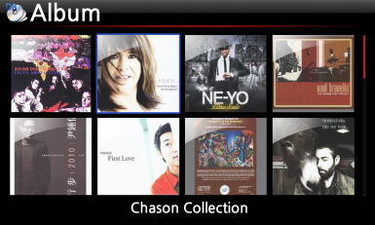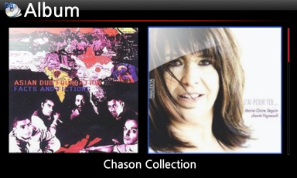

19-5. LYRICS

The LYRICS function is used to display lyrics on the screen during playing in the case that the song playing has lyrics file (.LRC file).
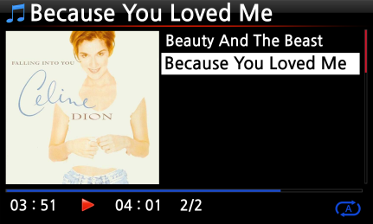
- On the playing screen, press LYRICS button of remote control. The lyrics will be displayed as below.
- Press LYRICS key again to go back to the playing screen.

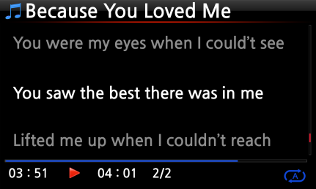
※ NOTE 1: LYRICS function works at Browser mode only, not at Music DB.
※ NOTE 2: If LYRICS is broken on the screen, you need to check OSD language setting and LRC file language

19-6. BOOKMARK

Files can be bookmarked while playing them. This function is useful for long files such as audio books.
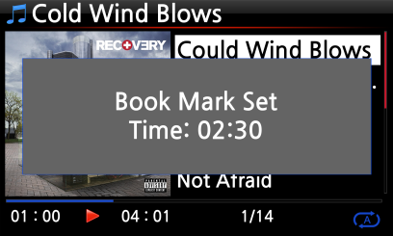
- Press the BOOKMARK button on the playing screen.
- The bookmarked music or story is stored in the Bookmark list as shown below.

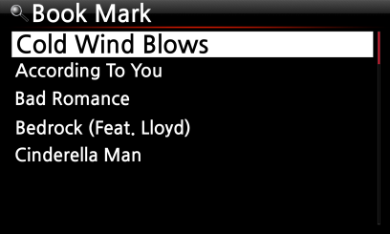
- If you would like to list up the bookmarked music or story, and play it, press the BOOKMARK button on any screen (except playing screen).

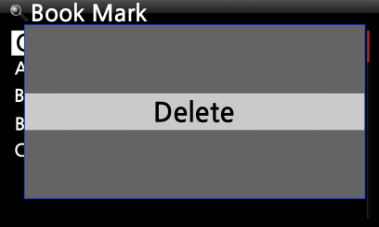
- If you would like to delete bookmarked music or story, press the MENU key on the Book Mark list screen, shown left.
- Select Delete and confirm with the OK button.

19-7. Resume Play

When you boot up the X45, it will automatically resume playing the music in the Music DB, Browser or i-Radio from where it was last stopped.
Select Resume Play and confirm with the OK key.
Set it as ON as shown left.

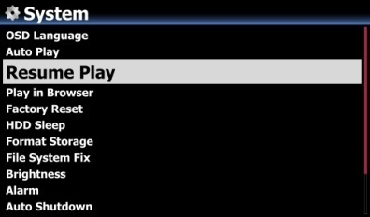
※ Default is OFF
【 TIP 】
- This function does NOT work in the case that the ‘Alarm’ function or ‘Auto Play’ function is enabled.
- Function priority : Alarm function ---- Auto Play function ----- Resume Play function

19-8. CLOCK and Display (LCD) OFF

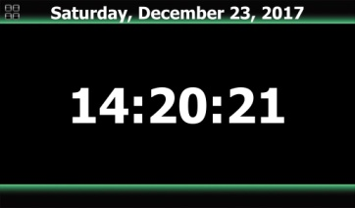
Whilst playing, press the CLOCK button. The digital clock will be displayed, see left. And, press it once again, the LCD will be OFF like below. This function is useful when you are listening to music at night as the light from the screen is reduced. Exit from LCD OFF mode by pressing if any button on the remote control.


※ LCD OFF mode

19-9. Changing the play mode
- Press the MENU button on the playing screen to change the playing mode.
- Alternatively, press the SHUFFLE button to change the mode without using the popup menu.
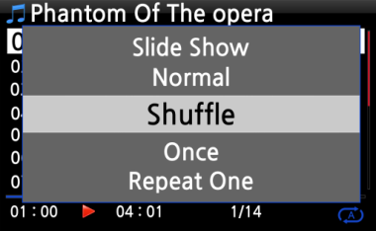

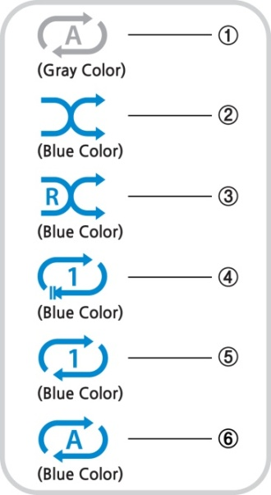
- Normal: Play all the music in an album or in a folder at once in sequence.
- Shuffle: Play songs randomly, but any song will not be repeated.
- Random: Play songs randomly, but a song may be repeated
- Once: Play the current music once only.
- Repeat One: Play the current music repeatedly
- Repeat All: Play all music in an album or in a folder in sequence and repeatedly

19-10. Alarm set

You can set six (6) alarm settings on the X45.
- Go to Alarm at SETUP, and confirm it with the OK key.
The following screen will appear.
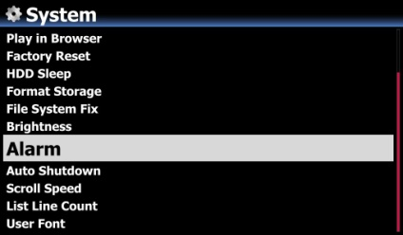
- Select the line you require and press the OK button.
The following screen will appear.
※ NOTE: The time should be set minimum 10 minutes later than current time.

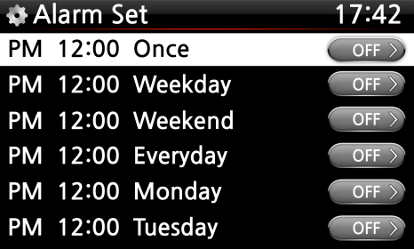
- Set time, cycle and sound source.
- Set Snooze ON.
- Select OK and confirm it with the OK button.

- Selecting time with up/down button.
- Selecting cycle with OK button
- Selecting sound source from Playlist or iRadio (My Favorites)
- Selecting snooze ON/OFF

- NOTE:
A : Alarm
2 : Two
D : Day
Alarm is set as ‘after 2 days from now’.
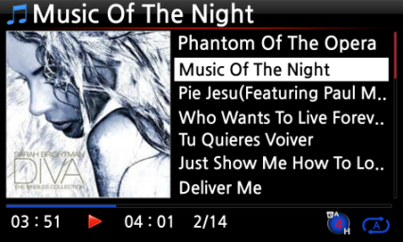

19-11. Auto Shutdown
The X45 will power off automatically at the assigned date and time.

※ NOTE: Refer to section 4-7-14 Auto Shutdown (Page 64) for detailed explanation.
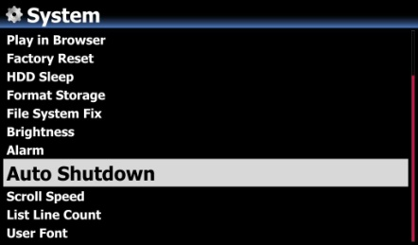

19-12. Sleep mode

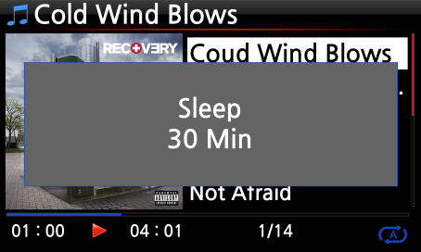
- Press the SLEEP button on any screen (except setup), the popup Sleep Off/Sleep 10Min/Sleep 20Min/Sleep 30Min/Sleep 1Hour/Sleep 2Hour/Sleep 3Hour is displayed.
- The X45 will be set as per the last popup

- NOTE:
S : Sleep
56 : Fifty six
M : Day
After 56 minutes, it will go into Sleep mode (power off).
- NOTE: Sleep icon will show up after setting.
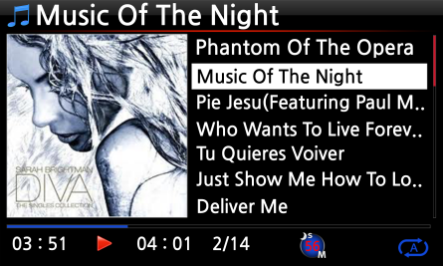

19-13. Auto Play

When the power is ON, Auto Play function allows the X45 to boot up and start playing automatically the song in the Auto Play folder in the Playlist on the home screen.
- Navigate to the Playlist to Auto Play.
- Place the cursor on Auto Play and press the MENU button.
- Select Add Song and press the OK button.
- Place cursor on the music you would like to Auto Play.
- You can see plus (+) mark at the end of the cursor. Press the OK button. The music will disappear and be added to the Auto Play.
- Go to Setup and set Auto Play ON.

※ NOTE: Default of Auto Play in SETUP: OFF
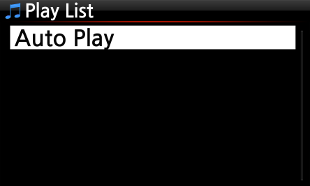

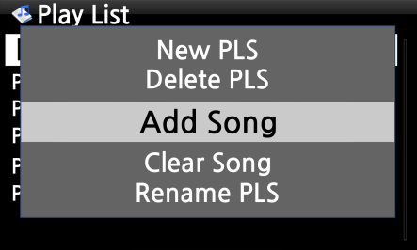

19-14. Shortcut to find files in all list modes

On each list mode if you press an alphabet key on the remote control the cursor will jump to the first file will that character at the beginning.

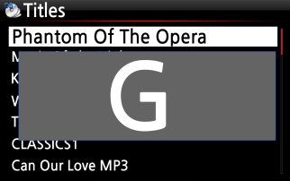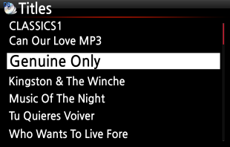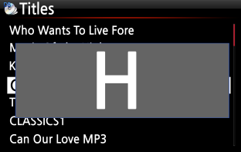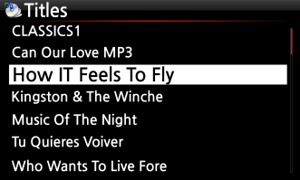

19-15. Seek function on the Playing Screen

At the playing screen you can run a seek function by pressing numeric keys on the remote control. For example, if you press the 5 key while playing a file it will start playing from the 50% position of the file based on total playing time.

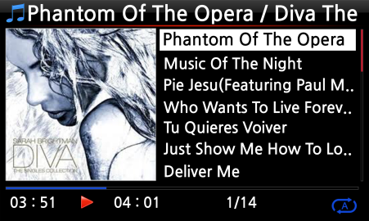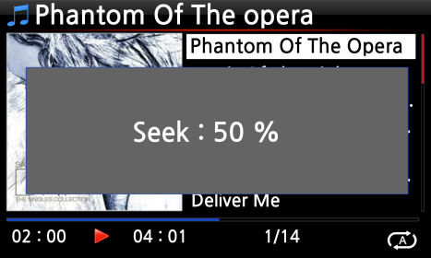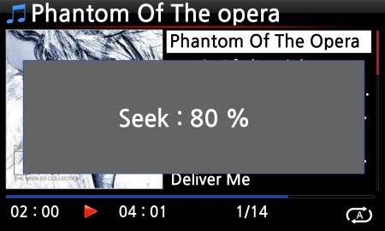

19-16. Function of Multi-Cutting(Auto-Cutting) for recorded file
You can record iRadio of X45. Otherwise, you may have a file recorded by other devices like X40. With this new function, you can cut the file into each track by auto or by manual. To understand this function, you need to understand each key's function well by reading this manual very carefully.
※ NOTICE: This function works in Browse mode only for most of file format, except for DSD file. But, after running this function, all tracks (files) cut will be 'WAV' file format.

19-16-1. How to set 'cutting point' by auto
① Look for recorded file in Browse mode and place the cursor on it
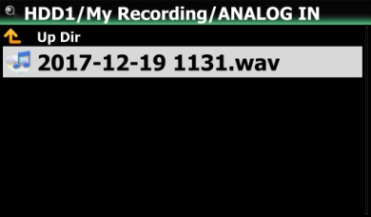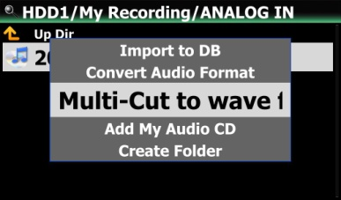

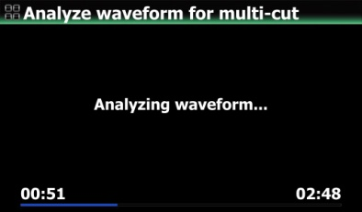
② Press MENU key and confirm 'Multi-Cut to wav...' to start analyzing waveform of the file.
There are four(4) spins to set 'cutting point'.
※ Press MENU key to toggle Enable/Disable for these spins
※ Role of each spin
-. -35 dB: to set max dB value for auto cutting.
Scope settable: -30dB~-40dB
-. 4.0 Sec: to set duration for the above max dB value.
Scope settable: 0.1 ~ 5 Sec
※ For example, if you set -35dB and 4.0Sec, 'cutting point' will be created automatically at the points where volume level -35dB below and the volume level(-35dB below) lasts for over 4 seconds
-. 1 X: to zoom graph by 1X, 2X, 4X, 8X, 16X ~ 128X
-. 1 Sec: to set 'seek time' unit when moving 'playing point' by LEFT/RIGHT arrow key. Scope settable: 0.1~30 sec
-. 1/2/3/4/5: Number of track which will be cut
-. Vertical green line: Cutting point
-. Vertical blue line: Current playing point
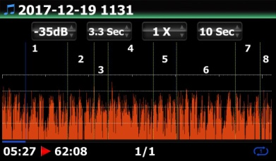

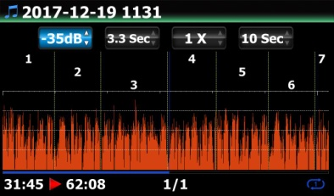

19-16-2. How to set 'cutting point' by manual

① You have to disable four(4) spins.
② You can seek cutting point you want by LEFT/RIGHT key
(For this job, you can set 3rd spin and 4th spin properly)
③ You can set 'current playing point' as 'cutting point' by pressing UP arrow key
④ By pressing DOWN key, you can remove 'cutting point' within 10 sec and closest to 'current playing point'.

19-16-3. How to start cutting
① Set cutting points properly according to the above procedure
② Press RETURN key, then it will ask 'OK' or 'Cancel' like below
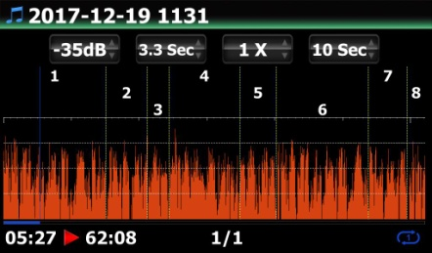
③ Select OK and confirm it. Then, it will start cutting like below
※ If you confirm 'Cancel', it will go back to 'Playing Screen'
※ If you press RETURN key, it will go back to 'Multi-cut screen'
④ To see cut tracks, go to the same folder where original file is
⑤ There will be one folder whose name is same as original file
⑥ There will be five(5) cut tracks in the folder like below.

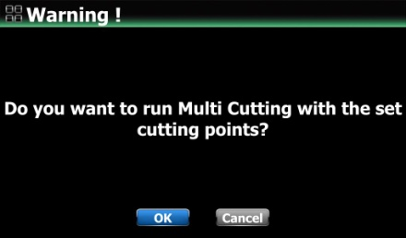

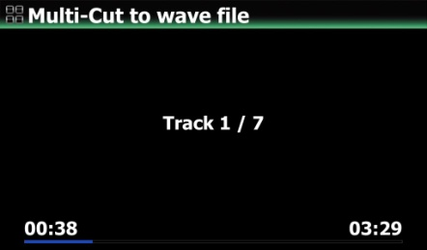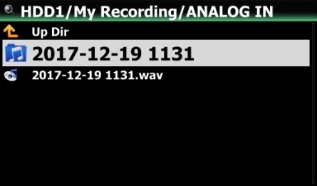

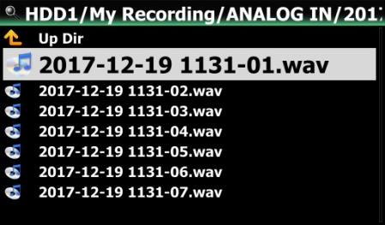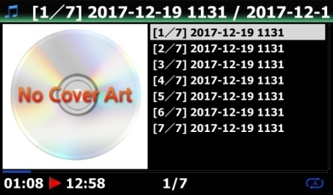

19-16-4. Role of each key on 'Multi-Cut Screen'

1) All keys of remote control except for VOL BAL, VOL+/-, PAUSE/PLAY, SETUP and POWER don't work
2) MENU key: to toggle Enable/Disable for four(4) spins
2-1) When Spin is enabled
<Buttons on the front of X35 unit>
-. OK: to go to next spin
-. JOG spinning: to up/down spin value
-. MENU: to disable Spin

<Keys of remote control>
-. OK: to go to next spin
-. LEFT/RIGHT: to move Spin to left/right
-. MENU: to disable Spin

2-2) When Spin is disabled
<Buttons on the front of X35 unit>
-. OK: to toggle Play/Pause
-. JOG spinning: to seek 'current playing point' by the value of forth Spin
-. JOG spinning with JOG pressed: to seek 'cutting point'
-. MENU: to enable Spin

<Keys of remote control>
-. OK: no working
-. LEFT/RIGHT: to seek 'current playing point' by the value of forth Spin
-. UP: to set 'current playing point(vertical blue line)' as 'cutting point(vertical green line)'
-. DOWN: to remove the cutting point within 10 seconds and closest to the current
playing point
-. MENU: to enable Spin

2-3) Regardless of Spin Enabled or Disabled
-. INPUT on the unit: t to set 'current playing point (vertical blue line)' as 'cutting
point (vertical green line)'
-. STOP on the unit: to remove the cutting point within 10 seconds and closest to the
current playing point
-. NEXT/PREVIOUS of remote control: to seek 'cutting point' to right/left
-. -15/+15 of remote control: to work just as original role
-. CAP/NUM of remote control: to toggle 'Seek to percent mode' or 'Jump to track mode'
of the numeric keys.
-. Numeric keys of remote control
* in 'Seek to percent mode': to seek by 0%, 10%, 20% within current displaying area
* in 'Jump to Track mode': to seek to starting point of each cutting area

19-17. Audio CD burning function

You can burn Audio CD with X45 like below

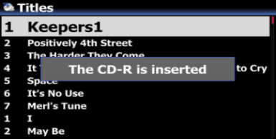
① Insert empty CD-R to CD drive on any screen
② Wait until media detection message comes out like left screen

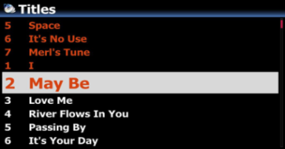
③ Look for target files(tracks) and place the cursor on the target file
※ On the file(track) list, press RIGHT arrow key to select multiple files

④ After selecting files, press MENU key and confirm 'Add My Audio CD' to send selected files(tracks) into 'My Audio CD' folder

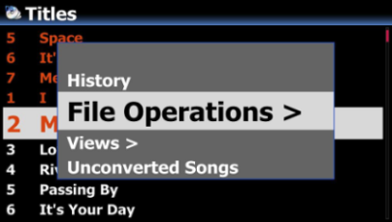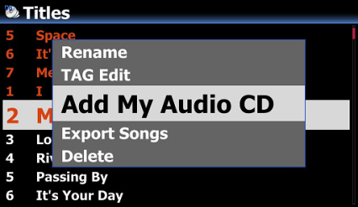
⑤ Selected files will start copying to 'My Audio CD' folder in the storage set as MusicDB storage

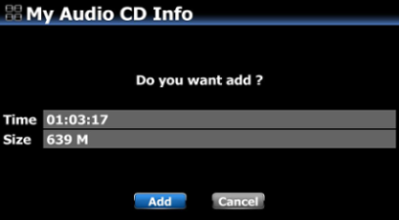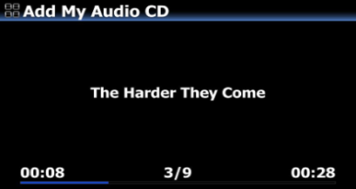
⑥ Go to Browser and look for 'My Audio CD' foler.(There will be WAV files in the folder)
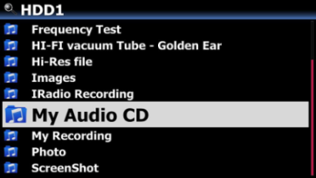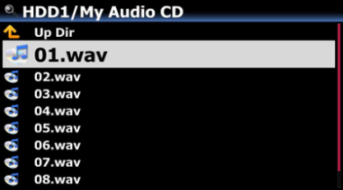
⑦ Place the cursor on the 'My Audio CD' folder, and press MENU key to select and confirm 'Burn My Audio CD' to start burning

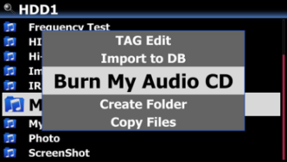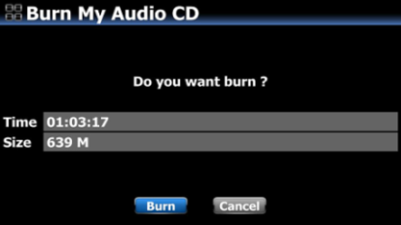
※ NOTICE: For next Audio CD burning and inserting new track, you have to make 'My Audio CD' folder empty.
19-18. Function of Jump to a song on Playing Screen
We added 'function of Jump to a Song Mode' on Playing Screen.
Press CAP/NUM key of remote control to toggle 'Seek to Percent Mode and 'Jump to a Song Mode'
* Jump to a Song Mode : Press numeric key to seek a song
* Seek to Percent Mode : Press numeric key to go to a certain playing position.
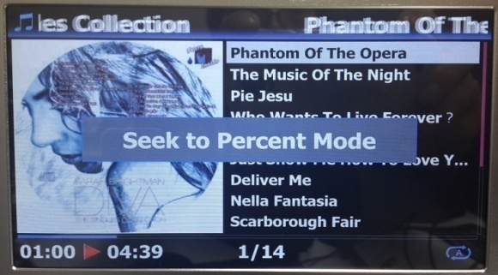

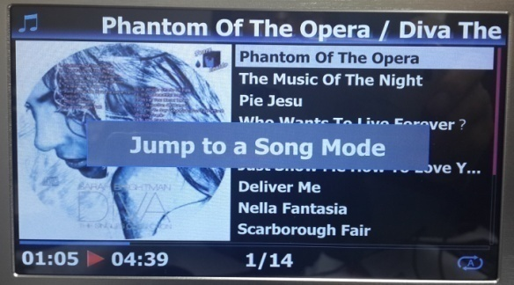

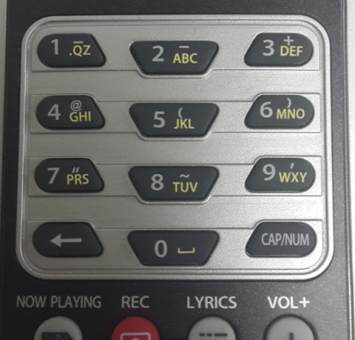

19-19. Multi-room (Group Play)

Multi-room (Group play) function lets you play hi-res music including DSD, MQA and 192Khz/24Bit HD FLAC, WAV seamlessly in any room of the home wirelessly. You can play the same song in every room or play the same song with two devices as Left/Right channel in perfect sync.
※ Multiple devices are required for this function
※ External Inputs like digital/Analog inputs and FM Radio/DAB+ don’t support Multiroom function
- Multi-room supported: MusicDB, Browser (USB storage, UPnP, NAS), CD Play, i-Radio, streaming service like Tidal, Qobuz, etc.
- Multi-room not supported: Digital/Analog Input, Bluetooth Input, FM Radio/DAB+, Roon, Spotify Connect.

19-19-1. File formats and sample rate with which Multi-room (Group Play) function work

File Format |  | Wireless LAN | Wired LAN | Remarks
PCM(WAV, FLAC) | 44.1Khz(48Khz) | OK | OK
PCM(WAV, FLAC) | 88.2Khz(96Khz) | OK | OK
PCM(WAV, FLAC) | 176.4Khz(192Khz) | OK | OK
PCM(WAV, FLAC) | 352.8Khz(384Khz) | OK | OK
PCM(WAV, FLAC) | 768Khz | NO | NO | Not supported
DSD | 64 | OK | OK
DSD | 128 | OK | OK
DSD | 256 | OK | OK
DSD | 512 | NO | NO | Not supported
MQA | 44.1Khz(48Khz) | OK | OK
MQA | 88.2Khz(96Khz) | OK | OK
MQA | 176.4Khz(192Khz) | OK | OK
MQA | 352.8Khz(384Khz) | OK | OK
High-resolution files are reduced to 44.1Khz(48Khz)/16bit for multi-room (group play)

19-19-2. Group Play main menu

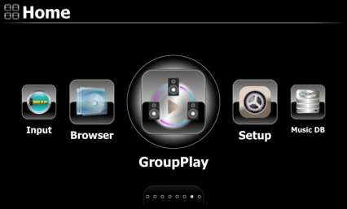
To set for Multi-room (Group Play), click Group Play icon on the home screen to open it

19-19-3. Device name and Host name

Give the device a unique name to easily identify the devices in each zone. The device name for Group Play is linked to the Samba Server Host name

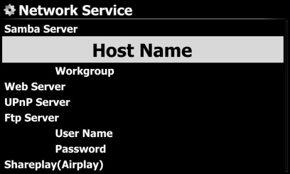
① Go to Setup>Network Service>Samba Server to open 'naming dialog window' for Host Name
② Input name as you want, and confirm it by clicking OK icon

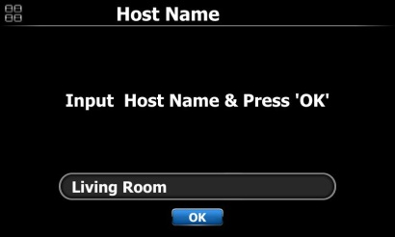

19-19-4. Basic Setup by device

19-19-4-1. How to set a device as server device
You can set a device as Server device
- Go to home screen and click the Group Play icon
- Place the cursor on the 'Group Play Enabled' or 'Group Play Disabled'
- Press OK key to set to 'GroupPlay Enabled'
- Once you start playing song, the device becomes server device
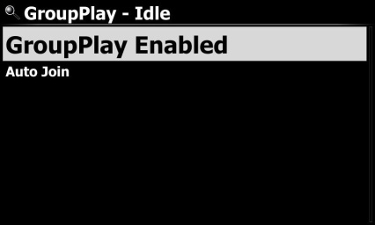

19-19-4-2. Auto Join
You can toggle 'Auto Join' or 'Manual Join' with OK key

If a client device is set to 'Auto Join', the client device will be automatically connected to a Group Play once the server device starts playing
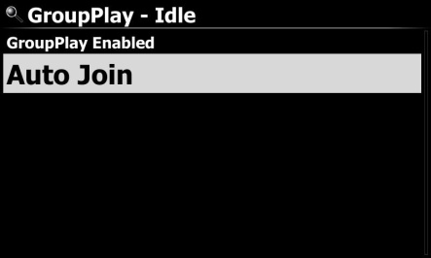

19-19-4-3. Manual Join

If you set ‘manual Join’ on the Client device, you can add the device manually as a client later.

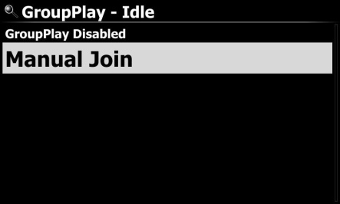
You can toggle 'Auto Join' or 'Manual Join' with OK key
If a client device is set to 'Manual Join', you can add the client device manually to a Group Play after the server device starts playing

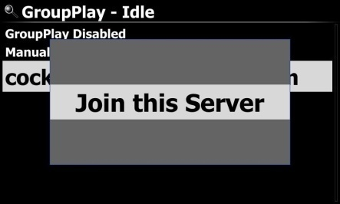
To add a client device manually to a Group Play
- Place the cursor on the server device
- Press MENU key to open menu window and click 'Join this Server'

19-19-4-4. Playing screen

If you play the songs over the Group Play, you can find the playback screen of Server and Client like below.

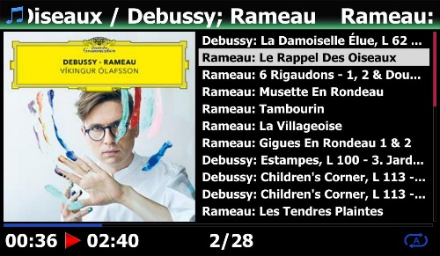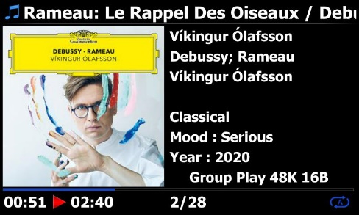
Server device screen Client device screen

19-19-5. Advanced setup by MusicX NEO app

You are recommended to use MusicX NEO app for advanced setup and easy use of Group Play.

19-19-5-1. Look for devices available over a Group Play

Click the 'GroupPlay icon on the MusicX NEO, you can find out all devices available over a Group Play like below screen
For example, you can see the three (3) devices of Living Room, Bed Room, Library like below screen. All three (3) devices are currently in the status of idle
-. Living Room device: This is set as 'GroupPlay Enabled'
-. Bed Room device: This is set as 'GroupPlay Enabled' and 'Auto Join'
-. Library device: This is set as 'GroupPlay Enabled' and 'Manual Join'

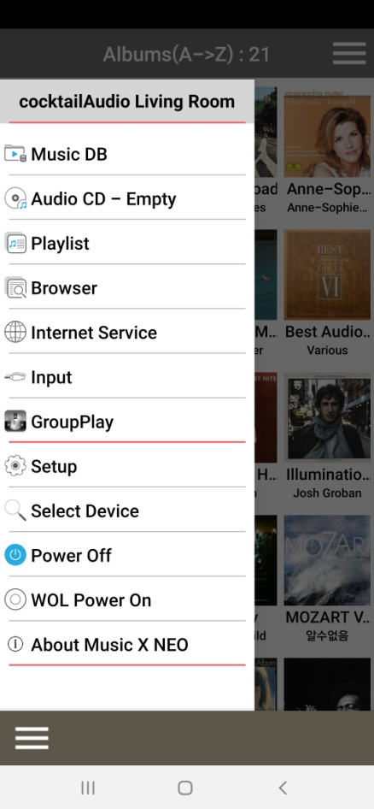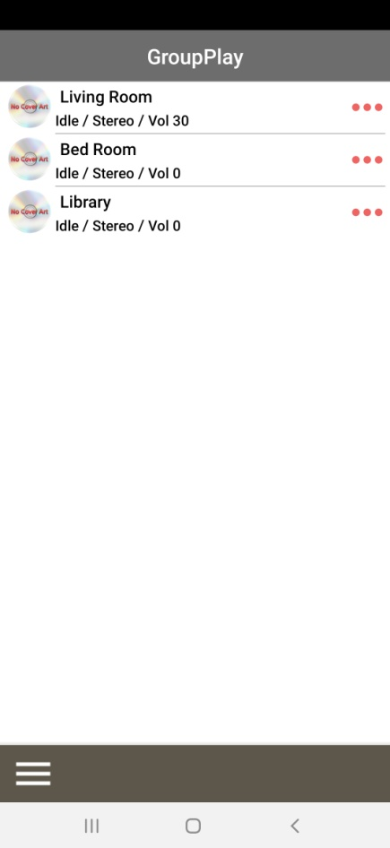

19-19-5-2. Start playing songs to set as server device

Once you play music on the Living room device, the three (3) devices will be like below
-. Living Room device: This will be server device
-. Bed Room device: This will be a client device and automatically joined to the Group Play, because this device is set as 'Auto Join'
-. Library device: This will be still idle, because it is set as 'Manual Join'

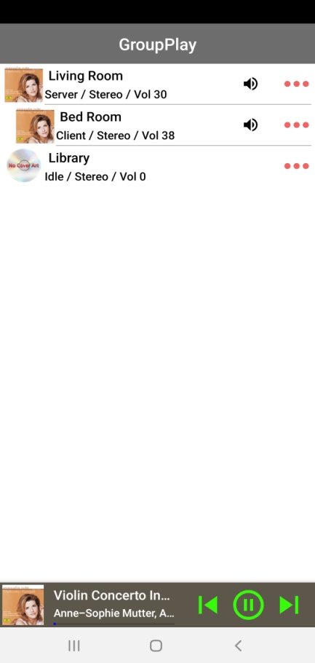
You can add the Library device to the Group Play by Manual Join method
19-19-5-3. How to add client devices to Group Play by manual

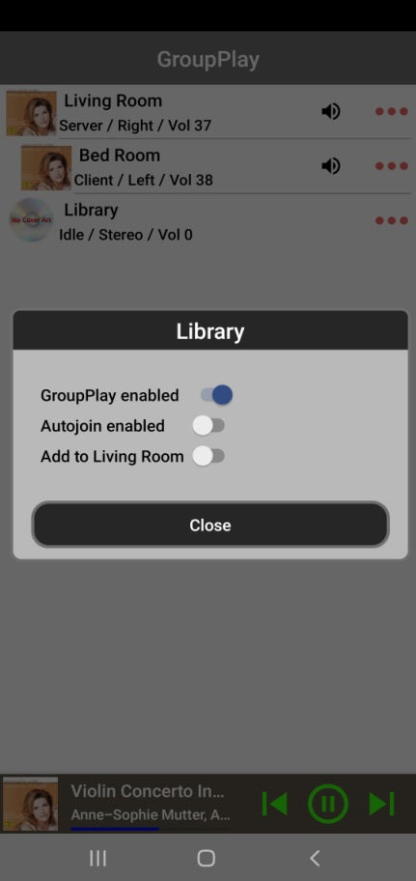
- On the above screen of devices list, tapping the area marked with a square on the screen will pop up the setting window.

- For 'Add to Living Room' on the pop up window, drag to enable to add the Library device into the Group Play as a client

19-19-5-4. Control devices

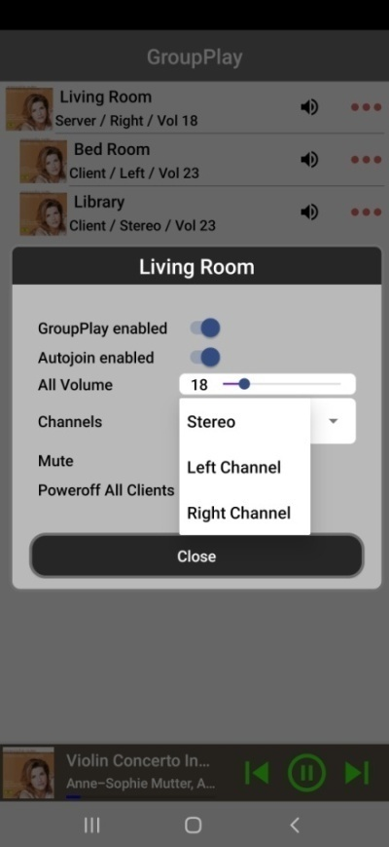
For server device (Living Room)

① Tap the area marked with a square to pop up control window
② You can control volume of all devices including client devices at the same time, and can set channel of the server device as you want like Stereo, Left channel or Right channel. You can also do Mute and power off all clients

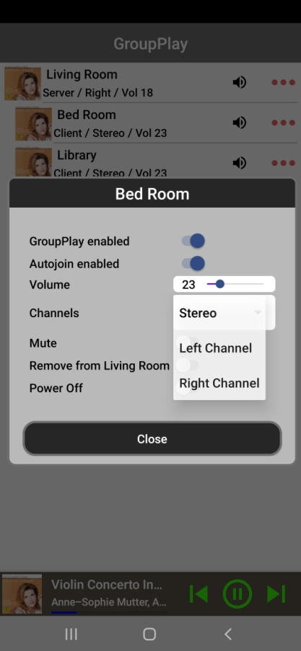
For client device (Bed Room)

① Tap the area marked with a square to pop up control window
② You can control volume of client device, and can set channel of the client device as you want like Stereo, Left channel or Right channel. You can also do Mute and power off the client device
③ Tap the ‘speaker’ icon marked with a vertical square, the tapped device will be muted immediately

- Specification
Model name | X45 |  |  |  |  |  |  |  |  |  | Remarks
Host CPU & Memory | CPU: Dual Core ARM Cortex A9 running at 1.0GHz
Host CPU & Memory | Main Memory: DDR-1066 1GByte
Host CPU & Memory | NAND Flash 8GByte
CD Player | Type |  |  |  |  | Front Loading
CD Player | Supported media |  |  |  |  | CD, CD-DA, CD-R, CD-RW, DVD-R/RW
Display | 7.0" TFT LCD(1,024 x 600pixels)(* able to connect to ext. screen via HDMI out)
Interface | Key & Jog(Volume/Scroll), IR Remote Control, Customized Remote App for iOS and Android devices, Web Interface
Analog Out  (Sabre³² ES9018K2M Dual DAC) | Balanced  (PRE-OUT) |  |  |  | XLR, Dynamic Range: 130dB (Max 4.5Vrms, Stereo) THD +N: 0.0004%
Analog Out  (Sabre³² ES9018K2M Dual DAC) | Unbalanced  (PRE-OUT) |  |  |  | RCA, Dynamic Range: 130dB (Max 2Vrms, Stereo) THD +N: 0.0004%
Analog Out  (Sabre³² ES9018K2M Dual DAC) | Headphone Out |  |  |  | 6.35mm Jack, 100mW+100mW@1Khz, 600ohm, 0.1% THD
Digital out  (Variable/Fixed) | COAXIAL x 1 |  |  |  | S/PDIF 75ohm RCA, Sample rate: up to 24bit/192KHz
Digital out  (Variable/Fixed) | TOSLINK x 1 |  |  |  | S/PDIF, Sample rate: up to 24bit/192KHz
Digital out  (Variable/Fixed) | AES/EBU/XRL x 1 |  |  |  | 110ohm, Sample rate: up to 24bit/192KHz
Digital out  (Variable/Fixed) | USB Audio x 1 |  |  |  | USB Audio Class2.0 Output
Digital out  (Variable/Fixed) | HDMI Out x 1 |  |  |  | HDMI Audio Out(*Shared with HDMI Out for external screen)
Analog Input | LINE In x 1 |  |  |  | L&R RCA at the rear, default 2Vrms(controllable 1~4Vrms)
Analog Input | Aux In x 1 |  |  |  | 3.5mm Phone Jack on the front, default 1Vrms(controllable 0.5~2Vrms)
Analog Input | Phono In x 1 |  |  |  | MM Input, default 7.5mVrms(controllable 3.75~15mVrms)
Digital Input | COAXIAL x 1 |  |  |  | Sample Rate: up to 24bit/192Khz
Digital Input | TOSLINK x 1 |  |  |  | Sample Rate: up to 24bit/192Khz
Digital Input | AES/EBU XLR x 1 |  |  |  | Sample Rate: up to 24bit/192Khz
USB Audio Input  (USB DAC) | USB B type connector, USB Audio Class 2.0 input  (support up to PCM 384Khz/32Bit, DSD Native 256, and MQA file)
Supported Storage | Hard Disk |  | 2.5" SATA, up to 2TB |  |  |  |  |  |  | * Bigger capacity of storage will be supported by firmware update when available in the market
Supported Storage |  |  | 3.5" SATA, up to 8TB
Supported Storage | SSD |  | 2.5" SATA, up to 2TB
TUNER | DAB+/FM Radio |  | Selectable for DAB/DAB+ or FM Radio
Connectivity | USB Host |  | USB3.0(5V/1A) x 2 at rear  USB2.0(5V/1A) x 1 at front
Connectivity | Network |  | Wired |  |  |  |  |  | Giga Fast Ethernet(10/100/1000Mbps)
Connectivity |  |  | Wireless(Option) |  |  |  |  |  | ※ 802.11b/g/n WiFi USB dongle(Option)
Connectivity | HDMI Out |  | Connect to external screen(* Shared with HDMI Audio Out)
Codec & Format supported | MQA, PCM 384Khz/32Bit, DSD(DSD64, DSD128, DSD256), DXD(24Bit/352.8KHz),  HD WAV(24Bit/192KHz), HD FLAC(24Bit/192KHz), APE/CUE, WAV, FLAC, ALAC, AIFF, AIF, AAC, M4A, MP3, WMA, CAF, Ogg Vorbis, PCM, M3U, PLS, etc
Network Protocols  Supported | UPnP(DLNA) Server/Client/Media Renderer, Samba Server/Client, FTP Server, Web Server, etc
Internet  Services | Internet Radio |  |  | Airable
Internet  Services | Online Music Services |  |  | TIDAL, TIDAL MQA, Deezer, Qobuz, Napster, Spotify Connect, Amazon Music, HighResAudio, etc
Supported OSD  languages | English, German, French, Spanish, Italian, Polish, Dutch, Russian, Traditional Chinese, Korean,(To be added by request)
Isolated Power management | Toroidal Transformer |  |  |  |  |  | For audio signal management
Isolated Power management | 70W internal SMPS |  |  |  |  |  | For digital CPU management
12V Trigger Out | Max 200mA, 12V
Power Source | 220V area | AC 220V - 240V, 50/60Hz
Power Source | 110V area | AC 110V - 120V, 50/60Hz
Mechanical | Material | Front |  |  |  |  |  | 13mm thickness aluminum by CNC cutting
Mechanical | Material | Knob |  |  |  |  |  | Aluminum by CNC cutting
Mechanical | Material | Body |  |  |  |  |  | Metal
Mechanical | Dimension | Without foot |  |  |  |  |  | 441mm(W) x 330mm(D) x 100mm(H)
Mechanical | Dimension | With foot |  |  |  |  |  | 441mm(W) x 330mm(D) x 111mm(H)
Certificate | CE, FCC, EMI, etc
Specification to be changed without notification

- MQA (Master Quality Authenticated)

MQA is an award-winning British technology that delivers the sound of the original master recording. The master MQA file is fully authenticated and is small enough to stream or download.
Visit mqa.co.uk for more information.

X45 includes MQA technology, which enables you to play back MQA audio files and streams, delivering the sound of the original master recording.

The LED light next to MQA logo on the X45 screen glows green or blue to indicate that the unit is decoding and playing an MQA stream or file, and denotes provenance to ensure that the sound is identical to that of the source material. It glows blue to indicate it is playing an MQA Studio file, which has either been approved in the studio by the artist/producer or has been verified by the copyright owner.

The MQA logo is a trade mark of MQA Limited.

- Troubleshooting

- There is no power.
  - Make sure the power cord is connected.
  - Check the X45 is switched ON at the rear panel.
  - Make sure the plug is fully inserted into the wall socket.

- The X45 does not respond to the remote control.
  - Replace remote batteries
  - Check for interference from other IR sources
  - Reduce the distance between the remote control and the X45.

- The X45 does not display the network-shared folder on your PC
3-1. Check the network connection status between the X45 and your PC
3-2. According to the network environment there may be a time delay in connecting to the network.
3-3. Try rebooting the X45 and configure the network setup again.

- No sound from the speaker during music file play back
4-1. Check if the MUTE function in ON
4-2. Check all cables connected to each device.
4-3. Check the volume level
4-4. Check Audio settings at SETUP

- The X45 does not read the disc.
5-1. Check if you have inserted the disc upside down.
5-2. Check to see if the disc is scratched or dirty.

- The disc is skipping
6-1. Check for scratches or dirt.
6-2. Make sure that the X45 is on a firm surface and not subject to vibrations.

- There is a hum coming from the speaker.
Make sure that all cable connections are secure.

